

CAPSTONE PROJECT REPORT
Report 3 – Software Requirement Specification

– Hanoi, Aug 2026 –
Table of Contents
Change Log 6
Definition and Acronyms 7
I. Overall Requirements 7
1. Context Diagram 7
2. Main Business Flow 8
2.1 Consumer Purchase Flow (BF-01) 8
2.2 Farmer product upload flow (BF-02) 9
2.3 B2B Offtake Contract Flow 10
3. Conceptual Data Model 11
3.1 Entity Relationship Diagram 11
3.2 Entity Descriptions 13
3.3 Data Business Rules 17
4. User Requirements 18
4.1 Actors 18
4.2 Use Cases (UC) 19
4.3 Use Case Diagrams 26
4.4 Permission Matrix 31
5. System Functionalities 35
5.1 Screen Inventory 35
5.2 External API Inventory 37
5.3 Background Job Inventory 37
II. Use Case Specifications 39
1. Authentication 39
1.1 UC-AUTH-01 - Register Consumer or Farmer Account 39
1.2 UC-AUTH-03 - Manage Profile 40
1.3 UC-AUTH-04 Log In 42
1.4 UC-AUTH-05 Log Out 43
1.5 UC-AUTH-06 Change Password 44
1.6 UC-AUTH-07 - Reset Password 46
1.7 UC-AUTH-02 – Register Buyer B2B Account 47
1.8 UC-AUTH-08 Verify Email OTP 48
2. Marketplace 49
2.1 UC-MKT-01 Browse Marketplace 49
2.2 UC-MKT-02 View Product Detail 50
3. Farmer Sales 51
3.1 UC-FAR-06 - Process Order 51
3.2 UC-FAR-05 - Manage Pre-Order Campaign 54
4. Administration 57
4.1 UC-ADM-04 - Product Listing Moderation Screen 57
4.2 UC-ADM-03 - Manage User Account Status 59
4.3 UC-ADM-05 - Manage Product Categories 60
4.4 UC-ADM-06 - Resolve Complaint 61
4.5 UC-ADM-07 - Manage Promotions and Vouchers 63
4.6 UC-ADM-01 - View Platform Dashboard and Pending Work 64
4.7 UC-ADM-09 - Manage Subscription Tiers 65
4.8 UC-ADM-02 - Seller & Buyer KYC Review Screen 66
4.9 UC-ADM-08 – Moderate Product Review 68
5. Product Management 69
5.1 UC-FAR-03 - Manage Product Listing 69
6.Consumer Ordering 73
6.1.1 UC-CON-01 - Manage Shopping Cart 73
6.1.2 UC-CON-02 - Checkout and Place Retail Order 76
6.2 UC-CON-03 - QR Payment & Transfer Screen 77
6.3 UC-CON-05 - Submit Product Review 79
6.4 UC-CON-06 - Submit Order Complaint 80
6.5 UC-CON-04 - Track Retail Order 82
7. B2B Procurement 84
7.1 UC-B2B-02 - View Supplier Capacity Profile 84
7.2 UC-B2B-03 - Create Wholesale Order 85
7.3 UC-B2B-04 - Create Pre-Order Commitment 87
7.4 UC-B2B-05 - Create Offtake Contract Proposal 89
7.5 UC-B2B-06 - Sign Offtake Contract 90
7.6 UC-B2B-07 - Track B2B Order and Contract Progress 92
7.7 UC-B2B-01 – Search Suppliers 93
7.8 UC-B2B-08 – Manage Buyer Subscription 94
8. Farm Management 95
8.1 UC-FAR-01 - Manage Crop Seasons 95
8.2 UC-FAR-02 - Record E-Farming Logs 97
9. Product Traceability 99
9.1 UC-FAR-04 - Manage Traceability Batches 99
10. B2B Contract Management 101
10.1 UC-FAR-08 - Manage Offtake Contract 101
11. Farmer Analytics 104
11.1 UC-FAR-09 - View Revenue Dashboard 104
12. Traceability 105
12.1 UC-TRC-01 – View Product Traceability 105
13. Certification 106
13.1 UC-FAR-07 – Submit Certificate Dossier 106
III. Functional Requirements 108
1. User Authentication 108
1.1 User Register 108
1.2 Sign In Screen 109
1.3 Change Password 110
1.4 Reset Password 112
1.5 Logout 113
1.6 Register Buyer B2B Account 114
2. MarketPlace 116
2.1 Browse Marketplace 116
2.2 View Product Detail 117
3. Farmer Sales 120
3.1 Process Order 120
3.2 Information Farmer 122
3.3 Manage Pre-Order Campaign 124
4. Administration 126
4.1 User Management 126
4.2 Product Management 129
4.3 Complaint Management 134
4.4 Promotion and Voucher Management 135
4.5 Platform Dashboard and Pending Work 137
4.6 Subscription Tier Management 138
4.7 Moderate Product Review 140
5.Product Management 142
5.1 Manage Product Listing 142
6.Consumer Ordering 144
6.1Checkout and Place Retail Order 144
6.2 Information Consumer 146
6.3Track Retail Order 148
6.4 Manage Shopping Cart 150
6.5 Submit Product Review 152
6.6 Submit Order Complaint 153
8. Farm Management 155
8.1 Manage Farm and Crop Seasons 155
8.2 Record E-Farming Logs 157
9. Farm Management 159
9.1 Manage Product Batch and Traceability 159
10. B2B Contract Management 161
10.1 Manage Offtake Contract 161
11. B2B Contract Management 163
11.1 View Revenue and Cash-Flow Dashboard 163
11.2 Create Offtake Contract Proposal 165
11.3 Sign Offtake Contract 167
11.4 Track B2B Order and Contract Progress 169
12. B2B Procurement 172
12.1 Search Suppliers and Production Regions 172
13. Certification 175
13.1 Submit Certificate Dossier 175
14. B2B Membership 177
15. Traceability 179
12. Background Job Inventory 183
12.1 Expire Password Reset Tokens (JOB-01) 183
12.2 Auto-Cancel Unpaid Retail Orders (JOB-02) 183
12.3 Reconcile Payment Status (JOB-03) 183
12.4 Pre-Order Campaign Status Update (JOB-04) 184
12.5 Contract Milestone Reminder (JOB-05) 185
12.6 Clean Up Old Notifications and Activity Logs (JOB-06) 185
12.7 Certificate Expiry Monitoring (JOB-07) 186
12.8 Pending KYC Review Reminder (JOB-08) 186
12.9 Notification Delivery Retry (JOB-09) 187
12.10 Archive Old Audit and Activity Logs (JOB-10) 187
13. External API Inventory 187
13.1 PayOS / VietQR Webhook (API-01) 187
13.2 Gmail Notification Service API (API-02) 188
IV. Non-Functional Requirements 188
1. External Interfaces 188
2. Quality Attributes 189
2.1 Usability 189
2.2 Performance 190
2.3 Security 190
V. Requirement Appendix 191
1. Business Rules 191
2. System Messages 196
3. Other Requirements 204

Change Log
Date | A*  M, D | In charge | Change Description
25/09/2026 | A | HuyNV,  DuND,  XumLM,  ThuongNQ | Add context diagram + Main Business Flow
26/09/2026 | A | HuyNV,  DuND,  XumLM,  TuTB | Add ERD + User Requirment
27/09/2026 | A | HuyNV,  DuND,  XumLM,  TuTB,  ThuongNQ | Add Use Case Specifications + Functional Requirements
28/09/2026 | A | HuyNV,  DuND,  XumLM,  TuTB,  ThuongNQ | Add Non-Functional Requirements + Requirement Appendix
30/9/2026 | M, A | HuyNV,  DuND,  XumLM,  TuTB,  ThuongNQ | Add 1 main flow B2B, edit context diagram, edit ERD. Add some actors and UCs, edit some UCs and UC diagrams
*A - Added M - Modified D - Deleted

Definition and Acronyms

Acronym | Definition
COS | AgriSustain - Digital Platform for Sustainable Agriculture
SEP490 | Software Engineering Graduation Capstone Project
B2B | Business-to-Business
B2C | Business-to-Consumer
CRUD | Create, Read, Update, Delete

I. Overall Requirements

1. Context Diagram
AgriSustain is a digital e-commerce platform for agricultural products that directly connects farmers and cooperatives with consumers and B2B buyers. The system supports product search and trading, crop and shipment management, QR-based traceability, production pre-ordering, B2B off-take contracts, online payments, dispute resolution, and operational reporting.
Key actors include Guests, Consumers, B2B Buyers, Farmers, and Administrators. The system also interfaces with the VietQR/PayOS payment gateway to generate payment codes and receive transaction results. The Context Diagram below illustrates the system boundaries and the primary data flows between AgriSustain and external actors.
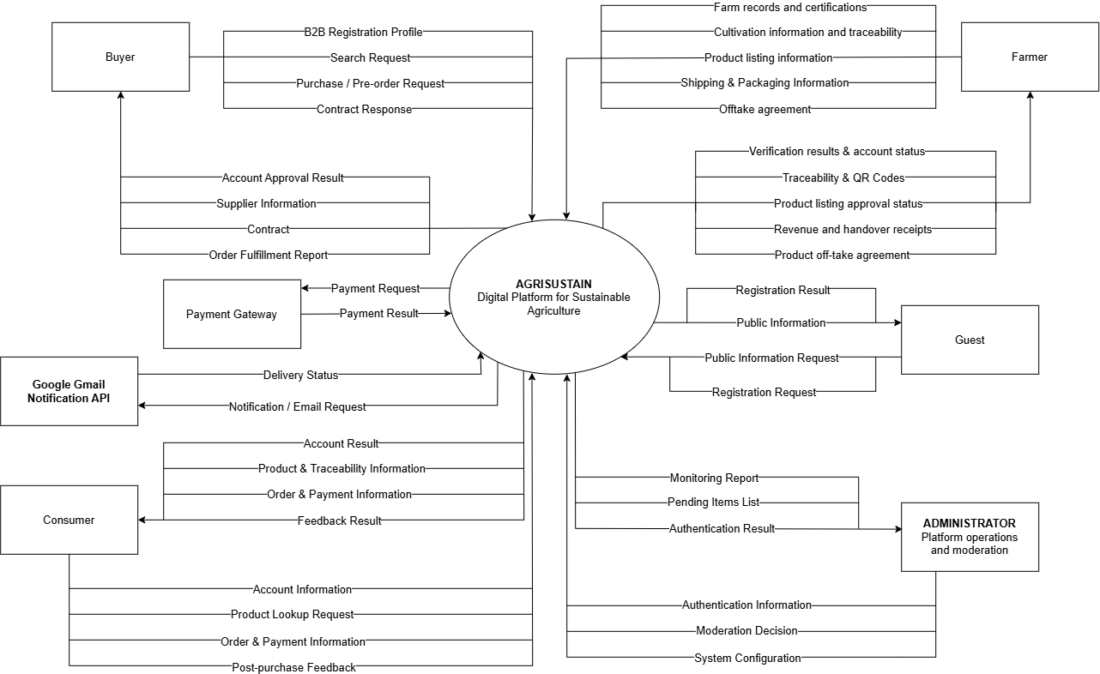
*** Note:
Ingredient name | Symbol
System Boundary | 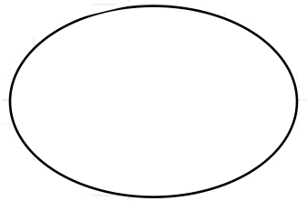
External Entity | 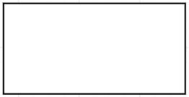
Data Flow | 

2. Main Business Flow

2.1 Consumer Purchase Flow (BF-01)
Trigger: Consumer proceeds to checkout.
End condition: Order is confirmed or cancelled.
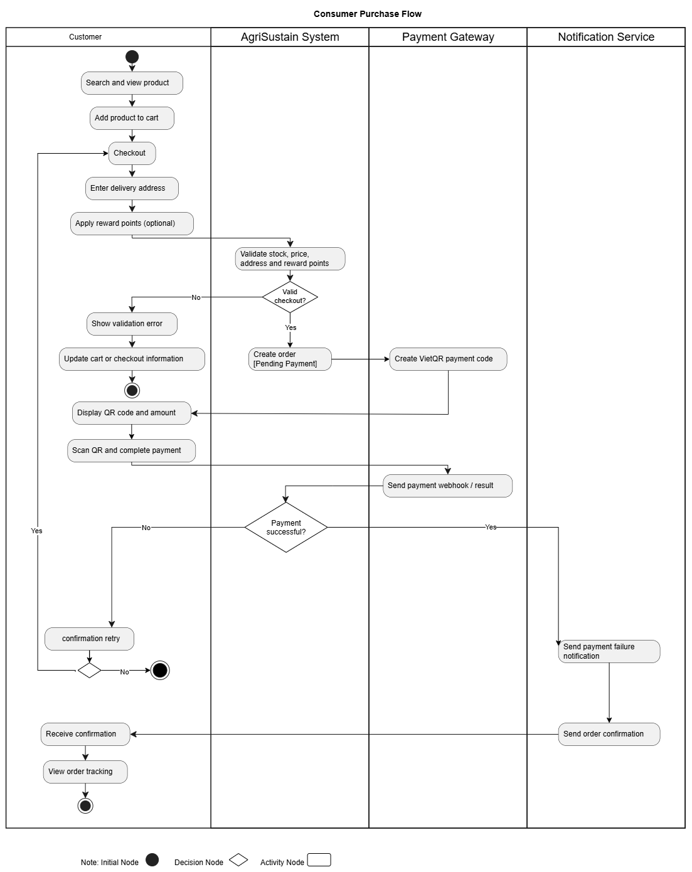

2.2 Farmer product upload flow (BF-02)
Trigger: Farmers want to list their products for sale.
End condition:Farmer successfully views the product's review status (approved or rejected).

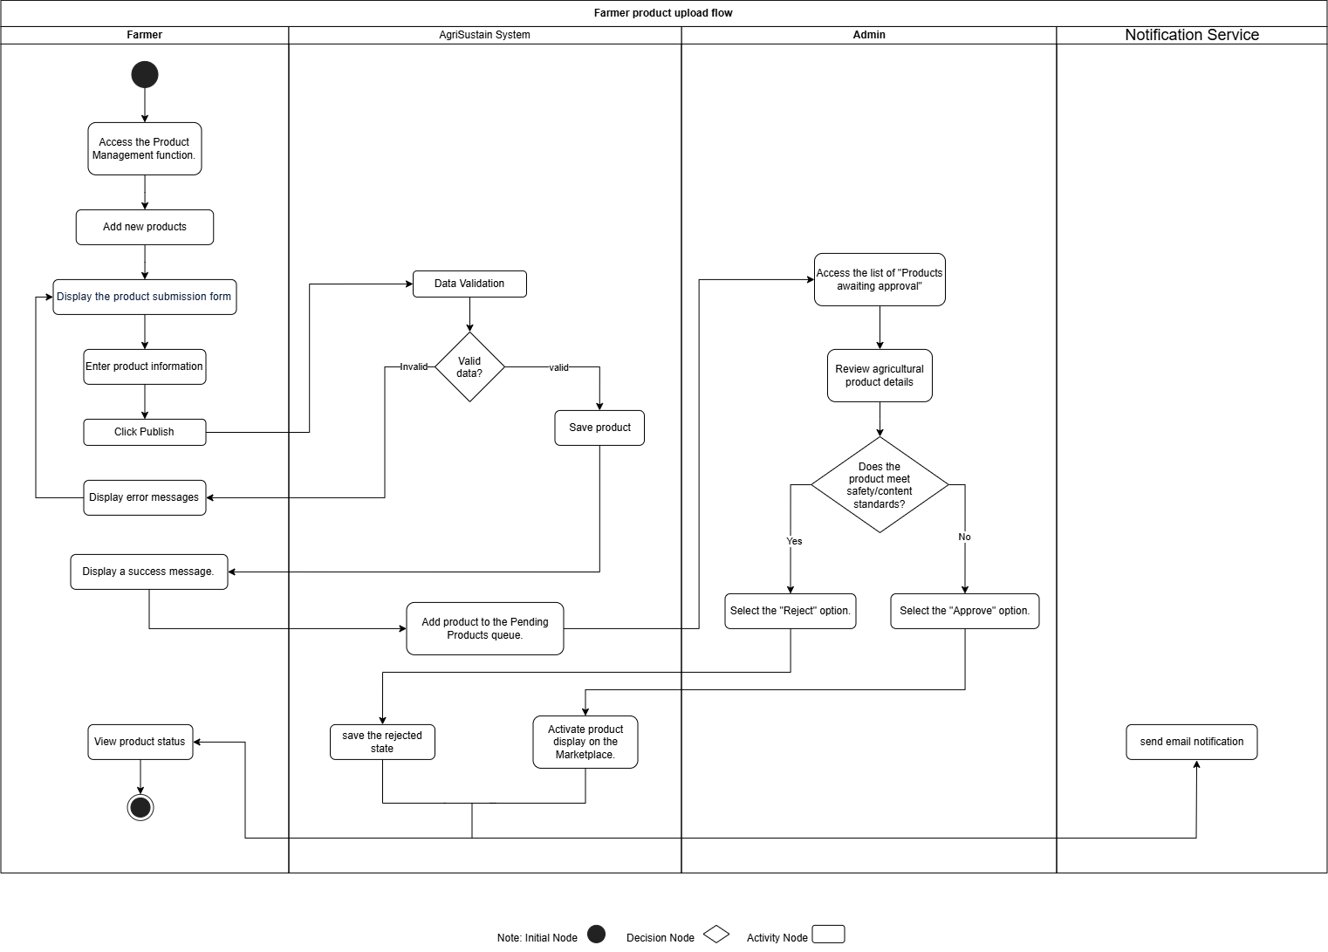

2.3 B2B Offtake Contract Flow
Trigger: Buyer B2B creates an offtake contract proposal.
End condition: Contract is activated or terminated.
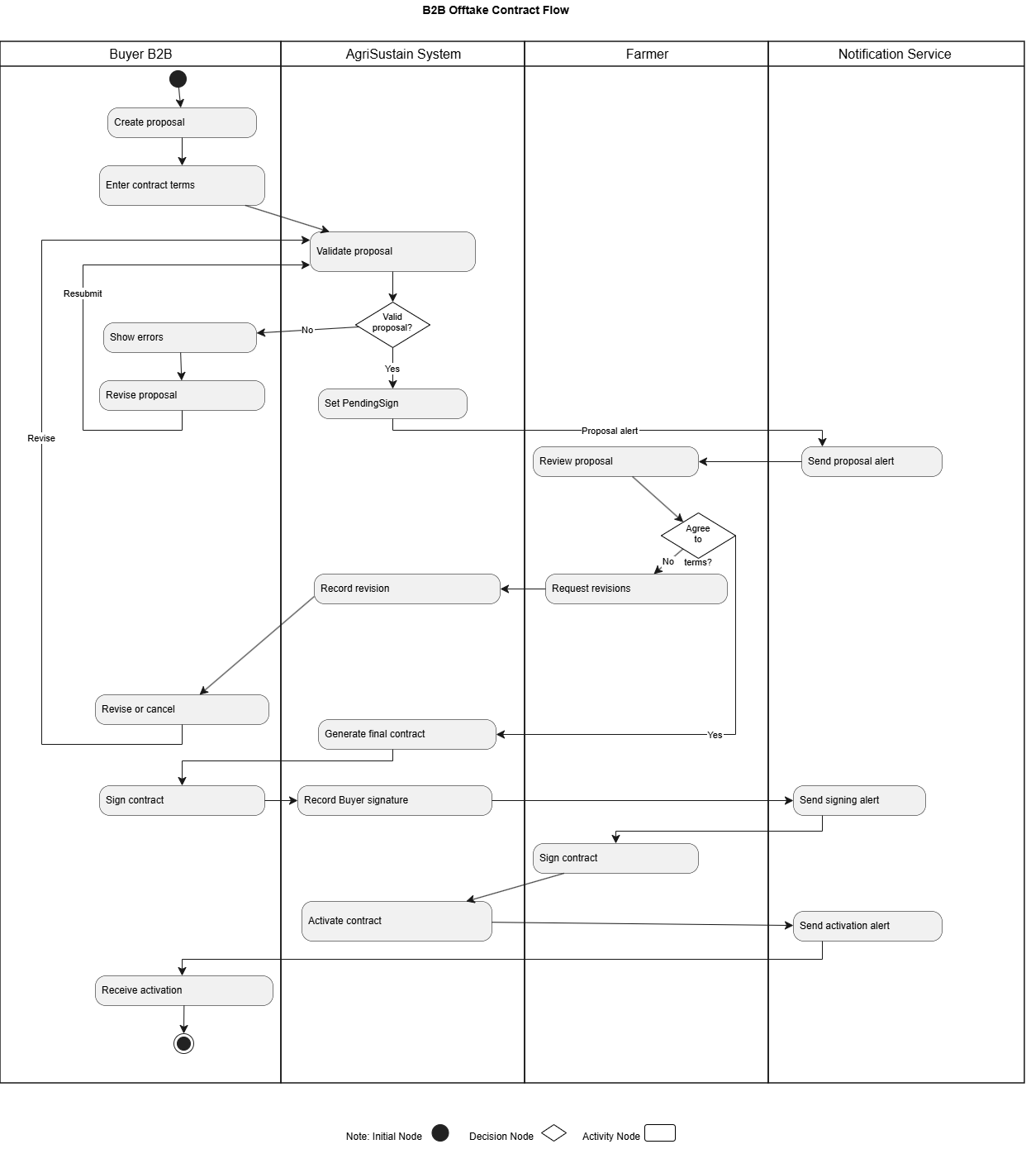

3. Conceptual Data Model

3.1 Entity Relationship Diagram

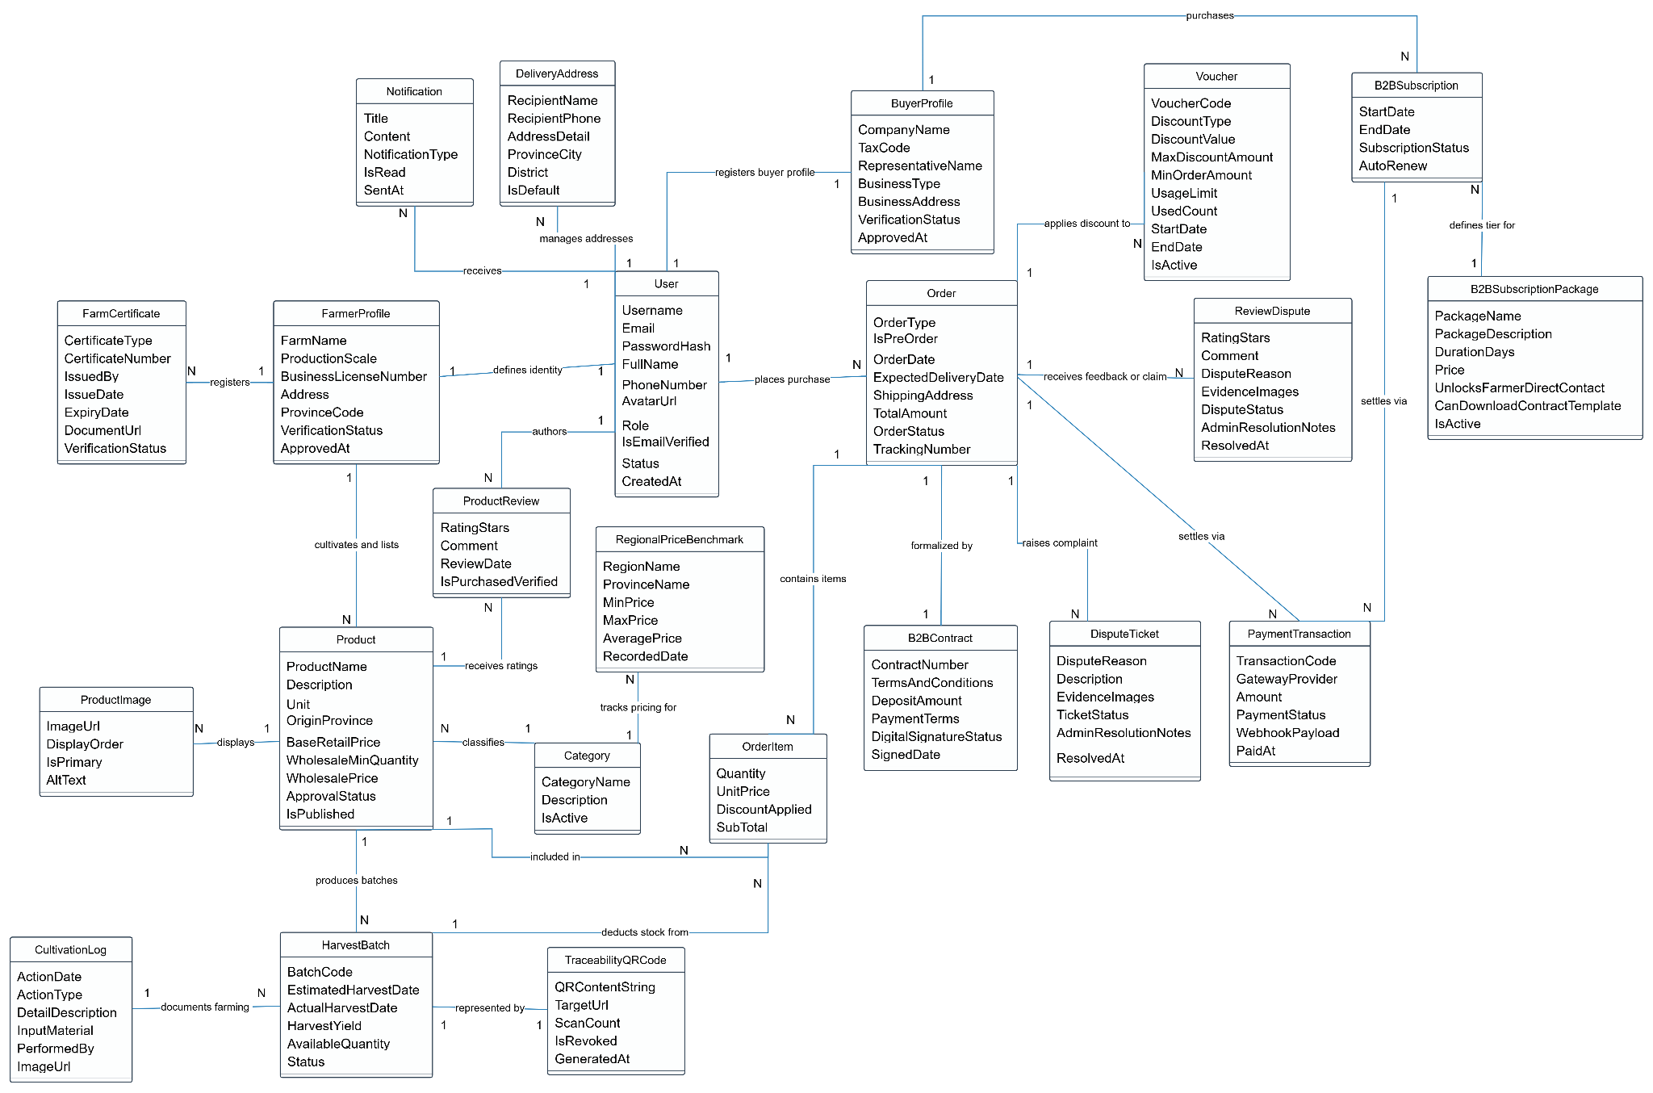
*** Note:
Symbol | Description
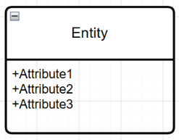 | Entity (Table): Represents an entity or a database table. The top section contains the entity name, and the bottom section lists its attributes (fields).
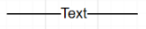 | Relationship: Connects two related entities, where the labeled text indicates the business action or relationship between them.
1—1 | One-to-One relationship: Exactly one record in this entity associates with exactly one record in the related entity.
1—N | One-to-Many relationship: One record in this entity can be associated with multiple records in the related entity.
N—N | Many-to-Many relationship: Multiple records in this entity can be associated with multiple records in the related entity.

3.2 Entity Descriptions
Entity: User
Field | Value
Purpose | Manages credentials and system identity for every actor on the platform, encompassing retail consumers (Consumer), enterprise buyers (Buyer), agricultural producers (Farmer), and administrators (Admin).
Key business attributes | Username, Email, PasswordHash, FullName, PhoneNumber, AvatarUrl, Role, Status, IsEmailVerified, CreatedAt
Business identity | Username unique across the entire system. Email unique across the entire system.
Status / lifecycle | PendingVerification (waiting for email OTP) → Active (normal) · Suspended (deactivated by Admin) · Locked (temporary after repeated failed sign-in attempts)
Entity: DeliveryAddress
Field | Value
Purpose | A personal address book storing pre-configured shipping destinations for purchasers (Consumers and Buyers) to streamline checkout.
Key business attributes | RecipientName, RecipientPhone, AddressDetail, ProvinceCity, District, IsDefault
Business identity | Composite of User, RecipientPhone, and AddressDetail. A User may designate at most one address as Default at any given time.
Status / lifecycle | Active · Archived (soft-deleted by user)
Entity: FarmerProfile
Field | Value
Purpose | Official legal identity, production scale, and location profile of an agricultural producer or cooperative, utilized for platform KYC verification.
Key business attributes | FarmName, ProductionScale, BusinessLicenseNumber, Address, ProvinceCode, VerificationStatus, ApprovedAt
Business identity | Strictly one-to-one relationship with a User having Role Farmer. BusinessLicenseNumber is unique across the entire platform.
Status / lifecycle | Draft → Submitted (pending verification) → Approved (KYC cleared) · Rejected (requires document correction and resubmission)
Entity: BuyerProfile
Field | Value
Purpose | Corporate legal credential record for commercial wholesale purchasers (restaurants, supermarkets, institutional catering services) authorizing bulk contract negotiation.
Key business attributes | CompanyName, TaxCode, RepresentativeName, BusinessType, BusinessAddress, VerificationStatus, ApprovedAt
Business identity | Strictly one-to-one relationship with a User having Role Buyer. TaxCode is unique across the entire system.
Status / lifecycle | PendingApproval → Approved (eligible for B2B negotiations) · Rejected
Entity: FarmCertificate
Field | Value
Purpose | Official agricultural credential and safety standards (VietGAP, GlobalGAP, OCOP) verified by Admin prior to public endorsement on the seller profile.
Key business attributes | CertificateType, CertificateNumber, IssuedBy, IssueDate, ExpiryDate, DocumentUrl, VerificationStatus
Business identity | CertificateNumber unique per CertificateType. Associated with exactly one FarmerProfile.
Status / lifecycle | PendingReview → Validated (active until expiration) · Expired (automatic) · Revoked (by Admin if quality criteria are compromised)
Entity: Category
Field | Value
Purpose | Standard taxonomy categorizing and organizing agricultural produce across the marketplace.
Key business attributes | CategoryName, Description, IsActive
Business identity | CategoryName unique across the entire platform.
Status / lifecycle | Active · Inactive (hidden from browsing navigation)
Entity: Product
Field | Value
Purpose | Commercial listing published by an approved Farmer, supporting base retail pricing alongside automated bulk discount tiers.
Key business attributes | ProductName, Description, Unit, OriginProvince, BaseRetailPrice, WholesaleMinQuantity, WholesalePrice, ApprovalStatus, IsPublished
Business identity | Composite pairing of FarmerProfile, ProductName, and OriginProvince.
Status / lifecycle | Draft → PendingApproval → Approved (Farmer can toggle Publish/Unpublish) · Rejected · Suspended (withdrawn by Admin due to quality complaints)
Entity: ProductImage
Field | Value
Purpose | Gallery media illustrating produce condition, packaging standards, and harvest origins.
Key business attributes | ImageUrl, DisplayOrder, IsPrimary, AltText
Business identity | Managed per Product. Exactly one image per Product must have IsPrimary = True.
Status / lifecycle | Active · Removed
Entity: HarvestBatch
Field | Value
Purpose | Specific seasonal yield lot of a product serving as the physical unit for stock deduction and traceability verification.
Key business attributes | BatchCode, EstimatedHarvestDate, ActualHarvestDate, HarvestYield, AvailableQuantity, Status
Business identity | BatchCode unique across the entire platform.
Status / lifecycle | Planned (seasonal pre-orders active) → Growing → Harvested (ready for fulfillment) → Depleted (AvailableQuantity = 0) · Discarded (crop failure)
Entity: CultivationLog
Field | Value
Purpose | Chronological electronic field log capturing daily farming activities (land prep, sowing, fertilizing, pesticide application, harvesting).
Key business attributes | ActionDate, ActionType, DetailDescription, InputMaterial, PerformedBy, ImageUrl
Business identity | No natural unique key; recorded sequentially against a specific HarvestBatch.
Status / lifecycle | Recorded (immutable audit entry once committed)
Entity: TraceabilityQRCode
Field | Value
Purpose | Public verification token and QR metadata generated for each harvest batch, scannable by consumers to inspect cultivation history.
Key business attributes | QRContentString, TargetUrl, ScanCount, IsRevoked, GeneratedAt
Business identity | QRContentString unique across the platform. Strictly one-to-one relationship with HarvestBatch.
Status / lifecycle | Active (publicly resolvable) · Revoked (disabled, redirects to recall notice)
Entity: Voucher
Field | Value
Purpose | Order-level promotional discount mechanism (percentage off or fixed deduction) intended to incentivize transactions.
Key business attributes | VoucherCode, DiscountType, DiscountValue, MaxDiscountAmount, MinOrderAmount, UsageLimit, UsedCount, StartDate, EndDate, IsActive
Business identity | VoucherCode unique across the entire system.
Status / lifecycle | Inactive → Active → Depleted (limit exhausted) · Expired
Entity: B2BSubscriptionPackage
Field | Value
Purpose | Subscription tiers configured by Admin for B2B buyers granting direct contact rights and off-take procurement capabilities.
Key business attributes | PackageName, PackageDescription, DurationDays, Price, UnlocksFarmerDirectContact, CanDownloadContractTemplate, IsActive
Business identity | PackageName unique across the entire system.
Status / lifecycle | Active (available for purchase) · Inactive (discontinued)
Entity: B2BSubscription
Field | Value
Purpose | Active membership entitlement records of a BuyerProfile governing the visibility of unmasked farmer contact details.
Key business attributes | StartDate, EndDate, SubscriptionStatus, AutoRenew
Business identity | Linked instance between a BuyerProfile and a B2BSubscriptionPackage.
Status / lifecycle | PendingPayment → Active (in-force) → Expired (re-masks farmer contact info) · Terminated
Entity: Order
Field | Value
Purpose | Commercial transaction created when purchasing produce for immediate dispatch or reserving upcoming seasonal harvest yields.
Key business attributes | OrderType (B2C / B2B), IsPreOrder, OrderDate, ExpectedDeliveryDate, ShippingAddress, TotalAmount, DiscountAmount, FinalAmount, OrderStatus, TrackingNumber
Business identity | TrackingNumber / Order code uniquely generated upon checkout.
Status / lifecycle | PendingPayment → Paid / Confirmed → Harvesting / Packing → Shipping → Delivered (terminal) · Cancelled (terminal) · Disputed
Entity: OrderItem
Field | Value
Purpose | Line-item detail linking ordered quantities directly to specific harvest lots for physical stock deduction.
Key business attributes | Quantity, UnitPrice, DiscountApplied, SubTotal
Business identity | Composite association between Order and HarvestBatch.
Status / lifecycle | Allocated → Fulfilled · Cancelled / Restocked
Entity: B2BContract
Field | Value
Purpose | Legally binding electronic off-take and bulk supply contract governing high-volume commercial pre-orders.
Key business attributes | ContractNumber, TermsAndConditions, DepositAmount, PaymentTerms, DigitalSignatureStatus, SignedDate
Business identity | ContractNumber unique across the system. Strictly one-to-one relationship with an eligible B2B Order.
Status / lifecycle | Drafted → AwaitingSignatures → Executed (dual-party signed) · Completed · Terminated
Entity: PaymentTransaction
Field | Value
Purpose | Financial settlement and reconciliation attempt processed via PayOS / VietQR (for order fulfillment or B2B subscription activation).
Key business attributes | TransactionCode, GatewayProvider, Amount, PaymentType, PaymentStatus, WebhookPayload, PaidAt
Business identity | TransactionCode unique as issued by the external payment gateway.
Status / lifecycle | Pending → Success (terminal) · Failed (terminal) · Expired · Refunded
Entity: ProductReview
Field | Value
Purpose | Post-delivery feedback and rating submitted by verified purchasers, published publicly on the marketplace listing.
Key business attributes | RatingStars (1–5), Comment, ReviewDate, IsPurchasedVerified
Business identity | Exactly one review per User per completed Product purchase in an Order.
Status / lifecycle | Published · Hidden (moderated by Admin)
Entity: DisputeTicket
Field | Value
Purpose | Post-harvest fulfillment claim (damaged goods, delivery failure, quality mismatch) escalated for administrative mediation.
Key business attributes | DisputeReason, Description, EvidenceImages, TicketStatus, AdminResolutionNotes, ResolvedAt
Business identity | Unique ticket identifier assigned sequentially per escalated Order.
Status / lifecycle | Open → UnderReview → Resolved (refund/compensation settled) · Rejected
Entity: RegionalPriceBenchmark
Field | Value
Purpose | Daily regional market price indicator tracked across administrative regions to ensure fair trade transparency.
Key business attributes | RegionName, ProvinceName, CommodityName, MinPrice, MaxPrice, AveragePrice, RecordedDate
Business identity | Unique combination of Category, CommodityName, ProvinceName, and RecordedDate.
Status / lifecycle | Published (daily market snapshot; historical entries are strictly read-only)
Entity: Notification
Field | Value
Purpose | Centralized in-app notifications and event dispatch history for tracking order progress, KYC verifications, and dispute tickets.
Key business attributes | Title, Content, NotificationType, IsRead, SentAt
Business identity | Unique system-generated alert ID directed to an assigned User.
Status / lifecycle | Unread → Read

3.3 Data Business Rules

Rule | Description | Enforced On
Unique user credentials | No two users may share the same username or email address, regardless of role. | Account registration and profile updates
Farmer KYC prerequisite | A User with role Farmer cannot list products or create harvest batches until their FarmerProfile status is Approved by an Admin. | Product listing creation and batch initialization
B2B information masking | If a Buyer has no active B2BSubscription (or if it is expired), the system automatically masks the direct phone number, detailed address, and tax license of FarmerProfiles; full details are unmasked only when an active subscription is in effect. | Farmer profile and product detail API responses
Automatic wholesale tier | When the ordered quantity of a product meets or exceeds WholesaleMinQuantity, the line item unit price must automatically switch from BaseRetailPrice to WholesalePrice. | Shopping cart calculation and OrderItem generation
Batch-level inventory deduction | Produce quantities ordered must be deducted directly from the AvailableQuantity of the corresponding HarvestBatch, never generically from the Product entity. | Order confirmation and successful payment webhook settlement
Pre-order season validity | An Order with IsPreOrder = True can only be created against a HarvestBatch with status 'Planned' and an EstimatedHarvestDate occurring in the future. | Seasonal pre-order placement
Cultivation log immutability | Once recorded, a CultivationLog entry cannot be modified or deleted by the Farmer to ensure an uncompromised audit trail for food safety traceability. | Field log submission
Single default shipping address | A user may register multiple shipping destinations, but exactly one record can have IsDefault = True. Designating a new default automatically unsets the flag on existing entries. | Delivery address book creation and updates
Voucher applicability | A Voucher is applied only if the pre-discount order total meets MinOrderAmount, current date falls within StartDate and EndDate, and UsedCount has not reached UsageLimit. | Checkout discount calculation
Subscription renewal idempotency | Purchasing an additional subscription while an existing one is still active extends EndDate by DurationDays starting from the current EndDate, rather than overwriting from the current transaction date. | Subscription payment webhook fulfillment
Purchase-verified review | A User may only submit a ProductReview for a product that was included in a completed Order with status 'Delivered'. | Product review submission
Dispute filing window | A DisputeTicket can only be opened for an Order within 48 hours following the transition of OrderStatus to 'Delivered'. | Dispute escalation submission
Single active QR per batch | Each HarvestBatch is strictly associated with exactly one TraceabilityQRCode. If a batch is revoked due to pesticide/chemical non-compliance, its QR URL must immediately resolve to a safety warning page. | QR scanning and batch status modification
Historical price immutability | RegionalPriceBenchmark records represent point-in-time daily market snapshots; once recorded for a given commodity and province, historical entries cannot be modified or deleted. | Daily market index synchronization

4. User Requirements

4.1 Actors

# | Actor | Description
1 | Administrator | A platform administrator responsible for platform operations and moderation, including managing users, categories, vouchers and membership tiers, reviewing KYC and certificates, managing accounts, and resolving complaints and reviews.
2 | Guest | An unregistered visitor who can access the public AgriSustain website, browse public farm/seller information, search and view products, and request account registration.
3 | Buyer | A registered user who searches for suppliers, views farm information, creates B2B orders or pre-orders, manages and signs offtake contracts, and tracks order and delivery progress.
4 | Farmer | A registered agricultural producer who manages farm information, provides cultivation and seasonal information, submits agricultural products, updates order and logistics information, and provides certification information for verification.
5 | Consumer | A registered end user who searches for agricultural products, views product details and traceability information, manages the shopping cart, places orders, makes payments, tracks orders, submits ratings and reviews, and sends complaints.
6 | Payment Gateway | An external payment service that processes payment requests from AgriSustain and returns payment results to the system.
7 | Gmail Notification Service API

4.2 Use Cases (UC)
ID | Use Case | Feature | Use Case Description
UC-AUTH-01 | Register Consumer or Farmer Account | Authentication and Profile Management | Primary actor: Guest. Creates a Consumer or Farmer account using full name, phone number, email, and password, verifies the email by OTP (includes UC-AUTH-08), and activates the account.
UC-AUTH-02 | Register Buyer B2B Account | Authentication and Profile Management | Primary actor: Guest. Creates a Buyer B2B account, verifies the email by OTP (includes UC-AUTH-08), and submits company information, tax code, and legal documents for KYC review.
UC-AUTH-03 | Manage Profile | Authentication and Profile Management | Primary actor: Consumer, Farmer, Buyer B2B, Administrator. Completes or updates role-specific profile information, including delivery addresses, farm details, business information, or administrator contact details. Farmer and Buyer B2B can submit their profile for Administrator verification.
UC-AUTH-04 | Log In | Authentication and Profile Management | Primary actor: Consumer, Farmer, Buyer B2B, Administrator. Authenticates credentials, checks account status, and opens the appropriate role workspace.
UC-AUTH-05 | Log Out | Authentication and Profile Management | Primary actor: Authenticated User. Ends the active session and invalidates the active token or session.
UC-AUTH-06 | Change Password | Authentication and Profile Management | Primary actor: Authenticated User. Changes the password after validating the current password and password policy.
UC-AUTH-07 | Reset Password | Authentication and Profile Management | Primary actor: Guest or User. Starts and completes the verified password-reset process for a forgotten password, verifying the email by OTP (includes UC-AUTH-08).
UC-AUTH-08 | Verify Email OTP | Authentication and Profile Management | Primary actor: Guest, Registered User; secondary actor: Gmail Notification Service API. Sends a one-time verification code to the user's email and validates the code entered, as a shared step of registration and password reset.
UC-MKT-01 | Browse Marketplace | Marketplace | Primary actor: Guest, Consumer, Buyer B2B. Browses public products and optionally searches or filters them by name, category, supplier, region, season, or certification.
UC-MKT-02 | View Product Detail | Marketplace | Primary actor: Guest, Consumer, Buyer B2B. Views a product's description, price, available stock or batches, farm information, certificates, and eligible reviews.
UC-TRC-01 | View Product Traceability | Traceability | Primary actor: Consumer. Enters a batch code or scans a QR code to view the farm, crop season, farming logs, harvest date, and quality certificates.
UC-CON-01 | Manage Shopping Cart | Consumer Ordering | Primary actor: Consumer. Adds products to a cart, changes quantities, or removes products before ordering.
UC-CON-02 | Place Retail Order | Consumer Ordering | Primary actor: Consumer. Selects a delivery address, applies eligible reward points, validates stock and price, and creates an order with Pending Payment status.
UC-CON-03 | Pay Retail Order | Consumer Payment | Primary actor: Consumer; secondary actor: VietQR/PayOS Payment Gateway. Requests a dynamic QR payment and records payment success only after a valid gateway webhook is received.
UC-CON-04 | Track Retail Order | Consumer Ordering | Primary actor: Consumer. Views order history and order details.
UC-CON-05 | Submit Product Review | Consumer Engagement | Primary actor: Consumer. Submits a star rating and comment for a product after the related order is completed.
UC-CON-06 | Submit Order Complaint | Consumer Engagement | Primary actor: Consumer. Creates an order complaint with a reason and supporting evidence within the allowed policy period.
UC-B2B-01 | Search Suppliers | B2B Procurement | Primary actor: Buyer B2B. Searches Farmers and production regions by location, supply capacity, crop season, and certification.
UC-B2B-02 | View Supplier Capacity Profile | B2B Procurement | Primary actor: Buyer B2B. Views a selected supplier's cultivated area, production capacity, crop calendar, available products, certificates, and reputation information.
UC-B2B-03 | Create Wholesale Order | B2B Procurement | Primary actor: Buyer B2B. Creates a bulk order with quantity, packaging requirements, and a requested delivery schedule.
UC-B2B-04 | Create Pre-Order Commitment | B2B Procurement | Primary actor: Buyer B2B. Reserves output from an upcoming crop season under agreed quantity, price, and commitment or deposit terms.
UC-B2B-05 | Create Offtake Contract Proposal | B2B Contract Management | Primary actor: Buyer B2B. Drafts a long-term offtake proposal containing quantity, price framework, delivery terms, and validity period.
UC-B2B-06 | Sign Offtake Contract | B2B Contract Management | Primary actor: Buyer B2B and Farmer. Electronically signs or confirms an offtake contract after both parties agree to its terms.
UC-B2B-07 | Track B2B Fulfillment | B2B Contract Management | Primary actor: Buyer B2B. Tracks contract fulfillment, wholesale delivery milestones, invoices, and related records.
UC-B2B-08 | Manage Buyer Subscription | B2B Membership | Primary actor: Buyer B2B. Views, selects, renews, or cancels an eligible subscription tier.
UC-FAR-01 | Manage Crop Seasons | Farm Management | Primary actor: Farmer. Creates and updates crop-season plans, expected harvest dates, estimated and actual yields, and season status.
UC-FAR-02 | Record E-Farming Logs | Farm Management | Primary actor: Farmer. Records cultivation activities such as irrigation, fertilisation, pest management, and supporting evidence.
UC-FAR-03 | Manage Product Listing | Product Management | Primary actor: Farmer. Creates, updates, archives, and submits product listings with product name, category, unit, price, images, and publishing information.
UC-FAR-04 | Manage Traceability Batches | Product Traceability | Primary actor: Farmer. Creates product batches linked to crop seasons, maintains harvest/expiry/stock data, and requests QR traceability identifier generation.
UC-FAR-05 | Manage Pre-Order Campaign | Farmer Sales Management | Primary actor: Farmer. Opens, updates, or closes a pre-order campaign for an upcoming crop season using target quantity and campaign dates.
UC-FAR-06 | Process Order | Farmer Sales Management | Primary actor: Farmer. Confirms or rejects an order, packs it, and records handover or delivery status with a reason when required.
UC-FAR-07 | Submit Certificate Dossier | Certification | Primary actor: Farmer. Uploads VietGAP, GlobalGAP, Organic, or other approved certificate evidence for verification.
UC-FAR-08 | Manage Offtake Contract | B2B Contract Management | Primary actor: Farmer. Reviews, accepts, signs, or requests termination of an offtake contract.
UC-FAR-09 | View Revenue Dashboard | Farmer Analytics | Primary actor: Farmer. Views retail and B2B sales, revenue, and cash-flow information by crop season or payment stage.
UC-ADM-01 | View Platform Dashboard and Pending Work | Administration | Primary actor: Administrator. Monitors KPIs, GMV or revenue, user growth, orders requiring coordination, and pending work queues.
UC-ADM-02 | Review KYC Application | Administration | Primary actor: Administrator. Reviews Farmer and Buyer B2B KYC applications and certificate dossiers, then approves, rejects, or requests additional information with a recorded reason.
UC-ADM-03 | Manage User Account Status | Administration | Primary actor: Administrator. Searches user accounts and activates, suspends, unlocks, or deactivates them according to policy.
UC-ADM-04 | Moderate Product Listing | Administration | Primary actor: Administrator. Reviews product images, descriptions, origin information, and publication status before or after listing.
UC-ADM-05 | Manage Product Categories | Administration | Primary actor: Administrator. Creates, updates, reorders, activates, or deactivates the product-category hierarchy.
UC-ADM-06 | Resolve Complaint | Administration | Primary actor: Administrator. Reviews evidence, records a resolution, and updates the complaint and related order status.
UC-ADM-07 | Manage Promotions and Vouchers | Administration | Primary actor: Administrator. Configures voucher codes, discount rules, minimum order value, usage limits, validity periods, and activation status.
UC-ADM-08 | Moderate Product Review | Administration | Primary actor: Administrator. Reviews reported or policy-violating product reviews and decides whether to retain or remove them.
UC-ADM-09 | Manage Subscription Tiers | Administration | Primary actor: Administrator. Configures tier price, feature entitlement, transaction limits, and availability status.

4.3 Use Case Diagrams

4.3.1 UCs for Guest
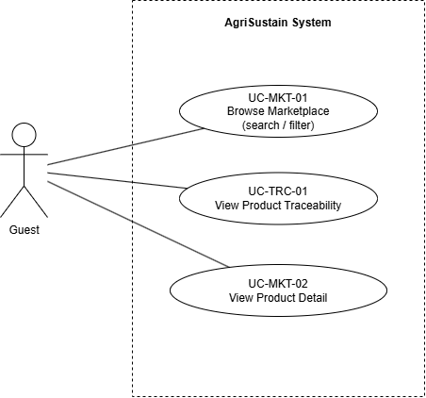

4.3.2 UCs for Consumer
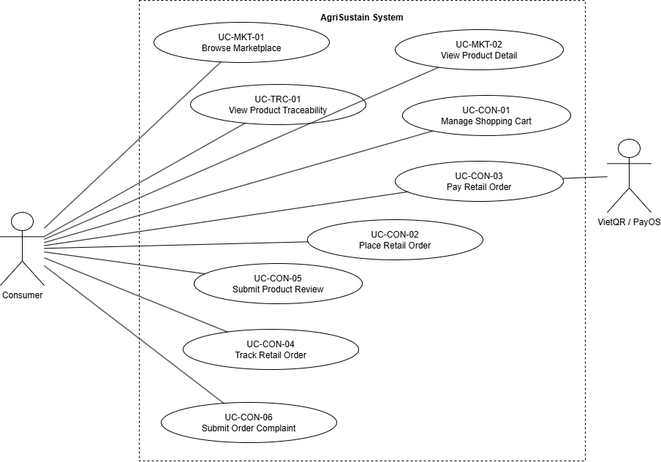

4.3.3 UCs for farmer

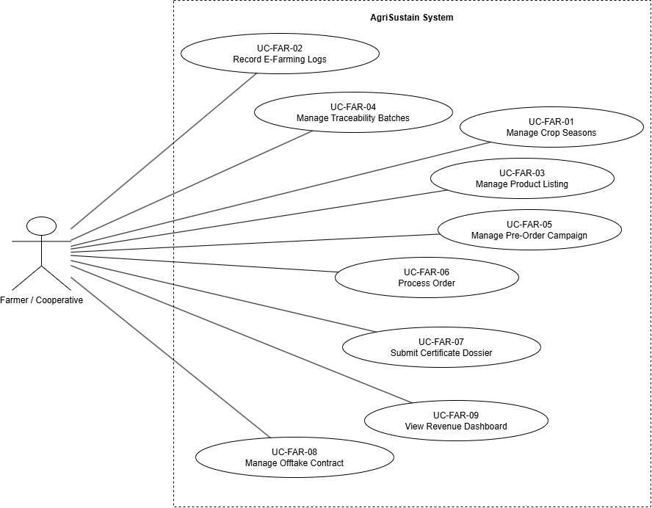

4.3.4 UCs for B2B
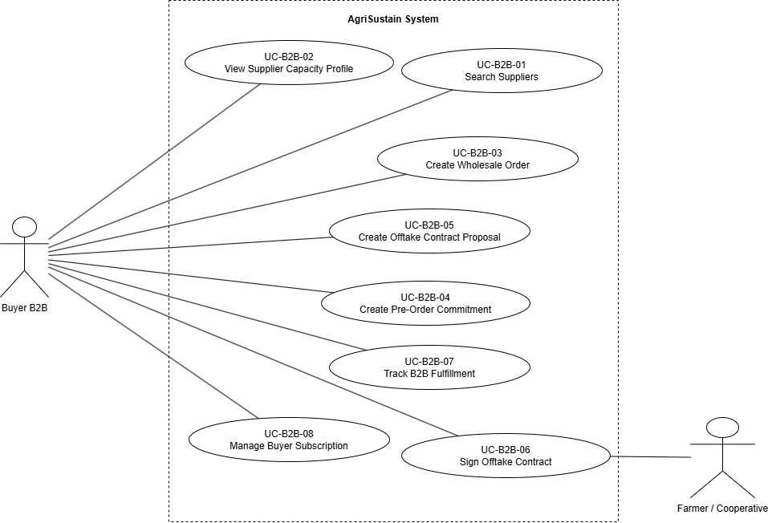

4.3.5 UCs for Admin
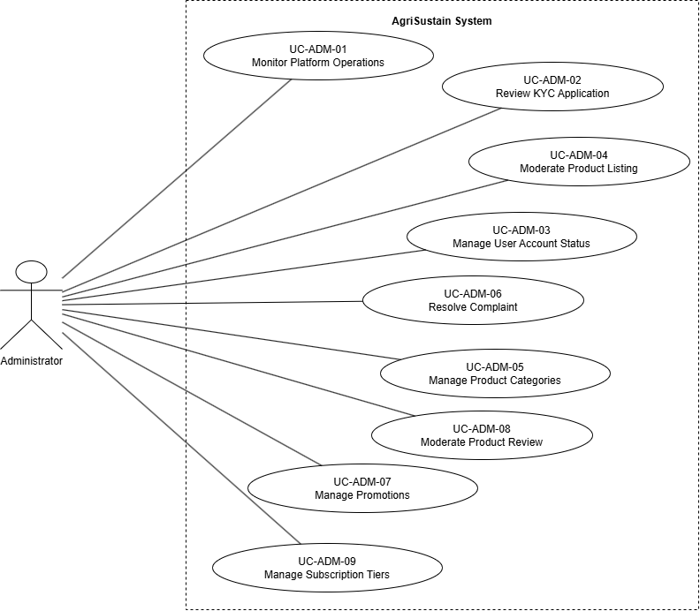

4.3.6 UCs for Authentication
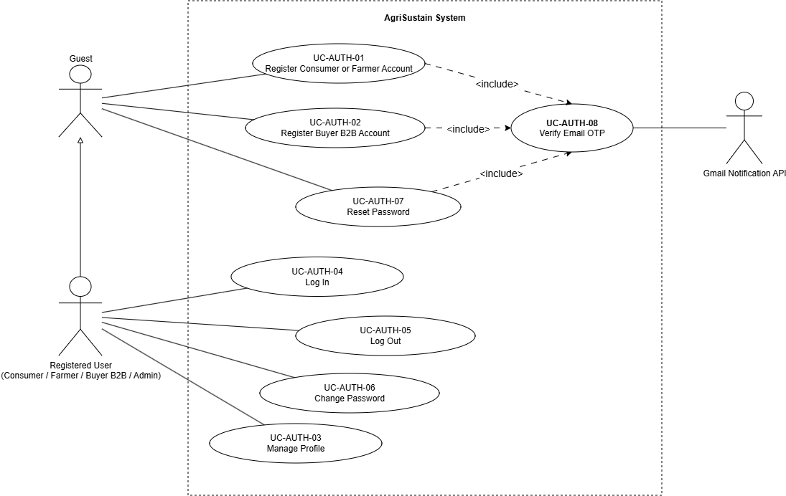

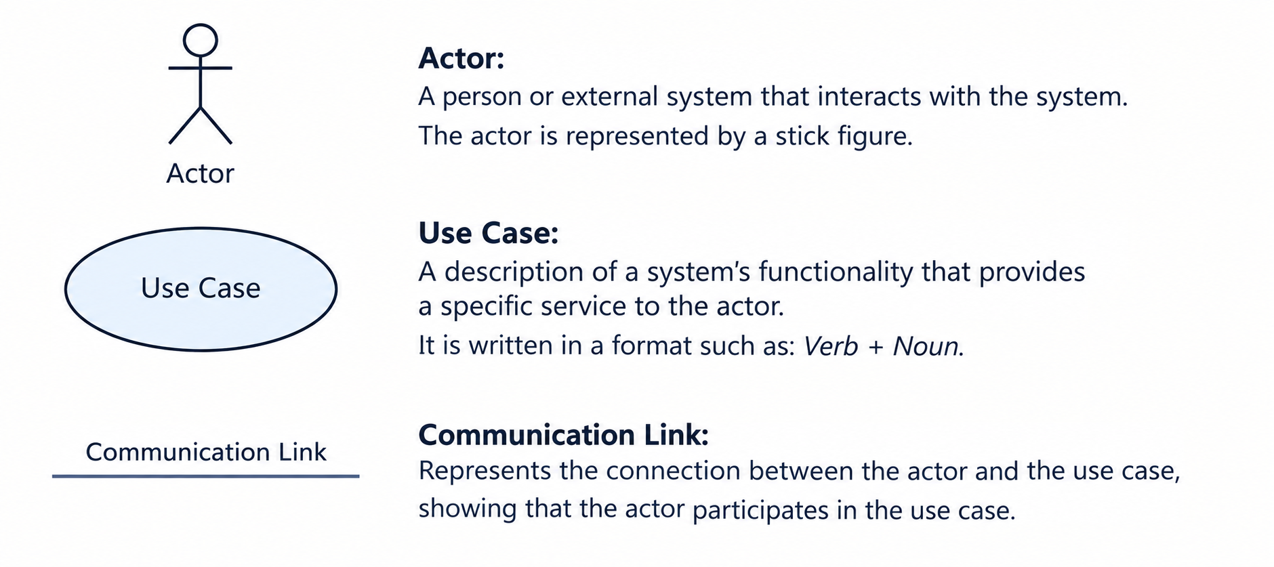

4.4 Permission Matrix
Full = unrestricted · Restricted = conditions apply (see footnotes) · No = denied

Entity | Action | Admin | Farmer / Cooperative | Buyer B2B | Consumer | Guest
Account | Register account | No | Full | Full | Full | Full
Account | Log in / log out / reset password | Full | Full | Full | Full | Restricted ¹
Account | View/update own profile | Full | Full | Full | Full | No
Account | Submit KYC dossier | No | Full | Full | No | No
Account | Approve/reject KYC dossier | Full | No | No | No | No
Account | Search/view user directory | Full | No | No | No | No
Account | Suspend/unlock/activate account | Full | No | No | No | No
Marketplace | Browse/search public products | Full | Full | Full | Full | Full
Marketplace | View product details | Full | Full | Full | Full | Full
Farm / supplier profile | View public profile | Full | Full | Full | Full | Full
Traceability | View QR traceability data | Full | Full ² | Full | Full | Restricted ³
Farm and crop season | Create/update own farm and crop seasons | No | Full | No | No | No
Farming log | Create/update own e-farming logs | No | Full | No | No | No
Certificate dossier | Submit/view own certificate dossier | Restricted ⁴ | Full | No | No | No
Product listing | Create/update/archive own listing | No | Full | No | No | No
Product listing | Approve/reject/moderate listing | Full | No | No | No | No
Product batch | Create/update own batch, stock and QR traceability | No | Full | No | No | No
Pre-order campaign | Create/update/close own campaign | No | Full | No | No | No
Shopping cart | Add/update/remove cart items | No | No | No | Full | No
Retail order | Checkout and place retail order | No | No | No | Full | No
Payment | Initiate QR payment for own retail order | No | No | Restricted ⁵ | Full | No
Order | View own purchase/order history | Restricted ⁶ | Full ⁷ | Full | Full | No
Order | Confirm/reject/pack/hand over assigned order | No | Full | No | No | No
B2B procurement | Search suppliers and production regions | No | Restricted ⁸ | Full | No | No
B2B order | Create wholesale order | No | No | Full | No | No
Pre-order commitment | Create commitment/reservation | No | No | Full | No | No
Offtake contract | Create contract proposal | No | No | Full | No | No
Offtake contract | Review/sign/manage own contract | Restricted ⁹ | Full | Full | No | No
B2B subscription | View/manage own subscription | No | No | Full | No | No
Subscription tier | Create/update/activate tier | Full | No | No | No | No
Product review | Submit review | No | No | No | Full | No
Product review | Moderate/remove violating review | Full | No | No | No | No
Complaint | Submit complaint | No | No | No | Full | No
Complaint | View/resolve complaint | Full | No | No | No | No
Voucher / promotion | Create/update/activate voucher | Full | No | No | No | No
Voucher / reward points | Apply eligible voucher/reward points | No | No | No | Full ¹² | No
Product category | Create/update/activate category hierarchy | Full | No | No | No | No
Dashboard | View platform KPI and pending work | Full | No | No | No | No
Dashboard | View own revenue/cash-flow dashboard | No | Full | No | No | No
Notification | View own notifications | Full | Full | Full | Full | No

5. System Functionalities

5.1 Screen Inventory

a. Screen Flow
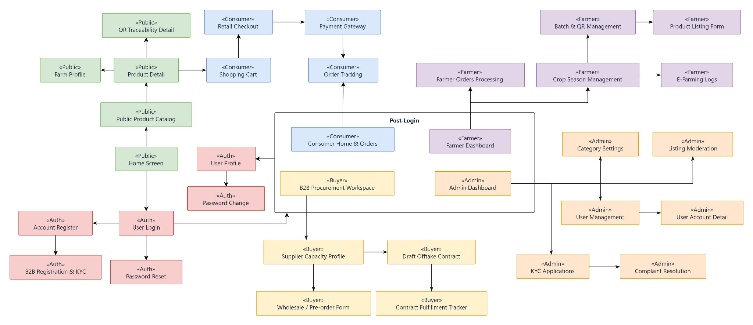

b. Screen List
# | Screen Name | Feature | Description
1 | Home Screen | Marketplace | Landing page displaying featured agricultural products, key platform highlights, and entry points for search and role-based login.
2 | Public Product Catalog | Marketplace | Allows guests and buyers to browse, search, and filter public agricultural products by name, category, region, season, or certification.
3 | Product Detail | Marketplace | Displays full product information including pricing, stock, descriptions, farm background, certifications, and eligible customer ratings.
4 | Farm Profile | Marketplace / Capacity | Displays public farm information, verified certifications, production capabilities, crop seasons, and listed agricultural items.
5 | QR Traceability Detail | Traceability | Displays origin batch logs, harvest dates, farming practices, and verified certification dossiers retrieved via batch code or QR scanning.
6 | User Login | Authentication | Allows registered users (Consumer, Farmer, Buyer B2B, Administrator) to authenticate and navigate to their role-specific workspaces.
7 | Account Register | Authentication | Enables new individual users to create either a Consumer or Farmer account using their phone number and initial security credentials.  The OTP verification modal is shared across these screens (UC-AUTH-08).
8 | B2B Registration & KYC | Authentication | Allows corporate B2B buyers to submit enterprise profiles, tax codes, representative info, and legal dossiers for KYC verification.  The OTP verification modal is shared across these screens (UC-AUTH-08).
9 | Password Reset | Authentication | Enables users to securely recover their forgotten account passwords via verification code confirmation.  The OTP verification modal is shared across these screens (UC-AUTH-08).
10 | Password Change | Authentication | Allows logged-in users to update their account credentials after validating their current password against system policies.
11 | User Profile | Authentication & Profile | Enables users across roles to view and edit role-specific details, contact information, farm properties, or delivery addresses.
12 | Consumer Home & Orders | Consumer Ordering | Serves as the landing hub for consumers to access order records, track active shipments, and manage loyalty points or vouchers.
13 | Shopping Cart | Consumer Ordering | Allows consumers to view selected products, update package quantities, and review subtotal amounts before checkout.
14 | Retail Checkout | Consumer Ordering | Enables consumers to configure shipping addresses, apply reward points or discount vouchers, and initialize pending retail orders.
15 | Payment Gateway | Consumer Payment | Facilitates dynamic payment processing via VietQR / PayOS integrations and awaits webhook execution results.
16 | Order Tracking | Consumer Ordering | Provides tracking of delivery milestones, parcel tracking codes, driver handoffs, and fulfillment status for retail purchases.
17 | B2B Procurement Workspace | B2B Procurement | Central hub for wholesale buyers to search for farming cooperatives, filter supply capacity, and track off-take contracts.
18 | Supplier Capacity Profile | B2B Procurement | Shows comprehensive supplier metrics including cultivation area, crop calendar, seasonal yields, and trust ratings for B2B procurement.
19 | Wholesale / Pre-order Form | B2B Procurement | Allows verified B2B buyers to construct bulk wholesale purchase requests or reserve yields from upcoming harvest seasons.
20 | Draft Offtake Contract | B2B Contract Management | Provides drafting tools for commercial offtake commitments, outlining supply schedules, terms, pricing formulas, and quality clauses.
21 | Contract Fulfillment Tracker | B2B Contract Management | Tracks contractual delivery milestones, scheduled consignments, invoices, and acceptance logs for active offtake deals.
22 | Farmer Dashboard | Farmer Analytics | Offers producers an operational overview of active season revenue, cash flow stages, inventory summaries, and order requests.
23 | Crop Season Management | Farm Management | Allows farmers to schedule production plans, estimate yield dates, allocate plots, and monitor crop growth phases.
24 | E-Farming Logs | Farm Management | Enables farmers to record cultivation tasks such as irrigation, fertilization, pest interventions, and supporting photo records.
25 | Batch & QR Management | Product Traceability | Enables farmers to pack harvested output into traceable batches and generate distinct QR codes linked to farming journals.
26 | Product Listing Form | Product Management | Allows farmers to create, adjust, price, and submit crop listings under defined categories for public cataloging.
27 | Farmer Orders Processing | Farmer Sales Management | Allows agricultural producers to accept incoming retail and wholesale orders, manage dispatch packaging, and log carrier handovers.
28 | Admin Dashboard | Administration | Displays operational metrics, GMV growth, system KPIs, incident reports, and pending administrative review items.
29 | User Management | Administration | Provides administrators with user search directories to monitor activity, unlock, suspend, or terminate user access permissions.
30 | User Account Detail | Administration | Detailed view of a selected user's account history, connected roles, activity trail, and compliance flags.
31 | KYC Applications | Administration | Allows platform administrators to review submitted legal certificates, verify tax documentation, and approve or reject B2B/Farmer accounts.
32 | Listing Moderation | Administration | Moderation portal to inspect product content, evaluate origin documentation, and approve or reject public agricultural listings.
33 | Category Settings | Administration | Interface for administrators to organize hierarchical product taxonomies, measurement units, and filtering classifications.
34 | Complaint Resolution | Administration | Allows administrators to examine evidence, review order timelines, mediate buyer-seller conflicts, and issue final resolutions.

5.2 External API Inventory
# | API Name | Calling Path | Description
1 | PayOS / VietQR Payment Webhook | PayOS Gateway → AgriSustain | Inbound webhook receiving Instant Payment Notifications (IPN) upon successful VietQR bank transfers to transition orders to Paid status and update transaction records.
2 | Google Gmail Notification API | AgriSustain $→$ Google Gmail API | Dispatches account verification OTP codes, order confirmations, password reset links, and bilateral offtake signing alerts via Google Gmail.

5.3 Background Job Inventory
# | Job Name | Group | Description
1 | Expire Password Reset Tokens | Scheduled | Runs every 15 minutes to invalidate expired password-reset OTPs/tokens.
2 | Auto-Cancel Unpaid Retail Orders | Scheduled | Runs every 30 minutes to cancel retail orders that remain unpaid beyond the configured payment time limit; restores reserved inventory when applicable.
3 | Reconcile Payment Status | Scheduled | Runs every 15 minutes to re-check pending VietQR/PayOS payment transactions when a payment webhook is delayed or unavailable.
4 | Pre-Order Campaign Status Update | Scheduled | Runs every hour to automatically activate, close, or mark pre-order campaigns as completed based on start time, end time, capacity, and campaign rules.
5 | Contract Milestone Reminder | Scheduled | Runs daily at 8:00 AM to notify Buyers and Farmers about upcoming or overdue B2B contract milestones.
6 | Subscription Expiry Reminder | Scheduled | Runs daily at 8:00 AM to notify B2B Buyers before their membership subscription expires and update expired subscription status.
7 | Certificate Expiry Monitoring | Scheduled | Runs daily at 8:00 AM to identify certificates nearing expiry or already expired and notify Farmers/Admins.
8 | Pending KYC Review Reminder | Scheduled | Runs daily at 8:00 AM to notify Administrators of Consumer, Farmer, or Buyer accounts pending KYC approval.
9 | Notification Delivery Retry | Scheduled | Runs every 15 minutes to resend failed in-app, email, or system notifications.
10 | Archive Old Audit and Activity Logs | Scheduled | Runs monthly at 2:00 AM to archive old activity logs according to the platform’s data-retention policy.

II. Use Case Specifications

1. Authentication

1.1 UC-AUTH-01 - Register Consumer or Farmer Account

Primary Actors | Guest | Secondary Actors | Gmail Notification Service API (API-02)
Description | As a Guest, I want to register a Consumer or Farmer account using my full name, phone number, email, and password so that I can access the AgriSustain platform and use role-specific features.
Preconditions | - User is not logged into the system.  - User accesses the User Registration Screen (SCR-07).  - Phone number and email address are not registered previously in the system.
Normal Flow | Register Consumer or Farmer Account  - User selects the account role: Consumer or Farmer.  - User enters required information: Full Name, Phone Number, Email, Password, and Confirm Password.  - User checks the checkbox agreeing to Terms of Service & Privacy Policy.  - User clicks the "Register" button.  - System validates all input data (mandatory fields, email format, phone format, password strength, password confirmation match, and uniqueness of email/phone).  - System verifies the user's email by including UC-AUTH-08 (Verify Email OTP).  - System hashes the password using BCrypt/Argon2, creates a new Account record with Status = 'Active', and records the registration in the system audit log.  - System initializes a Consumer profile (if Consumer role was selected) or an empty Farmer profile with VerificationStatus = 'NotSubmitted' (if Farmer role was selected).  - System displays a registration success notification (MSG56) and redirects the user to the Sign In screen.
Alternative Flows | Step 5_Validation Failure  System identifies empty fields (MSG02), invalid formats, password complexity violations, password mismatch, or existing email/phone; system highlights invalid fields and allows the user to correct them.  Step 6_Email Verification Failure  The email verification in UC-AUTH-08 fails (email delivery failure, invalid or expired OTP, or too many attempts); the system does not create an account and the user may retry or resend the code as described in UC-AUTH-08.  Step 1-6_Cancel Registration  User clicks the "Cancel" button before the account is created; system clears the input form and redirects to the Home page without creating an account.
Postconditions | - A new Account is created with Status = 'Active' and an encrypted password hash.  - A Consumer profile is created directly, or a Farmer profile is created with VerificationStatus = 'NotSubmitted'. The Farmer cannot list products until the farm profile is approved by an Administrator (see UC-AUTH-03, UC-ADM-02).  - The registration is recorded in the system audit log.

1.2 UC-AUTH-03 - Manage Profile

Primary Actors | Consumer, Farmer, Buyer B2B, Administrator | Secondary Actors | None
Description | As an authenticated Consumer, Farmer, Buyer B2B, or Administrator, I want to view, complete, and update my personal profile, contact information, farm details, or enterprise legal data so that platform interactions and transactions remain accurate.
Preconditions | - User is authenticated with an active account session.  - Account status is 'Active'.  - User navigates to the Profile & Farm Management Screen from the user header menu.
Normal Flow | Manage Profile  - User selects "Account / Profile" from the top navigation bar.  - System displays the Profile screen and loads existing profile attributes based on the user's role:  - Common: Full Name, Phone Number, Email, Avatar.  - Consumer: Gender, Date of Birth, Default Delivery Address, Reward Points Balance (read-only).  - Farmer: Farm Name, Representative Name, Farm Address, Cultivation Zone, Farm Size (ha), GPS Coordinates, Production Model, Short Description, Business License Number, Verification Status (read-only), Reputation Score (read-only).  - Buyer B2B: Company Name, Tax Code (read-only after approval), Business Address, Business Type, Verification Status (read-only).  - Administrator: Common fields only (no additional role-specific attributes).  - User modifies the editable fields and/or uploads a new avatar/farm banner image.  - User clicks the "Save Changes" button.  - System validates the updated values (phone format, positive numeric values for farm size, required address fields).  - System persists updated records to the database and updates the UpdatedAt timestamp.  - (Optional) If the user's Verification Status is 'NotSubmitted' (Farmer) or 'Rejected' (Farmer or Buyer B2B), the system displays a "Submit for Verification" button. When the user clicks it, the system checks that all required profile fields are completed, sets Verification Status = 'PendingApproval', and adds the profile to the Administrator's KYC queue (UC-ADM-02).  - System displays a success toast notification: "Profile updated successfully!" (MSG13) and refreshes the form.
Alternative Flows | Step 5_Input Validation Failure  - System identifies invalid fields (e.g., negative farm size, missing required address components); displays inline red validation messages and stops submission.  Step 3_Cancel Profile Editing  - User clicks the "Cancel" button; system reverts all edited fields to their previously saved values without updating the database.  Step 6_Changing Verified Identity / KYC Fields  - Farmer or Buyer updates legal verification fields (e.g., Business License, Tax Code) of an approved profile; the system notifies the user that the change requires re-verification and sets Verification Status to 'PendingApproval', and adds the profile to the Administrator's KYC queue (UC-ADM-02).  Step 7_Incomplete Profile  - The user clicks "Submit for Verification" while required fields are missing; the system highlights the missing fields, displays a message, and keeps Verification Status unchanged.
Postconditions | - User profile details are updated and persisted in the database.  - Session user profile cache is refreshed.  - If a Farmer submitted the farm profile, Verification Status = 'PendingApproval' and awaits Administrator review. Product listing, batch creation, and pre-order campaigns are enabled only after it is 'Approved'.  - Any modification to KYC-sensitive fields is flagged for Administrator re-moderation.

1.3 UC-AUTH-04 Log In

Primary Actors | Consumer, Farmer, Buyer B2B, Administrator | Secondary Actors | None
Description | As a registered user, I want to be able to log into the system so that I can access the system's authenticated features and use functions according to my role.
Preconditions | User account has been created and is active/authorized.
Normal Flow | Login System  1. User clicks the Login button from the page header or accesses an authenticated feature.  2. System shows the User Login screen.  3. User enters the login details (email and password).  4. User clicks the Login button.  5. System validates the login details.  6. System verifies that the user account is active and authorized.  7. System identifies the user's role (Consumer, Farmer, Buyer B2B, or Administrator).  8. System creates an authenticated session for the user.  9. System directs the user to the Home Page or the previously requested page.
Alternative Flows | Step 4_System can’t authenticate the user  - User can’t be authenticated & get relevant error message in one of below cases  - 1. He/she leaves the Email and/or Password field blank (MSG02)  - 2. Input Email or Password are incorrect (MSG09)  - 3. Input Email/Password are correct but email has not been verified (MSG03)  - 4. The user account is blocked / inactive (MSG10)
Postconditions | - User logs into the system successfully.  - The system creates an authenticated session.  - The system identifies the user's role and grants access to authorized features.  - User can access the system according to their permissions.

1.4 UC-AUTH-05 Log Out

Primary Actors | Consumer, Farmer, Buyer B2B, Administrator | Secondary Actors | None
Description | As a logged-in user, I want to be able to log out of the system so that I can securely terminate my current session and prevent unauthorized access to my account and authenticated features.
Preconditions | User has successfully logged into the system and has an active authenticated session.
Normal Flow | Logout System  1. User opens the Profile / Account menu from the page header.  2. System displays the Logout option.  3. User clicks the Logout button.  4. System receives the logout request.  5. System validates the user's current authenticated session.  6. System terminates the user's authenticated session.  7. System clears the user's authentication information from the current session.  8. System redirects the user to the Home Page.  9. System displays a logout success message.
Alternative Flows | Step 3_User cancels the logout operation  - System displays a confirmation message before logging the user out.  - User selects Cancel.  - System closes the confirmation message.  - User remains logged in and can continue using authenticated features.
Postconditions | - User is logged out of the system successfully.  - The system terminates the user's authenticated session.  - The user's authentication information is cleared from the current session.  - User can no longer access authenticated features without logging in again.  - User is redirected to the Home Page or Login Page.

1.5 UC-AUTH-06 Change Password

Primary Actors | Authenticated User (Consumer, Farmer, Buyer B2B, Administrator) | Secondary Actors | None
Description | As an authenticated user, I want to change my account password so that I can maintain the security of my account.
Preconditions | 1. User is logged in successfully.  2. User account is active.  3. User has a valid authenticated session.
Normal Flow | Change Password  1. User opens the Change Password screen from Account Settings.  2. System displays Current Password, New Password, and Confirm New Password fields.  3. User enters the required password information.  4. User selects Change Password.  5. System verifies the Current Password and validates the New Password according to GBR-21.  6. System verifies that the confirmation password matches the New Password.  7. System securely hashes and updates the new password.  8. System displays MSG11.
Alternative Flows | Step 3–5 – Required field empty: System displays MSG02.  Step 5 – Incorrect Current Password: System displays MSG04.  Step 5 – Invalid New Password: System displays MSG06.  Step 5 – New Password equals Current Password: System displays MSG12.  Step 6 – Password confirmation mismatch: System displays MSG05.  Step 7 – Password update failure: Existing password remains unchanged and system displays MSG07.  Cancel Operation: System discards entered information and returns to the previous screen.
Postconditions | - On success, the new password is securely stored as a hash.  - User can use the new password for future sign-ins.  - If the operation fails or is cancelled, the previous password remains unchanged.

1.6 UC-AUTH-07 - Reset Password

Primary Actors | Guest / Registered User | Secondary Actors | Gmail Notification Service API (API-02)
Description | As a Guest or Registered User, I want to reset my password through a verification code sent to my registered email so that I can regain access to my account securely.
Preconditions | User is not logged in; the Password Reset screen is accessible from Sign In; the user can access the registered email address.
Normal Flow | Reset Password  - User selects Forgot Password on the Sign In screen.  - System displays the Password Reset screen.  - User enters the registered email and selects "Send Verification Code".  - System verifies the user's email by including UC-AUTH-08 (Verify Email OTP).  - System displays the reset-password fields.  - User enters and confirms the new password.  - System validates the password policy, updates the password securely, invalidates the code, displays success, and redirects to Sign In.
Alternative Flows | Step 4_Email Verification Failure: The email verification in UC-AUTH-08 fails (invalid or expired code, resend, or delivery failure); the system does not display the reset-password fields, and the user may retry as described in UC-AUTH-08.  Step 7_Invalid Password or Mismatch: System displays validation errors and lets the user correct the values.  Step 1-7_Cancel: User returns to Sign In; the password remains unchanged.
Postconditions | The password is updated only after successful code and password validation; the password is stored as a secure hash; the reset code is invalidated; the system displays success and redirects the user to Sign In.

1.7 UC-AUTH-02 – Register Buyer B2B Account

Primary Actors | Guest | Secondary Actors | Gmail Notification Service API (API-02)
Description | As a Guest, I want to register a Buyer B2B account by submitting company information, tax code, and legal documents so that after Admin KYC approval I can use wholesale procurement and offtake contract features.
Preconditions | - Guest is not currently authenticated.  - Guest navigates to the B2B Registration screen.  - Email, Phone Number, and Company Tax Code are not already registered on the platform.
Normal Flow | - Guest opens the B2B Registration screen.  - Guest enters account credentials: Email, Phone Number, Password, Confirm Password.  - Guest enters company information: CompanyName, TaxCode, Representative Name, BusinessType, BusinessAddress, and uploads the Business License (GPKD) document.  - Guest accepts Terms of Service and clicks "Register".  - System validates: Email/Phone/TaxCode uniqueness, Vietnamese Tax Code format, password policy, password confirmation match, and file format/size.  - System verifies the Guest's email by including UC-AUTH-08 (Verify Email OTP).  - System hashes the password, creates a User record (Role = Buyer, Status = 'Active') and a linked BuyerProfile with VerificationStatus = 'PendingApproval', adds the profile to the Administrator's KYC queue (UC-ADM-02), and records the registration in the audit log.  - System displays: "B2B registration successful! Wholesale ordering and offtake contract features will be enabled after Administrator KYC approval."
Alternative Flows | AF1 – Invalid / Incomplete Input (at Step 5): Missing fields, weak password, or invalid TaxCode format; system shows inline validation errors.  AF2 – Email / Phone / TaxCode Already Registered (at Step 5): System finds an existing record; displays an error; Guest may go to Login or change the value.  AF3 – Invalid Business License Document (at Step 5): File is corrupt, exceeds 5 MB, or not PDF/JPG; system highlights the upload area with an error.  AF4_Email Verification Failure (at Step 6): The email verification in UC-AUTH-08 fails; the system does not create an account and the Guest may retry or resend the code as described in UC-AUTH-08.  AF5 – Cancel Registration: Guest cancels; no account is created.
Postconditions | A User record is created with Role = Buyer and Status = 'Active'. A linked BuyerProfile is created with VerificationStatus = 'PendingApproval'. Wholesale ordering and offtake contract features remain restricted until Admin KYC approval (UC-ADM-02).

1.8 UC-AUTH-08 Verify Email OTP

Primary Actors | Guest, Registered User | Secondary Actors | Gmail Notification Service API (API-02)
Description | As a user, I want to verify my email with a one-time code so that the system can confirm I own the email address before completing registration or password reset.
Preconditions | - The calling use case (UC-AUTH-01, UC-AUTH-02, or UC-AUTH-07) has validated the user's input.  - The calling use case has provided the target email address.
Normal Flow | Verify Email OTP  - System generates a single-use OTP (valid for 5 minutes) and sends it to the email address via Gmail Notification Service API.  - The system displays a confirmation toast (MSG14) and the OTP input with a 'Verify' button and a 'Resend Code' option.  - User enters the received code and clicks "Verify".  - System validates the code (correct, unexpired, unused), marks it as used, and returns success to the calling use case.
Alternative Flows | Step 1_Email Delivery Failure  Gmail API fails to dispatch the OTP; system logs the error and displays MSG26 ("Failed to send verification code. Please try again later."). Verification does not proceed.  Step 4_Invalid or Expired Code  User enters an incorrect, expired, or already-used code; system displays an error message and keeps the OTP input open.  Step 4_Too Many Failed Attempts  User enters an incorrect code more than 5 times; system invalidates the current OTP and requires the user to request a new code.  Step 2_Resend Code  User clicks "Resend Code" after the 60-second cooldown; system invalidates the existing OTP, generates a new code, and sends it to the same email address.
Postconditions | - On success: the OTP is marked as used and invalidated, and the calling use case continues.  - On failure or expiry: the OTP is invalidated, no account is created and no password is changed, and the calling use case does not continue.

2. Marketplace

2.1 UC-MKT-01 Browse Marketplace

Primary Actors | Guest, Consumer, Buyer B2B | Secondary Actors | None
Description | As a user, I want to browse, search, and filter agricultural products so that I can find products that meet my needs
Preconditions | 1. Marketplace is accessible.  2. Product listings exist in the system.  3. Only approved and publicly available products may be displayed.
Normal Flow | Browse Marketplace  1. User opens the Marketplace page.  2. System retrieves products according to GBR-22.  3. System displays product image, name, price, unit, supplier, region, and available certification information.  4. User enters a keyword or applies filters such as category, region, crop season, certification, price, or rating.  5. User may choose a sorting option such as price, rating, or newest.  6. System validates the search and filter criteria.  7. System displays filtered, sorted, and paginated Marketplace results.  8. User selects a product to continue to UC-MKT-02 – View Product Detail.
Alternative Flows | Step 4–6 – Invalid Search/Filter Input: System rejects the invalid value and displays MSG40.  Step 7 – No Matching Products: System displays MSG01. User may modify or clear search/filter criteria.  Clear Filters: System resets all current criteria and displays the default Marketplace product list.
Postconditions | The system displays the product listings matching the user's search or filter criteria. No product data is modified.

2.2 UC-MKT-02 View Product Detail

Primary Actors | Guest, Consumer, Buyer B2B | Secondary Actors | None
Description | As a user, I want to view detailed product information so that I can evaluate a product before purchasing or contacting a supplier.
Preconditions | 1. Selected product exists.  2. Product is approved and available for public viewing.
Normal Flow | View Product Detail  1. User selects a product from the Marketplace.  2. System validates product visibility according to GBR-23.  3. System retrieves the product information.  4. System displays product name, images, description, category, price, unit, available quantity, and supplier information.  5. System displays available certifications, traceability information, and product reviews where applicable.  6. User reviews the product information.  7. User may add the product to the cart, view traceability information, or start an available B2B action according to permissions and product availability.
Alternative Flows | Step 2–3 – Product Not Found or Unavailable: System displays MSG16.  Step 5 – Optional Information Unavailable: System continues displaying the available product information without missing optional data.  Step 7 – Product Out of Stock: System prevents the purchase action and displays MSG38.
Postconditions | 1. Product details are displayed successfully.  2. No product information is modified.  3. User may continue to an eligible related function.

3. Farmer Sales

3.1 UC-FAR-06 - Process Order

Primary Actors | Farmer
Secondary Actors | None
Description | As a Farmer, I want to receive, confirm, or reject agricultural produce orders (retail or B2B wholesale), track packing progress, and record the handover of parcels to the shipping carrier (or update the reason for rejecting/canceling orders) in order to ensure order processing proceeds according to committed schedules and produce reaches buyers at peak freshness and highest quality.
Preconditions | 1. The Farmer has logged into the system successfully with the Farmer role.  2. The Farmer's farm profile has been successfully verified and approved by the Administrator.  3. There is at least one purchase order (retail from Consumers or wholesale from B2B Enterprises) sent to the farm currently in 'Pending Confirmation' or 'Pending Packing' status.
Normal Flow | 1. The Farmer navigates to the Order Management section on the navigation bar.  2. The system displays the order list sorted by latest time, including a new order currently in 'Pending Confirmation' status.  3. The Farmer clicks on the order code to view details: Customer Name, Phone Number, Shipping Address, List of ordered produce accompanied by linked harvest batch codes, Quantities, Order Type (Instant Buy or Pre-order), Packing Notes, and Payment Status.  4. The Farmer verifies that physical warehouse stock matches the available quantity of the harvest batch and clicks the 'Confirm Order' button.  5. The system transitions the order status to 'In Preparation / Packing'.  6. The system displays a green popup notification in the upper corner of the screen: 'Order confirmed successfully! Please proceed to pack the products according to specifications.'  7. The Farmer packs the parcel, attaches shipping information labels, and clicks the 'Hand Over to Carrier' button.  8. The system displays a handover confirmation form containing fields: Select Partner Carrier, Enter Tracking Number, and Delivery Notes.  9. The Farmer enters the complete, valid tracking number provided by the shipping carrier and clicks the 'Confirm Handover' button.  10. The system verifies that the tracking number is not left blank, updates the order status to 'In Transit / Delivering', and automatically sends a notification to the buyer's account.  11. The system displays a green popup notification: 'Carrier handover status updated successfully! The order has transitioned to the delivery phase.'  12. The system automatically changes the order status from "in transit" to "Delivered," and if the buyer has received the goods, the status changes to "Received."
Alternative Flows | Success Flow 1: Farmer proactively rejects a new order due to yield shortage or warehouse incident  - At step 4 of the Normal Flow: The Farmer inspects actual stock and finds that harvest batch quality does not meet dispatch standards or encounters a force majeure event.  - The Farmer clicks the 'Reject Order' button.  - The system displays a dialog prompting to select a rejection reason (...) and a detailed explanation input field.  - The Farmer selects a reason, enters a detailed explanation, and clicks 'Confirm Rejection'.  - The system validates, updates order status to 'Cancelled by Seller', restores available quantity to the harvest batch, and routes refund details.  - The system displays a success notification.  Success Flow 2: Print packing slip and delivery receipt  - At step 7 of the Normal Flow: The Farmer clicks 'Print Packing Slip' to assist sorting.  - The system generates a standard print layout containing complete information.  - The Farmer sends the print command or downloads the PDF.  - The system displays a success notification.  Exception Flow 1: Missing tracking number upon carrier handover  - At step 9 of the Normal Flow: The Farmer clicks confirm handover without entering the tracking number.  - The system blocks the update, highlights the input box, and displays an error message.  Exception Flow 2: Leaving explanation reason blank when rejecting order  - In Success Flow 1: The Farmer selects a rejection reason but leaves the detailed explanation blank or < 15 characters.  - The system displays an error message.
Postconditions | 1. The order status is accurately updated through each processing stage (from 'Pending Confirmation' → 'Preparing/Packing' → 'Shipping/Delivering' → 'Delivered' → 'Received' or 'Canceled by Seller').  2. The tracking number is strictly attached to the order allowing tracking.  3. Agricultural produce quantities are managed and reconciled accurately against their corresponding harvest batches.  4. The transition to 'Received' status successfully activates the 24-hour dispute escalation window and unlocks the buyer's eligibility to submit product reviews.

3.2 UC-FAR-05 - Manage Pre-Order Campaign

Primary Actors | Farmer (Farmer / Agricultural Producer) | Secondary Actors | None
Description | As a Farmer, I want to initiate, update progress for, and close pre-order campaigns for agricultural produce nearing harvest in the upcoming cultivation season by establishing target launch quantities, campaign timelines, and linking season batches, in order to proactively mobilize deposit capital and optimize yield consumption plans prior to official harvesting.
Preconditions | 1. The Farmer has logged into the system successfully with the Farmer role.  2. The Farmer's farm profile has been successfully verified and approved by the Administrator.  3. The Farmer already has a valid agricultural product listing and has initialized an associated harvest batch in "Planned" status with an estimated harvest date in the future.
Normal Flow | 1. The Farmer navigates to the Sales & Pre-order Management section on the navigation bar and clicks the "Launch New Pre-order Campaign" button.  2. The system displays the campaign setup form containing fields: Pre-order Campaign Name, Select Applicable Product, Select Linked Harvest Batch (only displays batches currently in "Planned" status), Campaign Start Date, Campaign End Date, Target Pre-order Yield, Required Deposit Percentage (%), and Promotional Pre-order Price.  3. The Farmer enters all valid information and clicks the "Activate Campaign" button.  4. The system validates business rules:  - Confirms that no mandatory data fields are left blank.  - Verifies that the selected harvest batch is in "Planned" status and its estimated harvest date is in the future.  - Verifies that the campaign end date occurs before or coincides with the estimated harvest date of the batch.  - Verifies that the campaign end date is after the campaign start date.  - Verifies that the target pre-order yield is a positive number greater than 0 and does not exceed the total estimated yield of the harvest batch.  5. The system activates the pre-order campaign and attaches a pre-order badge to the corresponding product on the marketplace.  6. The system displays a green popup notification in the upper corner of the screen: "Pre-order campaign launched successfully! The product is now ready to receive orders from customers." and redirects to the pre-order campaign list page.
Alternative Flows | Success Flow 1: Adjust information of an active campaign  - At step 1 of the Normal Flow: The Farmer selects an active campaign from the list and clicks the "Edit" button.  - The system displays the form populated with current campaign information (locks the linked harvest batch selection field to ensure consistency for existing pre-orders).  - The Farmer extends the campaign end date or increases the target pre-order yield (within the remaining estimated yield capacity of the batch).  - The Farmer clicks the "Save Changes" button.  - The system validates the new timeline and records updates.  - The system displays a notification: "Pre-order campaign information updated successfully!".  Success Flow 2: Proactively close a pre-order campaign early  - At step 1 of the Normal Flow: The Farmer reaches the desired target yield or is about to start harvesting, and clicks the "Close Campaign Early" button on the active campaign.  - The system displays a confirmation dialog: "Are you sure you want to end this pre-order campaign early? Customers will no longer be able to place pre-orders for this agricultural produce batch.".  - The Farmer clicks the "Confirm Close" button.  - The system removes the pre-order badge from the product on the marketplace, updates the campaign status to "Ended", and retains the list of previously deposited orders.  - The system displays a notification: "Pre-order campaign ended successfully!".  Exception Flow 1: Invalid harvest batch or harvest date already passed  - At step 4 of the Normal Flow: The system detects that the selected harvest batch is no longer in "Planned" status or the estimated harvest date has already passed.  - The system halts processing and displays a red error message directly below the batch selection field: "Error: Pre-orders are only allowed on harvest batches currently in Planned status with an estimated harvest date in the future."  - The Farmer selects a valid harvest batch and retries.  Exception Flow 2: Campaign end date occurs after the estimated harvest date  - At step 4 of the Normal Flow: The system detects that the campaign end date is set after the batch's estimated harvest date.  - The system prevents saving and displays an error message: "Error: Pre-order campaign end date must occur before or coincide with the batch's estimated harvest date."  - The Farmer adjusts the end date and resubmits the form.  Exception Flow 3: Pre-order yield exceeds estimated batch yield  - At step 4 of the Normal Flow: The Farmer enters a target pre-order yield greater than the total registered estimated yield of that harvest batch.  - The system highlights the yield input field in red and displays a warning notification: "Error: Target pre-order yield cannot exceed the total estimated yield of the linked harvest batch."  - The Farmer adjusts the target launch quantity accordingly and proceeds to activate.
Postconditions | 1. The pre-order sales campaign is successfully activated on the AgriSustain agricultural produce marketplace.  2. The product displays a Pre-order flag, allowing retail Consumers or B2B enterprise Clients to place pre-orders and commit to season yields.

4. Administration

4.1 UC-ADM-04 - Product Listing Moderation Screen

Primary Actors | Administrator | Secondary Actors | None
Description | As an Administrator, I want to review and moderate product listings submitted by Farmers/Sellers so that only valid and appropriate agricultural products can be displayed on the Marketplace.
Preconditions | Administrator has successfully logged into the system and has permission to access the Product Listing Moderation function.  Farmer/Seller has submitted a product listing that is waiting for approval.
Normal Flow | Product Listing Moderation Screen  1. Administrator accesses the Administration Dashboard.  2. Administrator selects the Product Listing Moderation function.  3. System displays the Product Listing Moderation Screen.  4. System shows the list of submitted product listings with status Pending Approval.  5. Administrator selects a product listing to review.  6. System displays product details including:  - Product name  - Product category  - Product images  - Price and quantity  - Farmer/Seller information  - Farm information  - Harvest information  - Traceability information and certificates (if available)  7. Administrator reviews the submitted product information.  8. Administrator chooses an action: Approve or Reject the product listing.  9. If Administrator approves, the system updates the product status to Approved.  10. If Administrator rejects, the system requires a rejection reason and updates the product status to Rejected.  11. System notifies the Farmer/Seller about the moderation result.
Alternative Flows | Step 8_Administrator rejects the product listing  - Administrator selects Reject.  - System requests a rejection reason.  - Administrator enters the reason and confirms the action.  - System updates the product status to Rejected.  - System stores the rejection reason.  - System sends a notification to the Farmer/Seller.  Step 4_No pending product listings available  - System displays a message: "No product listings require moderation."  - Administrator can search or return to the dashboard.
Postconditions | - Product listing moderation is completed successfully.  - Product status is updated.  - Approved products can be displayed on the Marketplace.  - Rejected products remain unavailable until resubmission.

4.2 UC-ADM-03 - Manage User Account Status

Primary Actors | Administrator | Secondary Actors | None
Description | As an Administrator, I want to search user accounts and suspend, activate, or unlock eligible accounts so that platform access is managed securely and account actions are traceable.
Preconditions | Administrator is authenticated with an Active account, has the Administrator role, and is authorized to access User Management.
Normal Flow | Manage User Account Status  1. Administrator opens User Management.  2. System displays paginated user records with search and filters.  3. Administrator searches or filters accounts and selects an eligible action.  4. System displays a confirmation dialog and requires a reason where applicable.  5. Administrator confirms the action.  6. System validates authorization and target eligibility.  7. System updates the status or lock state, writes the audit log, refreshes the list, and displays confirmation.
Alternative Flows | AF1 - View Details: System opens the selected account detail.  AF2 - No Results: System displays MSG01 and preserves filters.  AF3 - Cancel Action: System makes no change and writes no audit log.  AF4 - Pagination: System displays the requested page.
Postconditions | The selected account status or temporary lock state is updated only after valid confirmation; the action is audit logged; the User Management list displays the latest state.

4.3 UC-ADM-05 - Manage Product Categories

Primary Actors | Administrator | Secondary Actors | None
Description | As an Administrator, I want to create, update, activate, deactivate, and delete product categories so that marketplace products are consistently classified and managed.
Preconditions | Administrator is authenticated with an Active account, has the Administrator role, and is authorized to access Category Settings.
Normal Flow | Manage Product Categories  1. Administrator opens Category Settings.  2. System displays the category list with search, filters, and pagination.  3. Administrator selects New Category or Edit.  4. System displays category details.  5. Administrator enters or updates name, parent, description, image, priority, and status.  6. Administrator selects Save.  7. System validates required fields, name uniqueness, image type/size, and priority.  8. System creates or updates the category, writes the audit log, and displays confirmation.
Alternative Flows | AF1 - Cancel: System returns to the category list without saving.  AF2 - Delete: System checks GBR-10 and requests confirmation before deletion.  AF3 - Root Category: Administrator leaves Parent Category empty.  AF4 - No Results: System displays MSG01 and preserves filters.  AF5 - Activate or Deactivate: System requests confirmation, updates status, and refreshes the list.
Postconditions | The category is created, updated, activated, deactivated, or deleted only after validation; names remain unique within the parent category; applicable actions are audit logged.

4.4 UC-ADM-06 - Resolve Complaint
Primary Actors | Administrator | Secondary Actors | None
Description | As an Administrator, I want to review and resolve an order complaint so that the complaint is handled fairly and its outcome is recorded.
Preconditions | Administrator is authenticated and authorized to manage complaints. A submitted complaint exists and the administrator can access its related order information.
Normal Flow | Resolve Complaint  - Administrator opens the complaint-management screen.  - System displays complaint cases with search, filters, and status information.  - Administrator selects a complaint case.  - System displays the complaint details, submitted evidence, and related order information.  - Administrator reviews the case and selects a resolution.  - Administrator enters the decision details and reason, then confirms the resolution.  - System validates the required resolution information and updates the complaint status.  - System records the decision in the audit log and notifies the involved parties.
Alternative Flows | Step 2 - No matching complaint  System displays a message that no complaint matches the selected search or filter criteria.  Step 6 - Missing or invalid resolution information  System highlights the missing or invalid fields and asks the administrator to correct them.  Step 5 - Request additional information  Administrator requests additional information. System updates the complaint status and notifies the relevant party.  Step 6 - Cancel resolution  Administrator cancels. System keeps the complaint unchanged and returns to the complaint details.
Postconditions | - The complaint status and resolution details are updated when a decision is confirmed.  - The system records the action in the audit log and notifies the involved parties.  - Resolution must be Full Refund, Partial Refund, or Reject Claim. Partial Refund requires Refund Amount where 0 < amount <= Order.TotalAmount.  - For Full Refund or Partial Refund, create a manual Refund Request for Finance/Accounting; set ComplaintStatus to Resolved - Refund Pending and OrderStatus to Refund Pending. After Finance confirms transfer, set RefundStatus to Completed and OrderStatus to Refunded; on transfer failure, keep the case pending.  - For Reject Claim, set ComplaintStatus to Rejected, retain OrderStatus as Delivered, and release any unsettled payment to the Farmer/Seller.  - When additional evidence is requested, the requested party has 48 hours. On timeout, resolve against that party and log Evidence Overdue. If both parties fail to respond, automatically reject the complaint and retain Delivered.  - Fault Party values are Farmer/Seller, Buyer, and Not determined. No automatic restock occurs; stock is adjusted only after returned goods pass quality inspection. Fault Party does not automatically change ReputationScore.

4.5 UC-ADM-07 - Manage Promotions and Vouchers
Primary Actors | Administrator | Secondary Actors | None
Description | As an Administrator, I want to create and manage promotions and vouchers so that eligible customers can receive discounts under controlled conditions.
Preconditions | Administrator is authenticated, has the Administrator role, and is authorized to access Promotion and Voucher Management.
Normal Flow | Manage Promotions and Vouchers  - Administrator opens Promotion and Voucher Management.  - System displays the promotion and voucher list with search, filters, status, and validity dates.  - Administrator selects New Promotion/Voucher or selects an existing item to edit.  - System displays the promotion or voucher details.  - Administrator enters or updates the name, discount rule, eligibility conditions, quantity or usage limit, and validity period.  - Administrator saves the item or changes its active status.  - System validates the details and stores the promotion or voucher.  - System updates the list and records the action in the audit log.
Alternative Flows | Step 3 - Delete a promotion or voucher  Administrator selects Delete and confirms. System removes or archives the item according to the applicable business rule and records the action.  Step 6 - Invalid promotion or voucher details  System highlights invalid or missing fields, such as an invalid validity period or discount rule. Administrator corrects the information and returns to Step 6.  Step 6 - Cancel changes  Administrator cancels. System discards unsaved changes and returns to the list.  Step 2 - No matching item  System displays a message that no promotion or voucher matches the selected criteria.
Postconditions | - The promotion or voucher is created, updated, activated, deactivated, or removed as confirmed.  - The system records the administrator action in the audit log.

4.6 UC-ADM-01 - View Platform Dashboard and Pending Work
Primary Actors | Administrator | Secondary Actors | None
Description | As an Administrator, I want to view the platform dashboard and pending work so that I can monitor platform activity and prioritize administrative tasks.
Preconditions | Administrator is authenticated, has the Administrator role, and is authorized to access the platform dashboard.
Normal Flow | View Platform Dashboard and Pending Work  - Administrator opens the platform dashboard.  - System retrieves the current platform summary and pending-work data available to the administrator.  - System displays key platform information and pending-work items.  - Administrator selects a summary item, filter, or pending-work item to view more detail.  - System displays the selected details or directs the administrator to the relevant management screen.
Alternative Flows | Step 2 - No pending work  System displays the dashboard and indicates that there are no pending-work items.  Step 4 - No data matches the selected filter  System displays a message that no information matches the selected filter.  Step 2 - Data temporarily unavailable  System displays the available dashboard information and an error message for the unavailable data.
Postconditions | - The administrator has viewed the current dashboard and pending-work information.  - No platform data is changed by viewing the dashboard.  - Dashboard is read-only and auto-refreshes every 60 seconds; Administrator may also use Refresh. Pending KYC opens UC-ADM-02, pending product opens UC-ADM-04, and pending complaint opens UC-ADM-06. Dashboard shall show GMV (excluding cancelled orders and completed refunds), Total Orders with delivery-success and cancellation rates, User Growth by Consumer/Farmer/B2B Buyer, and Total Pending Work. Pending Work List columns are Task Type, Reference ID, Submitted By, Submission Time, Wait Time, Status, and Action; Wait Time over 24 hours is a red SLA warning.

4.7 UC-ADM-09 - Manage Subscription Tiers
Primary Actors | Administrator | Secondary Actors | None
Description | As an Administrator, I want to manage buyer subscription tiers so that subscription offerings, benefits, and availability are maintained consistently.
Preconditions | Administrator is authenticated, has the Administrator role, and is authorized to access Subscription Tier Management.
Normal Flow | Manage Subscription Tiers  - Administrator opens Subscription Tier Management.  - System displays the subscription-tier list with search, filters, and current status.  - Administrator selects New Tier or selects an existing tier to edit.  - System displays the tier details.  - Administrator enters or updates the tier name, price, billing period, benefits, usage limits, and status.  - Administrator saves the tier or changes its active status.  - System validates the tier details and stores the changes.  - System updates the tier list and records the action in the audit log.
Alternative Flows | Step 6 - Invalid or incomplete tier details  System highlights missing or invalid fields. Administrator corrects the information and returns to Step 6.  Step 6 - Cancel changes  Administrator cancels. System discards unsaved changes and returns to the tier list.  Step 3 - Delete a tier  Administrator selects Delete and confirms. System removes or archives the tier according to the applicable business rule and records the action.  Step 2 - No matching tier  System displays a message that no subscription tier matches the selected criteria.
Postconditions | - The subscription tier is created, updated, activated, deactivated, or removed as confirmed.  - The system records the administrator action in the audit log.

4.8 UC-ADM-02 - Seller & Buyer KYC Review Screen

Primary Actors | Administrator | Secondary Actors | None
Description | As an Administrator, I want to review and verify KYC information submitted by Sellers/Buyers so that only users with valid and sufficient information can be approved to use the system's applicable functions.
Preconditions | Administrator has successfully logged into the system and has permission to access the Seller & Buyer KYC Review function.  Seller/Buyer has submitted a KYC application for verification.
Normal Flow | Seller & Buyer KYC Review Screen  1. Administrator accesses the Administration Dashboard.  2. Administrator selects the Seller & Buyer KYC Review function.  3. System displays the Seller & Buyer KYC Review Screen.  4. System shows the list of submitted KYC applications with their verification status.  5. Administrator selects a Seller/Buyer KYC application to review.  6. System displays KYC information including:  - Account information  - Full name / Business name  - Contact information  - Identification or business information  - Submitted KYC documents  - Verification status  7. Administrator reviews the submitted KYC information and documents.  8. Administrator chooses an action: Approve, Reject, or Request Additional Information.  9. If Administrator approves, the system updates the KYC status to Approved.  10. If Administrator rejects, the system requires a rejection reason and updates the KYC status to Rejected.  11. If Administrator requests additional information, the system updates the KYC status accordingly and notifies the Seller/Buyer.
Alternative Flows | AF1 - View Details: System opens the selected Seller/Buyer KYC application detail.  AF2 - No Results: The system displays a notification and preserves the selected search and filter criteria.  AF3 - Approve KYC: Administrator approves the KYC application and the system updates the verification status to Approved.  AF4 - Reject KYC: Administrator enters the rejection reason and the system updates the verification status to Rejected.  AF5 - Request Additional Information: Administrator requests additional or corrected KYC information from the Seller/Buyer and the system updates the application status accordingly.  AF6 - Pagination: System displays the requested page of KYC applications.
Postconditions | - KYC review is completed successfully.  - The KYC verification status is updated.  - Approved Seller/Buyer accounts can access the functions allowed for verified users.  - Rejected KYC applications remain unapproved until the Seller/Buyer submits the required information again.  - Seller/Buyer receives the KYC review result.

4.9 UC-ADM-08 – Moderate Product Review

Primary Actors | Administrator | Secondary Actors | None
Description | As an Administrator, I want to review reported or policy-violating product reviews and hide or retain them so that marketplace evaluations stay authentic and compliant with content standards.
Preconditions | - Administrator is authenticated with an Active account (Role = Administrator).  - At least one ProductReview exists in the system.  - The Review Moderation screen is accessible from the Admin console.
Normal Flow | - Administrator opens the Review Moderation workspace.  - System displays a paginated list of reviews (All / Reported / Hidden) with Star Rating, Product Name, Reviewer, and Date.  - Administrator selects a review to inspect full content: Reviewer, Target Product, Linked Order, RatingStars, Comment, and current moderation status.  - Administrator evaluates the review against content policy (profanity, false claims, spam).  - Administrator chooses "Hide Review" or "Keep Visible".  - System updates the review's hidden/visible status and records the moderation action, acting Administrator, and timestamp in the audit log.  - System displays a success confirmation and refreshes the list.
Alternative Flows | AF1 – Filter / Search (at Step 2): Administrator filters by status or searches by product/comment text; system reloads the matching list.  AF2 – Restore Hidden Review: Administrator reopens a hidden review and selects "Restore"; system clears the hidden status, logs the decision, and the review becomes visible again.  AF3 – Missing Moderation Reason (at Step 5): If a reason is required but left blank, system blocks the action and shows an inline error ("Please provide a valid moderation reason").  AF4 – Empty List: No reviews match the filter; system displays "Không có đánh giá cần kiểm duyệt."
Postconditions | - The target review's visibility status is updated.  - Hidden reviews are excluded from the public product page and average-rating calculation.  - The moderation action is recorded in the audit log.

5. Product Management

5.1 UC-FAR-03 - Manage Product Listing

Primary Actors | Farmer | Secondary Actors | None
Description | As a Farmer, I want to view lists, search, filter by approval status, list new agricultural products for sale, update pricing information (automatic retail and wholesale pricing based on minimum quantities), descriptions, product image galleries with a designated primary image, and manage the farm's produce lifecycle prior to public display on the marketplace in order to reach consumers and wholesale purchasing partners.
Preconditions | 1. The Farmer has logged into the system successfully with the Farmer role.  2. The Farmer's farm profile has been verified, identity-confirmed, and granted operational permission by the Administrator.  3. The agricultural product category has been activated and enabled for use on the system by the Administrator.
Normal Flow | 1. The Farmer selects the Produce Management section on the navigation bar and clicks the "List New Product" button.  2. The system loads active agricultural product categories and displays the listing form including: Product Name, Product Category, Unit of Measurement (kg, ton, box, bundle...), Province/City of Origin, Base Retail Price, Minimum Quantity for Wholesale Price, Promotional Wholesale Price, Detailed Description, and Image Gallery Upload Area.  3. The Farmer fills in all business information, uploads actual photos of the agricultural produce, selects one image as the primary image, and clicks the "List Product" button.  4. The system validates business rules:  - Confirms that mandatory fields are not left blank (Product Name, Category, Unit of Measurement, Province/City of Origin, Base Retail Price, Wholesale Price, Minimum Wholesale Quantity).  - Verifies that the product image gallery has at least one image marked as the primary image.  - Checks pricing policies: Base retail price is greater than 0, Minimum wholesale quantity is greater than 1, and Wholesale price is lower than the base retail price.  5. The system records the new product listing under the ownership of the Farmer, sets the approval status to "Pending Approval", and the marketplace display status to "Unpublished".  6. The system displays a green popup notification in the upper corner of the screen: "New product listed successfully! The listing is awaiting content moderation by the Administrator." and redirects to the farm's product list page.
Alternative Flows | AF1: Search, filter, and view real-time inventory  - At step 1 of the Normal Flow: The Farmer enters product name keywords, selects a Product Category, or selects an approval status filter (Approved, Pending Approval, Rejected).  - The system automatically aggregates real-time available inventory quantities from valid linked harvest batches.  - The system displays a paginated product list (8 products/page) matching the filter criteria along with available stock quantities.  AF2: Update listed agricultural product information  - At step 1 of the Normal Flow: The Farmer clicks the "Edit" button on a product under their ownership.  - The system displays the form containing all current information and the image gallery of the product. If the product is already linked to harvest batches or has existing orders, the system automatically locks the Unit of Measurement field, preventing editing.  - The Farmer modifies the name, description, wholesale/retail pricing policy, updates images (always ensuring a primary image exists), and clicks the "Save Changes" button.  - The system validates the data, records the new information, and displays a green popup notification: "Product information updated successfully!".  AF3: View product details and harvest batch list  - At step 1 of the Normal Flow: The Farmer clicks on the name or image of the product to view details.  - The system opens the detail view displaying full produce information, wholesale/retail pricing policies, actual image gallery, list of directly affiliated traceable harvest batches, and total available yield.  AF4: Archive or Hide a product from the marketplace  - At step 1 of the Normal Flow: The Farmer wishes to temporarily stop selling an approved product and clicks the "Hide Product" button.  - The system displays a confirmation dialog: "Are you sure you want to hide this product from the AgriSustain marketplace?".  - The Farmer clicks "Confirm Hide".  - The system changes the display status of the product to "Unpublished" to temporarily remove it from the public shopping catalog.  - The system displays a notification: "Product successfully hidden from the marketplace!".  AF5: Exception Handling and Business Errors (Exceptions)  - E1 - Farm profile not yet approved: At step 1, if the Farmer account has not been verified by the Administrator, the system blocks opening the form and displays a red error message: "Error: Your farm profile has not been verified by the Administrator. You cannot list products for sale at this time."  - E2 - Missing primary image: At step 4, if the image gallery is empty or the Farmer deletes/unchecks the primary image without designating a replacement, the system retains the form and displays an error message: "Error: Every product listing must have at least one image designated as the primary image."  - E3 - Input error or invalid wholesale pricing policy: At step 4, if the Product Name is blank, the Retail Price is less than or equal to 0, the Wholesale Price is greater than or equal to the Retail Price, or the Minimum Wholesale Quantity is less than or equal to 1, the system highlights the corresponding fields in red and displays an error message: "Error: Please check pricing information. Wholesale price must be lower than the base retail price and Minimum wholesale quantity must be greater than 1."  - E4 - Attachment file error: At step 3, if an uploaded file exceeds the allowed file size (> 5MB) or has an invalid format (only JPG, JPEG, PNG are accepted), the system rejects the file and displays an error message: "Error: Image file is not in a supported format (JPG, JPEG, PNG) or exceeds the maximum size of 5MB."  - E5 - Changing unit of measurement when transactions exist: In AF2, if the Farmer attempts to modify the unit of measurement of a product already linked to harvest batches or orders, the system blocks saving and displays an error message: "Error: Cannot change unit of measurement because this product already has linked harvest batches or orders."  - E6 - Unauthorized action on another farm's product: In AF2 or AF3, if the system detects that the product is not owned by the currently logged-in account, it refuses processing and displays an error message: "Error: You do not have permission to access or edit products owned by another farm."
Postconditions | 1. The new product listing is successfully recorded in "Pending Approval" and "Unpublished" status, ready for Administrator content moderation.  2. Product information is updated accurately, ensuring a primary image exists and proper automated wholesale price transition mechanisms based on purchase volume are configured.  3. The farm's agricultural produce list is displayed synchronously with real-time available stock quantities from linked harvest batches.

6.Consumer Ordering

6.1.1 UC-CON-01 - Manage Shopping Cart

Primary Actors | Consumer | Secondary Actors | None
Description | As a Consumer, I want to view, add agricultural products, adjust purchase quantities, automatically apply retail or tiered wholesale pricing mechanisms based on quantity tiers, select items to purchase, or remove items from the shopping cart, in order to prepare an accurate list of goods prior to proceeding to checkout and payment (linked with UC-CON-02 and UC-CON-03).
Preconditions | - The Consumer has successfully logged into the AgriSustain account system.  - The account is in normal active status, not locked or suspended.
Normal Flow | Scenario: Add agricultural produce to cart, update quantity to reach wholesale tier, and proceed to Order  - The Consumer browses the e-commerce marketplace or agricultural product details page (UC-MKT-02), selects a quantity, and clicks the "Add to Cart" button.  - The system verifies the available quantity of the corresponding harvest batch, records the product into the cart, and displays a small green popup notification in the upper right corner of the screen: "Product added to cart successfully!".  - The Consumer clicks the Cart icon on the header bar to open the shopping cart management page.  - The system displays the list of items in the cart, grouped by Farmer/Supplier, including: Primary Image, Product Name, Unit of Measurement, Linked Harvest Batch Code, Base Retail Price, Currently Applied Unit Price, Quantity Adjustment Box, Line Item Subtotal, and Estimated Total Amount.  - The Consumer increases the quantity of an item to meet or exceed the minimum wholesale quantity threshold established by the Farmer.  - The system automatically converts the unit price of that item from the Base Retail Price to the discounted Wholesale Price according to the Automated Tiered Wholesale Pricing Rules, recalculates the line item subtotal, and updates the cart total amount.  - The system displays a green notification badge right next to the unit price: "Discounted wholesale pricing policy automatically applied for orders meeting the minimum quantity!".  - The Consumer checks the checkboxes for items intended for purchase in the list and clicks the "Proceed to Checkout" button.  - The system validates the available inventory quantity of each selected batch, confirms the cart is valid, and directly redirects the Consumer to the Retail Order Confirmation and Checkout screen (step 1 of UC-CON-02: Checkout and Place Retail Order).
Alternative Flows | Success Flow 1: Change product quantity in cart  - At step 4 of the Normal Flow: The Consumer decreases or increases the quantity using the + / - buttons or enters a new quantity into the quantity field.  - If the quantity drops below the minimum wholesale threshold, the system automatically reverts the unit price to the Base Retail Price and displays an annotation line: "Reverted to retail unit price as quantity has not met the minimum threshold.".  - The system recalculates the total cart value and updates the display immediately.  Success Flow 2: Remove individual products or clear entire cart  - At step 4 of the Normal Flow: The Consumer clicks the Delete icon (Trash can) on a product line or clicks the "Remove All Selected Items" button.  - The system displays a confirmation dialog: "Are you sure you want to remove this product from the shopping cart?".  - The Consumer clicks "Confirm".  - The system removes the product from the list, recalculates the total amount, and displays a notification: "Product removed from cart successfully!".  Success Flow 3: Return to cart from checkout or payment screen  - The Consumer is on the Checkout screen (UC-CON-02, AF3) or leaves the QR code payment screen (UC-CON-03, AF8) and selects "Return to Cart".  - The system reloads the cart list, retains the state of items that have not yet formed an order, and updates unit prices/actual inventory to the latest data at the time of return.  Exception Flow 1: Requested quantity exceeds batch's available yield  - At step 1 or step 5 of the Normal Flow: The Consumer enters a quantity greater than the remaining available stock in the Farmer's harvest batch.  - The system automatically adjusts the quantity in the input field to the maximum available in stock, outlines the quantity field in red, and displays a yellow warning notification: "Error: This agricultural batch currently only has [X] available units left in stock. The quantity has been adjusted to the maximum orderable amount."  - The Consumer continues operations with the newly adjusted available quantity.  Exception Flow 2: No product selected when clicking Checkout  - At step 8 of the Normal Flow: The Consumer clicks the "Proceed to Checkout" button, but the selection list is empty (no items have been checked for purchase).  - The system blocks redirection to UC-CON-02 and displays a red error notification at the top of the cart: "Error: Please select at least one product in the cart to proceed with checkout."  - The Consumer selects the products to purchase and proceeds.  Exception Flow 3: Products in cart out of stock or batch recalled  - At step 8 of the Normal Flow: While the user had items saved in the cart, the batch was sold out to other orders or subjected to a quality warning recall.  - The system grays out that product line, disables the purchase checkbox, and displays a red warning message: "Error: Some produce in your cart is currently out of stock or discontinued. Please remove them from the cart to continue placing your order."
Postconditions | - The Consumer's shopping cart state is synchronized accurately with quantities, pricing policies (wholesale or retail), and selected purchase items.  - Upon successful handover to UC-CON-02, selected items are ready for delivery address calculation, reward points application, and creation of an order in Pending Payment status, prior to progressing to VietQR/PayOS scanning in UC-CON-03.  - Once the order is successfully created in UC-CON-02, the ordered products are automatically cleared from the Consumer's shopping cart.

6.1.2 UC-CON-02 - Checkout and Place Retail Order
Primary Actors | Consumer | Secondary Actors | None
Description | As a Consumer, I want to select a delivery address, apply eligible reward points, validate stock and price, and create a retail order with Pending Payment status.
Preconditions | Consumer is logged in with an active account and the shopping cart contains at least one selected item.
Normal Flow | Checkout and Place Retail Order  1. Consumer opens Shopping Cart and selects Checkout.  2. System displays selected products, quantities, current prices, delivery addresses, eligible reward points, and total amount.  3. Consumer selects a delivery address and optionally applies eligible reward points.  4. System validates stock availability, current prices, address, and reward points.  5. System displays the recalculated order summary.  6. Consumer selects Place Order.  7. System creates the order with Pending Payment status, assigns an order code, reserves stock, removes ordered items from the cart, and directs the Consumer to payment.
Alternative Flows | AF1 - Reward points are validated and the total is recalculated.  AF2 - Consumer changes delivery address; system validates it.  AF3 - Consumer returns to cart, changes items, and starts checkout again.  AF4 - System prevents duplicate order creation.
Postconditions | A retail order with Pending Payment status is created, stock is reserved, ordered cart items are removed, and the Consumer can proceed to payment.

6.2 UC-CON-03 - QR Payment & Transfer Screen

Primary Actors | Consumer | Secondary Actors | VietQR / PayOS
Description | As a Buyer, I want to pay for my retail order using VietQR or PayOS so that I can complete the order payment securely and conveniently.
Preconditions | Consumer has successfully logged into the system.  Consumer has items in the shopping cart and has completed the checkout process.  An order has been created with a Pending Payment status.  The selected payment method is VietQR or PayOS.
Normal Flow | QR Payment & Transfer Screen  1.Consumer completes the checkout process and selects VietQR / PayOS as the payment method.  2. System creates the order with Pending Payment status.  3. System displays the QR Payment & Transfer Screen.  4. System displays the payment information including:  - Order number  - Total payment amount  - Payment method  - QR Code  - Payment instructions  5.Consumer scans the displayed QR Code using a supported banking/payment application.  6. Consumer confirms the payment using the selected banking/payment application.  7. VietQR / PayOS processes the payment.  8. System receives the payment result from VietQR / PayOS.  9. System verifies that the payment amount matches the order amount.  10. System updates the order payment status to Paid.  11. System displays a payment success message.  12. System redirects the Buyer to the Order Details or Order Confirmation screen.
Alternative Flows | AF1 - Payment Successful: VietQR / PayOS confirms successful payment and the system updates the order payment status to Paid.  AF2 - Payment Failed: VietQR / PayOS reports a failed payment and the system displays MSG01. The order remains in Pending Payment status.  AF3 - Payment Cancelled: Buyer cancels the payment. System keeps the order in Pending Payment status and allows the Buyer to retry payment.  AF4 - Payment Timeout: Payment is not completed within the allowed payment period. The system displays a notification and marks the payment as expired according to the payment policy.  AF5 - Incorrect Payment Amount: System detects that the received payment amount does not match the order amount and does not mark the order as Paid.  AF6 - Payment Verification Failure: System cannot verify the payment result from VietQR / PayOS. The system displays a notification and keeps the order payment status unchanged until verification is completed.  AF7 - Retry Payment: Buyer selects Retry Payment, and the system generates/displays the payment information again.  AF8 - Return to Order: Buyer leaves the payment screen without completing payment. System preserves the order with Pending Payment status.
Postconditions | - Payment is successfully processed and verified.  - Order payment status is updated to Paid.  - The system records the successful payment information.  - Consumer can view the updated payment status in Order Details.  - If payment fails or is cancelled, the order remains Pending Payment and the Buyer can retry the payment according to the payment policy.

6.3 UC-CON-05 - Submit Product Review

Primary Actors | Consumer | Secondary Actors | None
Description | As a Consumer, I want to submit a product rating and comment so that I can share my experience with other customers.
Preconditions | 1. Consumer is logged in.  2. Consumer has a completed order containing the selected product.  3. The selected order line has not already been reviewed by the Consumer.
Normal Flow | Submit Product Review  1. Consumer opens Order History or the product review function.  2. System identifies products eligible for review according to GBR-19.  3. Consumer selects a product.  4. System displays the review form with rating and comment fields.  5. Consumer selects a rating and enters the review information.  6. Consumer submits the review.  7. System validates the review information and verifies review eligibility according to GBR-19.  8. System saves the ProductReview.  9. System displays MSG39.
Alternative Flows | Step 5–7 – Invalid or Incomplete Review: System displays MSG41 and allows the Consumer to correct the information.  Step 2–7 – Product Not Eligible for Review: System rejects the review and displays MSG42.  Step 8 – Review Submission Failure: No review is created and system displays MSG43.
Postconditions | The review is saved and associated with the product and Consumer. If submission fails, no new review is created.

6.4 UC-CON-06 - Submit Order Complaint

Primary Actors | Consumer | Secondary Actors | None
Description | As a Consumer, I want to submit a complaint about an order so that I can report delivery or product issues and request support.
Preconditions | 1. Consumer is logged in.  2. Selected order belongs to the authenticated Consumer.  3. Order status is Delivered.  4. Complaint is submitted within 48 hours after the order status changes to Delivered.
Normal Flow | Submit Order Complaint  1. Consumer opens Order History.  2. System displays the Consumer's orders and their statuses.  3. Consumer selects an eligible order and chooses the complaint function.  4. System displays the complaint form.  5. Consumer selects a complaint reason, enters a description, and attaches supporting evidence where required.  6. Consumer submits the complaint.  7. System validates the complaint information, order ownership, Delivered status, and complaint period according to GBR-24.  8. System records the complaint and associates it with the selected order.  9. System displays MSG44.
Alternative Flows | Step 5–7 – Missing or Invalid Information: System displays MSG45.  Step 7 – Order Not Eligible: If the order does not belong to the Consumer, is not eligible, or the 48-hour complaint period has expired, system displays MSG46.  Step 8 – Complaint Submission Failure: No complaint is created and system displays MSG47.
Postconditions | 1. On success, the complaint is recorded and associated with the relevant order for further handling.  2. If submission fails, no new complaint is created.

6.5 UC-CON-04 - Track Retail Order

Primary Actors | Consumer (Customer) | Secondary Actors | None
Description | As a Consumer, I want to review my order history and track the real-time fulfillment status of my retail orders so that I can monitor shipment progress and perform post-order actions such as making payment, submitting reviews, or lodging complaints.
Preconditions | - Consumer is authenticated with an active session (Role = Consumer).  - Consumer accesses the Order History screen from the account navigation menu or is redirected immediately after checkout.  - At least one order record associated with the Consumer exists in the system.
Normal Flow | Track Retail Order  - Consumer selects "My Orders" (Lịch sử mua hàng) from the top header navigation menu.  - System queries the database for all orders belonging to the authenticated Consumer, sorted by creation date descending.  - System renders the order history list displaying order cards with: Order Date, Order ID, Total Amount, item summaries, and current status badges (All, Completed, Cancelled).  - Consumer selects a specific order and clicks the "View Details" (Xem chi tiết) button.  - System verifies ownership permissions and retrieves comprehensive order details by joining orders, line items, batches, and supplier data.  - System displays the Order Details screen including: Order metadata, recipient delivery info, purchased items with batch traceability codes, item unit prices, subtotal, and full payment breakdown.  - System presents contextual action buttons based on the active order fulfillment status.
Alternative Flows | Step 3_Filter and Search Orders  - Consumer filters orders by status tabs (All, Completed, Cancelled) or enters search keywords (Order ID or Product Name); system reloads and paginates matching results.  Step 3_Empty Order History  - Consumer has no purchase history; system displays empty state notice MSG23 ("You have no orders yet.") with a navigation button back to the public catalog.  Step 7_Complete Payment for Pending Order  - Order status is 'PendingPayment' and within the allowed payment window; Consumer clicks "Pay Now" and system redirects to UC-CON-03 (QR Payment Screen).  Step 7_Submit Product Review  - Order status is 'Completed' / 'Delivered' and items have not yet been evaluated; Consumer clicks the "Review" (Đánh giá) button to open the feedback modal (UC-CON-05).  Step 7_Submit Order Complaint  - Order is delivered but produce has quality defects within 48 hours; Consumer clicks "Submit Complaint" to open the dispute resolution form (UC-CON-06).  Step 6_Return to Order List  - Consumer clicks "Quay lại danh sách" (Back to list); system returns to the Order History overview screen without modifying data.
Postconditions | - Order history and tracking details are presented accurately to the Consumer.  - No transactional order records are modified (read-only query operation).  - Read status flag (IsRead) of any associated order notification is updated to true upon viewing.

7. B2B Procurement

7.1 UC-B2B-02 - View Supplier Capacity Profile

Primary Actors | Buyer B2B | Secondary Actors | None
Description | As a Buyer, I want to view a Supplier's farm capacity and credibility information so that I can evaluate the Supplier's ability and reliability to provide agricultural products before placing an order.
Preconditions | Buyer has accessed the Supplier's profile or a product supplied by the Farmer.  Supplier has provided farm capacity and credibility information.  The Supplier profile is available for viewing.
Normal Flow | Farm Capacity & Credibility Screen  1. Buyer accesses the Supplier Profile from a product listing or marketplace.  2. System displays the Farm Capacity & Credibility Screen.  3. System displays Supplier information including:  - Supplier name  - Farm location  - Cultivation area  - Current crop/season  - Expected production capacity  - Available product quantity  - Harvest period  - Farming method  - Farm verification status  4. System displays available credibility information including:  - Farm verification status  - Certifications  - Product traceability information  - Buyer reviews and ratings (if available)  5. Buyer reviews the Supplier's capacity and credibility information.  6. Buyer can return to the Supplier Profile or Product Details screen to continue browsing or place an order.
Alternative Flows | AF1 - View Supplier Details: System opens the selected Supplier's capacity and credibility profile.  AF2 - Incomplete Capacity Information: The system displays a notification that some farm capacity information has not been provided by the Supplier.  AF3 - No Verification Information:The system displays a notification that the Supplier's farm verification information is unavailable or has not been completed.  AF4 - No Certifications: The system displays a notification that no certifications are available for the Supplier.  AF5 - No Reviews: The system displays a notification that the Supplier does not have any reviews yet.  AF6 - View Traceability Information: Buyer selects a traceability record and the system displays the available product origin information.  AF7 - Return to Product: Buyer returns to the Product Details screen without making any changes.
Postconditions | - Buyer can view the Supplier's available farm capacity information.  - Buyer can view the Supplier's available credibility and verification information.  - No Supplier information is modified during the viewing process.  - Buyer can continue browsing products or proceed with an order.

7.2 UC-B2B-03 - Create Wholesale Order

Primary Actors | Buyer B2B | Secondary Actors | None
Description | As a Buyer B2B, I want to create a wholesale order by selecting products and specifying the required quantity so that I can purchase agricultural products in bulk from a Supplier.
Preconditions | Buyer B2B has successfully logged into the system.  Buyer B2B has selected a product that supports wholesale ordering.  The selected product has sufficient available quantity and applicable wholesale pricing.
Normal Flow | Wholesale Order Creation Screen  1. Buyer B2B accesses the Product Details screen.  2. Buyer B2B selects the Wholesale Order option.  3. System displays the Wholesale Order Creation Screen.  4. System displays product information including:  - Product name  - Supplier name  - Available quantity  - Wholesale price tiers  - Minimum order quantity  5. Buyer B2B enters the required order quantity.  6. System validates the entered quantity against the minimum order quantity and available inventory.  7. System applies the appropriate wholesale price based on the ordered quantity.  8. System calculates the estimated order total.  9. Buyer B2B reviews the order information.  10. Buyer B2B confirms the wholesale order.  11. System creates the wholesale order with Pending Confirmation status.  12. System displays the order confirmation and order number.
Alternative Flows | AF1 - Invalid Quantity: The system displays a notificaion when the entered quantity is below the minimum order quantity or exceeds the available quantity.  AF2 - View Price Tier: System displays the applicable wholesale price based on the selected order quantity.  AF3 - Product Unavailable: The system displays a notification when the product is no longer available or has insufficient inventory.  AF4 - Cancel Order Creation: Buyer B2B cancels the order creation process. System makes no changes and does not create an order.  AF5 - Update Quantity: Buyer B2B changes the order quantity and the system recalculates the applicable wholesale price and estimated order total.  AF6 - Confirmation Failure: System cannot create the wholesale order due to a system or database error.  AF7 - Return to Product: Buyer B2B returns to the Product Details screen without creating an order.
Postconditions | - Wholesale order is successfully created.  - The system assigns a unique order number.  - The order is stored with Pending Confirmation status.  - The system records the selected product, quantity, applicable wholesale price, and estimated order total.  - Buyer B2B can view the created wholesale order in the order list.

7.3 UC-B2B-04 - Create Pre-Order Commitment

Primary Actors | Buyer B2B | Secondary Actors | None
Description | As a Buyer B2B, I want to create a pre-order commitment for a seasonal agricultural product so that I can reserve the expected quantity before the harvest period.
Preconditions | Buyer B2B has successfully logged into the system.  Farmer has created an active seasonal pre-order offering.  The selected product has an available pre-order period and expected harvest period.
Normal Flow | Seasonal Pre-Order Setup Screen  1. Buyer B2B accesses the Seasonal Pre-Order option from the Marketplace or Product Details screen.  2. System displays the Seasonal Pre-Order Setup Screen.  3. System displays seasonal product information including:  - Product name  - Farmer/Supplier name  - Expected harvest period  - Expected available quantity  - Pre-order price  - Minimum commitment quantity  - Pre-order closing date  4. Buyer B2B enters the desired commitment quantity.  5. System validates the entered quantity against the minimum commitment quantity and available expected supply.  6. System calculates the estimated commitment value.  7. Buyer B2B reviews the seasonal pre-order information.  8. Buyer B2B confirms the pre-order commitment.  9. System creates the pre-order commitment with Pending Confirmation status.  10. System displays the commitment confirmation and reference number.
Alternative Flows | AF1 - Invalid Commitment Quantity: The system displays a notification when the entered quantity is below the minimum commitment quantity or exceeds the available expected supply.  AF2 - View Seasonal Information: System displays the selected product's expected harvest period, expected supply, and pre-order conditions.  AF3 - Pre-Order Closed: The system displays a notification when the pre-order period has ended or the pre-order is no longer available.  AF4 - Insufficient Expected Supply: The system displays a notification when the requested commitment quantity exceeds the remaining expected supply.  AF5 - Cancel Commitment: Buyer B2B cancels the pre-order process. System makes no changes and does not create a commitment.  AF6 - Update Commitment Quantity: Buyer B2B changes the commitment quantity and the system recalculates the estimated commitment value.  AF7 - Confirmation Failure: System cannot create the pre-order commitment due to a system or database error.  AF8 - Return to Product: Buyer B2B returns to the Product Details screen without creating a pre-order commitment.
Postconditions | - Pre-order commitment is successfully created.  - System assigns a unique commitment reference number.  - The commitment is stored with Pending Confirmation status.  - System records the selected product, committed quantity, expected harvest period, and estimated commitment value.  - Farmer can view the Buyer B2B's pre-order commitment for the corresponding seasonal product.

7.4 UC-B2B-05 - Create Offtake Contract Proposal

Primary Actors | Buyer B2B | Secondary Actors | Farmer
Description | As a Buyer B2B, I want to create an offtake contract proposal so that I can establish proposed long-term supply terms with a Farmer.
Preconditions | 1. Buyer B2B is logged in.  2. Buyer B2B account is approved and eligible for B2B contract functions.  3. Target Farmer or supplier exists and is available in the system.
Normal Flow | Create Offtake Contract Proposal  1. Buyer B2B opens the Offtake Contract Proposal function.  2. System displays the proposal form.  3. Buyer selects a Farmer/supplier and the relevant product.  4. Buyer enters proposed quantity, price framework, delivery terms, and contract validity period.  5. Buyer reviews the proposal and submits it.  6. System validates Buyer eligibility and required contract information according to GBR-25.  7. System creates and saves the proposal for Farmer review or further negotiation.  8. System sends/makes the proposal available to the selected Farmer.  9. System displays MSG34.
Alternative Flows | Step 4–6 – Missing or Invalid Proposal Information: System displays MSG48. Buyer corrects the information and submits again.  Step 5 – Buyer Cancels: System discards unsaved information. No proposal is created.  Step 7 – Proposal Creation Failure: No successful proposal is recorded and system displays MSG49.
Postconditions | 1. On success, the proposal is saved and available for Farmer review/negotiation.  2. If cancelled or creation fails, no new successful proposal is created.

7.5 UC-B2B-06 - Sign Offtake Contract

Primary Actors | Buyer B2B, Farmer | Secondary Actors | None
Description | As a Buyer B2B or Farmer, I want to review and sign an agreed offtake contract so that the supply agreement can be formally confirmed by the involved parties.
Preconditions | 1. User is logged in.  2. User is an authorized party of the selected contract.  3. An offtake contract proposal exists.  4. Contract is in a state eligible for signing.
Normal Flow | Sign Offtake Contract  1. Buyer B2B or Farmer opens the relevant offtake contract.  2. System displays contract details, agreed terms, parties, and current signing status.  3. User reviews the contract information.  4. User confirms agreement and performs the signing action.  5. System verifies authorization and contract eligibility according to GBR-26.  6. System records the user's signing or confirmation action.  7. System updates the contract signing status.  8. If all required parties have completed their signing/confirmation actions, system changes the contract to Executed according to GBR-27.  9. System displays MSG50.
Alternative Flows | Step 3–4 – User Does Not Agree: User leaves or declines the signing operation. No signing action is recorded.  Step 5 – Contract Cannot Be Signed: System rejects the request and displays MSG51.  Step 6 – Signing Failure: Previous signing status remains unchanged and system displays MSG52.
Postconditions | 1. Successful signing action is recorded.  2. Contract becomes Executed only after all required parties have completed signing/confirmation.  3. If signing fails or is cancelled, the previous signing status remains unchanged.

7.6 UC-B2B-07 - Track B2B Order and Contract Progress

Primary Actors | Buyer B2B | Secondary Actors | None
Description | As a Buyer B2B, I want to track the fulfillment progress of my contracts and B2B orders so that I can monitor delivery status and related business records.
Preconditions | 1. Buyer B2B is logged in.  2. At least one B2B contract or order may be associated with the Buyer account.
Normal Flow | Track B2B Fulfillment  1. Buyer opens the B2B fulfillment tracking function.  2. System retrieves only contracts and B2B orders associated with the authenticated Buyer according to GBR-28.  3. System displays the contract/order list and current fulfillment statuses.  4. Buyer selects a contract or order.  5. System retrieves its latest available fulfillment information.  6. System displays delivery milestones, fulfillment progress, invoices, and related records in read-only mode.  7. Buyer reviews the information and may select another record.  8. System continues displaying the latest available fulfillment information without modifying transactional data.
Alternative Flows | Step 2 – No Contracts or Orders: System displays MSG53.  Step 4–5 – Selected Record Unavailable: System displays MSG54 and returns Buyer to the contract/order list.  Step 2–6 – Information Cannot Be Loaded: System displays MSG55 and allows Buyer to retry.
Postconditions | 1. Buyer can view the latest available fulfillment information for contracts/orders associated with their account.  2. Contract, delivery, fulfillment, and invoice information remains unchanged.

7.7 UC-B2B-01 – Search Suppliers

Primary Actors | Buyer B2B | Secondary Actors | None
Description | As an approved Buyer B2B, I want to search and filter farmers by location, crop, certification, and production capacity so that I can identify suitable suppliers for wholesale procurement or offtake deals.
Preconditions | - Buyer B2B is authenticated with an Approved BuyerProfile.  - Buyer accesses the B2B Supplier Directory screen.  - Approved FarmerProfile records exist in the system.
Normal Flow | - Buyer opens the B2B Supplier Directory screen.  - System displays the search/filter panel: keyword, Province/Region, crop/category, certification type, and production scale.  - Buyer enters search criteria and applies filters.  - System queries Approved FarmerProfile records, joined with Product and HarvestBatch (for active crop/season availability) and verified FarmCertificate records.  - System displays the matching supplier list: Farm Name, Representative, Province, Farm Scale, active specialties, reputation, and verified badges.  - Buyer selects a supplier card to open the capacity profile (transitions to UC-B2B-02).
Alternative Flows | AF1 – No Matching Suppliers (at Step 4): No farms match the criteria; system displays "Không tìm thấy nhà cung cấp phù hợp." and offers to clear/broaden filters.  AF2 – Clear All Filters: Buyer resets filters; system reloads the default supplier directory.  AF3 – Sort Results: Buyer sorts by reputation, scale, or region; system reorders the list.  AF4 – Pagination: Buyer navigates pages; system fetches the next set of results.
Postconditions | - Matching supplier results are displayed based on the search criteria.  - No supplier or platform data is modified.  - Filter selections are preserved for the current session.

7.8 UC-B2B-08 – Manage Buyer Subscription

Primary Actors | Buyer B2B | Secondary Actors | None
Description | As a Buyer B2B, I want to view, select, renew, or cancel my membership subscription tier so that I can access higher transaction limits and premium B2B features.
Preconditions | - Buyer B2B is authenticated with an Approved BuyerProfile.  - Subscription tiers have been configured by Admin (UC-ADM-09).  - The B2B Membership Plans screen is accessible.
Normal Flow | - Buyer opens the B2B Membership Plans screen.  - System displays the Buyer's current subscription (tier, period, AutoRenew, status) alongside available tier comparison cards (fee, features, transaction limits).  - Buyer selects a tier to upgrade/renew, or chooses to cancel / turn off AutoRenew.  - If the selected plan requires payment, system generates a VietQR/PayOS payment request.  - Buyer completes the payment via a banking app.  - System receives the payment-success webhook (UC-CON-03 payment pattern).  - System creates/updates the Buyer's subscription record (tier, StartDate, EndDate, Status = Active) and logs the transaction in PaymentTransaction.  - System applies the entitlements of the new tier and refreshes the membership dashboard.
Alternative Flows | AF1 – Cancel / Turn Off Auto-Renewal: Buyer cancels auto-renew; system retains premium access until the current EndDate without billing the next cycle.  AF2 – Payment Failed or Expired (at Step 5): Payment is not completed in time; system keeps the previous tier unchanged and allows retry.  AF3 – Already on the Same Tier: Buyer selects the tier currently in use; system shows "Bạn đang sử dụng gói này."  AF4 – Toggle AutoRenew Only: Buyer only changes the AutoRenew flag; system updates it without changing the tier.
Postconditions | - The Buyer's subscription tier, period, and status are updated.  - A PaymentTransaction record is created when payment was required.  - Feature entitlements and transaction limits are adjusted according to the active tier.

8. Farm Management

8.1 UC-FAR-01 - Manage Crop Seasons

Primary Actors: | Farmer | Secondary Actors: | None
Description: | As a Farmer, I want to plan and track cultivation seasons (set estimated harvest dates, estimated/actual yields, and update crop progress) to serve as a basis for opening pre-orders, recording farming logs, and allocating agricultural supply batches to the market.
Preconditions: | - The Farmer has logged into the system successfully.  - The Farmer's farm profile has been verified and approved by the Administrator, granting operational permissions.
Normal Flow: | - The Farmer navigates to the Crop Management section on the navigation bar and clicks the "Create New Season" button.  - The system displays the crop planning form including fields: Crop Name, Cultivation Area Size, Crop Variety, Planting Start Date, Estimated Harvest Date, and Estimated Yield.  - The Farmer fills in all valid information (with the estimated harvest date set in the future) and clicks the "Save Plan" button.  - The system validates business rules:  - Confirms that no mandatory fields are left blank.  - Checks that the estimated harvest date is after the planting start date and is a future date.  - Checks that the estimated yield is a valid positive number.  - The system sets the initial status of the crop season to "Planned".  - The system displays a green popup message in the top corner of the screen: "New crop season plan created successfully!" and redirects the view to the Farmer's crop seasons list.
Alternative Flows: | Success Flow 1: Update information or advance progress to "In Cultivation"  - At step 1 of the Normal Flow: The Farmer searches for the crop season in the list and clicks the "Edit" button.  - The system displays the form containing all current information of that crop season.  - The Farmer changes the estimated harvest date, adjusts the estimated yield, or changes the status to "In Cultivation".  - The Farmer clicks the "Save Changes" button.  - The system validates the timeline and saves the new values.  - The system displays a message: "Crop season information updated successfully!" and refreshes the data on the screen.  Success Flow 2: Record harvest and complete the crop season  - At step 1 of the Normal Flow: The Farmer selects a crop season that has concluded its harvest cycle and clicks the "Complete Season" button.  - The system displays a confirmation dialog prompting two fields: Actual Harvest Date and Total Actual Yield Achieved.  - The Farmer enters all required information and clicks the "Confirm Completion" button.  - The system verifies that the actual harvest date is not earlier than the planting start date.  - The system updates the crop season status to "Completed".  - The system displays a message: "The crop season has been closed and the actual yield has been recorded successfully!".  Exception Flow 1: Invalid estimated harvest date  - At step 4 of the Normal Flow: The system detects that the estimated harvest date coincides with/is earlier than the planting start date or falls in the past.  - The system halts processing, preserves all input data on the form, and displays a red error message directly below the date input field: "Error: The estimated harvest date must be after the planting start date and must be in the future."  - The Farmer selects a valid date and clicks save again.  Exception Flow 2: Missing or invalid estimated yield  - At step 4 of the Normal Flow: The system detects that the estimated yield input field is empty, equal to 0, or a negative number.  - The system highlights the input field in red and displays an error message: "Error: Please enter an estimated yield greater than 0."  - The Farmer re-enters a valid quantity and clicks save again.
Postconditions: | - The new crop season is successfully created with the status "Planned", or the progress information of the crop season is accurately updated on the interface.  - The crop season is ready for the Farmer to proceed with subsequent operations: starting electronic farming logs, releasing harvested agricultural product batches, or launching pre-order campaigns.

8.2 UC-FAR-02 - Record E-Farming Logs

Primary Actors: | Farmer | Secondary Actors: | None
Description: | As a Farmer, I want to record actual farming activities (irrigation, fertilization, pest and disease control spraying, plant care) accompanied by proof images for each phase of the crop season to provide transparent data serving agricultural traceability for consumers and wholesale buyers.
Preconditions: | - The Farmer has logged into the system successfully with the Farmer role.  - The Farmer's farm profile has been successfully verified and approved by the Administrator.  - At least one crop season exists in a valid status (planned or in cultivation).
Normal Flow: | - The Farmer navigates to the Electronic Farming Logs section and clicks the "Add New Log" button.  - The system displays the logging form containing fields: Select applied crop season/cultivation plot, Date of execution, Type of farming activity (Sowing/Seeding, Irrigation, Fertilization, Pest & Disease Treatment, Harvesting), Materials used (fertilizer/pesticide/biological product name, dosage), Detailed description of action, Operator (performed by), and Upload actual proof images.  - The Farmer selects the corresponding crop season, fills in all operational information, attaches image files taken on-site, and clicks the "Save Log" button.  - The system validates business conditions:  - Confirms that no mandatory information is left blank (Crop Season, Date of Execution, Type of Activity, Detailed Description, Operator).  - Verifies that the date of execution does not exceed the current date (no logging activities for the future).  - Validates that the image file format is supported (PNG, JPG, JPEG) and the file size is within the allowed limit.  - The system locks edit/delete permissions for this record to ensure data immutability and the integrity of traceability information.  - The system displays a green popup notification in the upper corner of the screen: "Farming log recorded successfully! The record has been permanently stored and cannot be modified." and navigates the Farmer back to the season's log timeline.
Alternative Flows: | Success Flow 1: View the timeline of recorded farming logs  - At step 1 of the Normal Flow: The Farmer selects a specific crop season from the list to view cultivation history.  - The system displays a chronological list of all farming events along with attached proof images in read-only mode, with no Edit or Delete buttons available.  Exception Flow 1: Execution date is in the future  - At step 4 of the Normal Flow: The system detects that the Farmer selected an execution date later than the current date.  - The system halts processing, keeps the entered data on the form intact, and displays a red error message next to the date field: "Error: Date of execution cannot exceed the current date."  - The Farmer selects a valid actual date and clicks save again.  Exception Flow 2: Proof image file has an invalid format or exceeds size limit  - At step 4 of the Normal Flow: The Farmer uploads a file that is not a supported image format or exceeds the allowed file size.  - The system rejects the file upload and displays a red error message in the upload area: "Error: Unsupported file format or image size exceeds 5MB. Please select a valid JPG, JPEG, or PNG file."  - The Farmer selects an eligible proof image and clicks save again.  Exception Flow 3: Missing activity type or detailed description  - At step 4 of the Normal Flow: The Farmer has not selected an activity type or has left the detailed description blank.  - The system highlights missing fields in red and displays a warning message: "Error: Please select a farming activity type and enter a detailed description of the work performed."  - The Farmer fills in all required information and resubmits the form.
Postconditions: | - The farming log is stored successfully with an immutable property (cannot be edited or deleted by the Farmer).  - Log data is automatically linked to the crop season information chain, ready to be displayed when consumers scan the traceability QR code or when B2B partners evaluate production capacity.

9. Product Traceability

9.1 UC-FAR-04 - Manage Traceability Batches

Primary Actors: | Farmer
Secondary Actors: | None
Description: | As a Farmer, I want to create and manage harvested agricultural batches directly linked to cultivation seasons (set batch code, harvest date, available quantity, expiration date) and request the system to issue a unique traceability QR code for each batch to ensure information transparency for consumers and support accurate inventory deductions when orders arise.
Preconditions: | - The Farmer has logged into the system successfully with the Farmer role.  - The Farmer's farm profile has been successfully verified and approved by the Administrator, granting operational permissions.  - The Farmer has at least one created agricultural product and one valid cultivation season to link.
Normal Flow: | - The Farmer navigates to the Harvest Batch & Traceability Management section on the navigation bar and clicks the "Create New Harvest Batch" button.  - The system displays the batch creation form containing fields: Batch Code (or suggested auto-generated code according to standard syntax), Linked Product, Linked Cultivation Season, Actual Harvest Date (or estimated date if it is a pre-order batch), Expiration Date of the batch, Total Harvest Yield, and Initial Available Quantity.  - The Farmer fills in all valid information, checks the option "Generate Traceability QR Code", and clicks the "Save and Generate QR Code" button.  - The system validates business rules:  - Confirms that no mandatory fields are left blank.  - Ensures that the batch code is unique and has never existed across the entire system.  - Verifies that the expiration date occurs after the harvest date.  - Verifies that the harvest yield and available quantity are positive numbers greater than 0.  - The system successfully creates the harvest batch and automatically issues a single, unique traceability QR code directly linked to this batch.  - The system displays a green popup notification in the upper corner of the screen: "Harvest batch created and traceability QR code issued successfully!" while simultaneously displaying the QR code image along with an online lookup link so the Farmer can download it for printing.
Alternative Flows: | Success Flow 1: Download or print the QR code of an existing harvest batch  - At step 1 of the Normal Flow: The Farmer views the batch list, selects a batch with an existing valid QR code, and clicks the "Download QR Code" or "Print Traceability Label" button.  - The system opens a printable label preview window containing the QR code, batch code, product name, and farm name.  - The Farmer selects the file format (PNG, PDF) and downloads it to a computer/phone.  - The system displays a notification: "QR code image file downloaded successfully!".  Success Flow 2: Update expiration date information or batch notes  - At step 1 of the Normal Flow: The Farmer clicks the "Edit" button on a batch that has not been completely depleted from inventory.  - The system displays the form containing batch information (the QR code and batch code are permanently locked and cannot be modified).  - The Farmer updates the new expiration date or adds quality notes and clicks "Save Changes".  - The system verifies the validity of the new expiration date, records changes, and displays a notification: "Harvest batch details updated successfully!".  Exception Flow 1: Duplicate harvest batch code  - At step 4 of the Normal Flow: The system detects that the batch code manually entered by the Farmer already exists in the system.  - The system halts processing, highlights the batch code input box in red, and displays an error message: "Error: This harvest batch code already exists in the system. Please enter a different batch code or use the auto-generation feature."  - The Farmer enters a different valid batch code and clicks save again.  Exception Flow 2: Expiration date is before or identical to the harvest date  - At step 4 of the Normal Flow: The system detects that the selected expiration date is before or identical to the harvest date.  - The system prevents saving and displays a red error message directly below the date selection field: "Error: The batch expiration date must occur after the harvest date."  - The Farmer selects an appropriate timeline and resubmits the request.  Exception Flow 3: Invalid harvest yield  - At step 4 of the Normal Flow: The harvest yield or available quantity is left blank, equal to 0, or takes a negative value.  - The system displays a warning message: "Error: Harvest yield and available quantity must be positive numbers greater than 0."  - The Farmer adjusts to the correct quantity and continues saving.
Postconditions: | - The new harvest batch is successfully recorded, strictly tied to the corresponding product and cultivation season.  - A single unique traceability QR code is successfully activated for the batch, ready for consumers to scan and view the entire cultivation log and quality certifications upon purchase.  - The available quantity of the batch is ready to participate in the automated inventory deduction mechanism when retail or wholesale B2B orders arise.

10. B2B Contract Management

10.1 UC-FAR-08 - Manage Offtake Contract

Primary Actors: | Farmer | Secondary Actors: | None
Description: | As a Farmer, I want to review, approve, electronically sign, or request termination of e-commerce contracts / long-term agricultural produce offtake contracts with B2B Corporate Buyers (including terms on guaranteed purchase volume, price ranges, delivery schedules, deposits, and payment terms) in order to secure stable market outlets and legally bind season produce yields.
Preconditions: | - The Farmer has successfully logged into the system with the Farmer role.  - The Farmer's farm profile has been successfully verified and approved by the Administrator.  - The B2B Corporate Buyer (with an approved identity-verified enterprise profile) has created and sent an agricultural produce offtake contract proposal to the Farmer.
Description of main sequence: | - The Farmer navigates to the B2B Offtake Contract Management subsystem on the navigation bar.  - The system displays the contract list, including a new contract sent by the B2B partner currently in "Pending Response / Pending Signature" status.  - The Farmer clicks on the contract code to review the full contract text including: Purchasing partner legal entity information, Contract Code, Produce category and specifications, Total guaranteed seasonal purchase volume, Agreed price framework, Estimated delivery schedule, Committed deposit amount, Payment method, and Accompanying terms and conditions.  - The Farmer agrees with all terms and clicks the "Confirm Contract Signing" button.  - The system displays a dialog to enter an electronic security verification code (OTP) sent to the Farmer's official phone number/email.  - The Farmer enters the accurate OTP and clicks the "Complete Digital Signing" button.  - The system validates that the OTP is correct, records the Farmer's electronic signature confirmation, and updates the contract status to "Signed / Active" (if the B2B partner has already signed) or "Pending Partner Signature".  - The system displays a green popup notification in the upper corner of the screen: "Offtake contract electronically signed successfully! The contract is now legally binding between both parties." and automatically dispatches a notification to the B2B Purchasing Enterprise's account.
Description of alternative sequences: | Success Flow 1: Farmer rejects contract proposal or requests amendment of terms  - At step 4 of the Normal Flow: The Farmer reviews the terms (concerning price, delivery schedule, or deposit) and finds them incompatible with actual production capacity.  - The Farmer clicks the "Reject / Request Adjustment" button.  - The system displays a dialog prompting for the rejection reason or required modifications (minimum 20 characters).  - The Farmer enters specific reasons and clicks the "Send Feedback" button.  - The system changes the contract status to "Rejected / Renegotiation Needed" and sends the feedback content to the B2B partner.  - The system displays a notification: "Feedback on rejection and contract adjustment reasons sent to the Purchasing Enterprise successfully!".  Success Flow 2: Farmer requests early liquidation or contract termination  - At step 1 of the Normal Flow: The Farmer selects a contract in "In Progress" status, and in the event of force majeure (natural disasters, crop failure) or upon both parties reaching an early termination agreement, the Farmer clicks the "Request Contract Termination" button.  - The system requires uploading evidence documents/photos of the incident and entering the reason for termination.  - The Farmer completes the information and submits the request.  - The system updates the contract status to "Pending Termination Processing" and sends an urgent notification to the B2B partner and the Administrator to coordinate deposit settlement.  - The system displays a notification: "Contract termination request submitted successfully! The request is being forwarded to the partner and Administrator for reconciliation.".
Exceptions: | Exception Flow 1: Signing verification code (OTP) is incorrect or expired  At step 6 of the Normal Flow: The Farmer enters an incorrect OTP or the code has expired (after 3 minutes). The system halts the digital signing process, highlights the input box in red, and displays an error message: "Error: OTP verification code is incorrect or has expired. Please verify again or click Resend Code." The Farmer receives a new code and re-enters it accurately to complete.  Exception Flow 2: Leaving rejection reason blank  In Success Flow 1: The Farmer clicks submit rejection request but leaves the reason blank or enters text shorter than the required minimum length. The system retains the dialog and displays a red error message: "Error: Please enter detailed reasons for rejecting the contract (minimum 20 characters) to provide basis for partner renegotiation." The Farmer provides full, specific reasons and resubmits.
Postconditions: | - The offtake contract is successfully digitally signed and transitions to active status, establishing a legal framework and binding obligations between the Farmer and the B2B Corporate Buyer.  - Agricultural yield from the linked season is marked as reserved under contract, serving as the basis for establishing wholesale delivery milestones, accurate inventory deduction against harvest batches, and deposit disbursement reconciliation.

11. Farmer Analytics

11.1 UC-FAR-09 - View Revenue Dashboard

Primary Actors: | Farmer
Secondary Actors: | None
Description: | As a Farmer, I want to track the overview dashboard of revenue, sales turnover (broken down by consumer retail channel and B2B wholesale channel), and payment cash flow by cultivation season and payment stage (deposits, milestone/installment payments, final settlements), in order to evaluate agricultural business performance and proactively manage finances for subsequent farming cycles.
Preconditions: | - The Farmer has logged into the system successfully with the Farmer role.  - The Farmer's farm profile has been successfully verified and approved by the Administrator.
Description of main sequence: | - The Farmer navigates to the Revenue Reports section on the navigation bar.  - The system displays the default financial dashboard (for the last 30 days) including metric groups: Key financial indicator summary cards, Cash flow chart, Detailed list of recent revenue transactions.  - The Farmer reviews visual charts and the cash flow list to capture business metrics.  - The lookup process completes without further data modification actions.
Description of alternative sequences: | Success Flow 1: Filter revenue data by specific season or time range  - At step 2 of the Normal Flow, the Farmer selects a specific cultivation season from the dropdown list or inputs a custom date range (From Date - To Date) and clicks "Apply Filter".  - The system recalculates metrics, filters cash flow transactions corresponding to the selected criteria, and updates the charts and lists in real time.  Success Flow 2: Export financial report to spreadsheet file  - The Farmer clicks the "Export Report (Excel/CSV)" button on the dashboard toolbar.  - The system generates and downloads a structured data file containing detailed transaction records, revenue breakdown by channel, and payment stage histories.  Informational Flow 1: Selected time range or season has not generated revenue  - If no financial transactions exist for the selected season or timeline, the system displays empty-state charts with a friendly notice: "No revenue records found for the selected criteria."
Exceptions: | Exception Flow 1: Invalid filter date range  If the Farmer enters a "From Date" that is later than the "To Date", the system prevents query execution and displays an inline error message: "Error: Start date must be prior to end date."
Postconditions: | - The Farmer thoroughly grasps the financial picture, retail sales, wholesale contract revenue, and actual cash flow for each cultivation season.  - Financial reconciliation data can be exported to files to facilitate expense planning for fertilizers, seeds, and labor in the next farming season.

12. Traceability

12.1 UC-TRC-01 – View Product Traceability

Primary Actors | Guest, Consumer, Buyer B2B | Secondary Actors | None
Description | As a Guest, Consumer, or Buyer B2B, I want to scan a product QR code or enter a batch code so that I can verify cultivation practices, harvest date, and quality certificates in a transparent, read-only origin record.
Preconditions | - A valid TraceabilityQRCode or BatchCode exists and is linked to a HarvestBatch.  - The Product Origin & Traceability screen is publicly accessible.
Normal Flow | - Actor opens the Traceability screen (via QR scan redirect, "Tra cứu nguồn gốc" link, or by clicking "View Traceability" on the Product Detail screen).  - Actor enters a BatchCode, or the system receives the QR content from the scan.  - System validates the code and retrieves linked data from HarvestBatch, Product, FarmerProfile, CultivationLog, and FarmCertificate.  - System increments the ScanCount attribute on the matched TraceabilityQRCode record.  - System displays: product name, batch code, harvest date, farm name/region, cultivation timeline (with proof photos if any), and verified quality certificates.  - Actor reviews the information and may navigate to the product listing to place an order.
Alternative Flows | - AF1 – Invalid / Unknown Code (at Step 3): System cannot find a matching batch or QR; displays "Mã lô / QR không hợp lệ hoặc không tồn tại."; Actor may re-enter the code.  - AF2 – Revoked Batch (at Step 3): TraceabilityQRCode.IsRevoked = true; system blocks normal viewing and shows a recall/warning page instead.  - AF3 – Empty Cultivation Log (at Step 5): Batch and farm info are still shown; the cultivation section displays "Chưa có nhật ký canh tác."  - AF4 – Inspect Certificate Dossier (at Step 5): Actor clicks a verified certificate badge; system opens a read-only modal with certificate details and issuing information.
Postconditions | - Traceability information is displayed in read-only format.  - ScanCount of the matched TraceabilityQRCode is incremented.  - No farming log, batch, or certificate data is modified.

13. Certification

13.1 UC-FAR-07 – Submit Certificate Dossier

Primary Actors | Farmer | Secondary Actors | None
Description | As a Farmer, I want to submit quality certificate dossiers (VietGAP, GlobalGAP, Organic, OCOP) with scanned evidence so that the Administrator can verify them and award verified quality badges to my products.
Preconditions | - Farmer is authenticated (Role = Farmer) with an Approved FarmerProfile.  - Farmer navigates to the Certificate Management section.
Normal Flow | - Farmer opens "Certificates & Quality Badges" and clicks "Add New Certificate".  - System displays the submission form: CertificateType, CertificateNumber, IssuedBy, IssueDate, ExpiryDate, and a document upload area.  - Farmer enters the required fields and uploads the certificate file (PDF/JPG/PNG).  - Farmer clicks "Submit for Verification".  - System validates: required fields are non-empty, CertificateNumber is unique for that CertificateType, ExpiryDate is a future date after IssueDate, and the file meets format/size limits (≤ 5 MB).  - System creates a FarmCertificate record with VerificationStatus = PendingReview, linked to the FarmerProfile, and stores the file.  - System displays: "Certificate dossier submitted successfully! Awaiting Administrator verification."
Alternative Flows | AF1 – Invalid / Incomplete Input (at Step 5): Missing fields, invalid dates, or unsupported file; system shows inline validation errors; Farmer corrects and resubmits.  AF2 – Duplicate CertificateNumber (at Step 5): Same CertificateType + CertificateNumber already exists; system rejects with "This certificate number is already registered on the platform."  AF3 – Invalid File Format or Size (at Step 5): File exceeds 5 MB or uses an unsupported extension; system rejects and prompts re-upload.  AF4 – Cancel: Farmer cancels the form; no certificate record is created.
Postconditions | - A new FarmCertificate record is stored with VerificationStatus = PendingReview.  - The document file is stored and linked to the record.  - Verified quality badges remain inactive until an Administrator approves the dossier (UC-ADM-02).

III. Functional Requirements

1. User Authentication

1.1 User Register
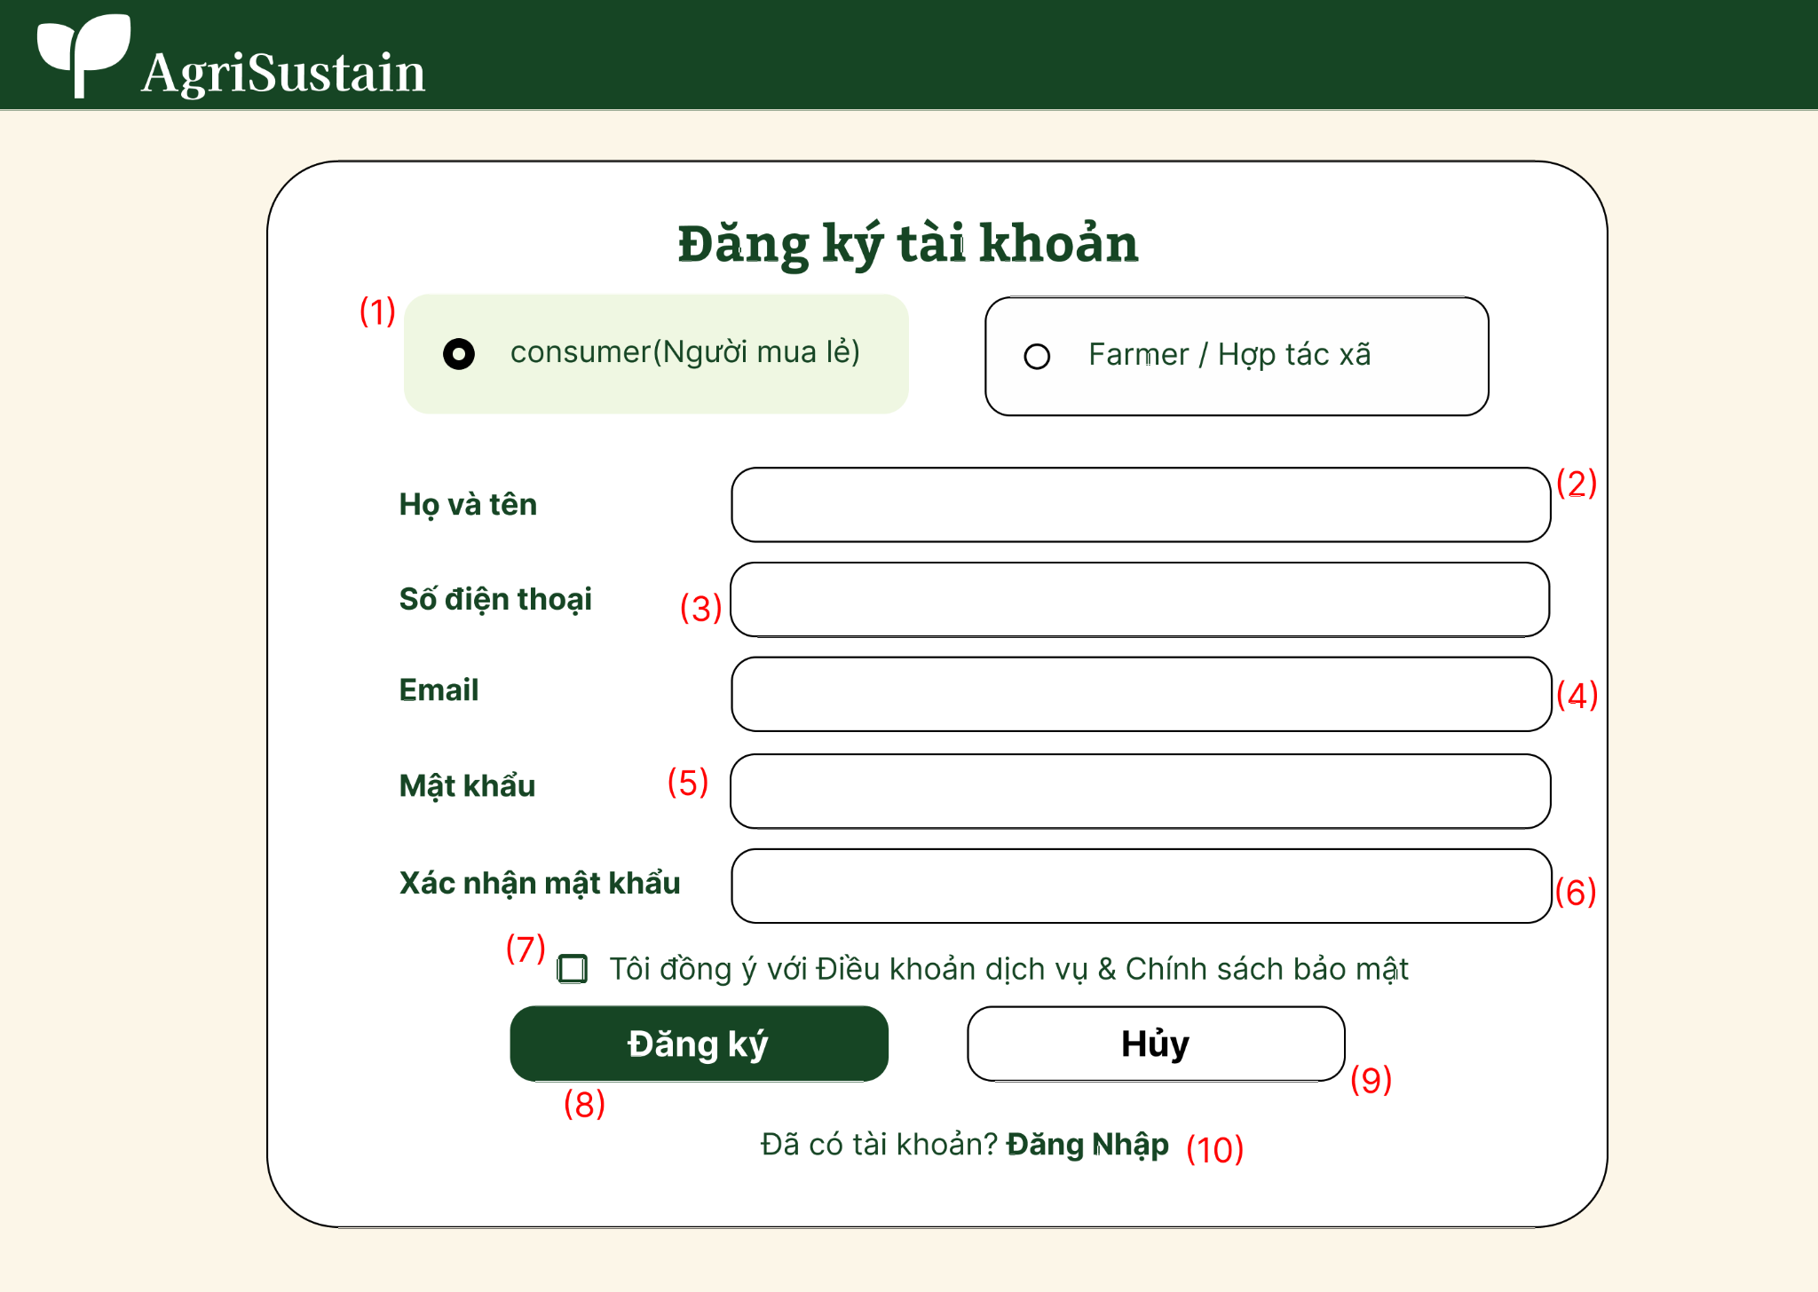

Field Name | Description
(1)Vai trò tài khoản (Consumer / Farmer) | Radio button group allowing the user to select the account role: Consumer (Retail Buyer) or Farmer / Cooperative. Default: Consumer.
(2) Họ và tên | Textbox for entering the user's full name. Mandatory string, length: 2–50 characters.
(3) Số điện thoại | Textbox for entering the user's phone number. Mandatory numeric string, standard Vietnamese phone format (10 digits), globally unique.
(4) Email | Textbox for entering the email address. Mandatory, standard email format, globally unique across all accounts.
(5) Mật khẩu | Password input box with toggle visibility icon. Mandatory, minimum 8 characters, requiring at least one letter and one number.
(6) Xác nhận mật khẩu | Password input box with toggle visibility icon. Mandatory, must exactly match the value entered in Password.
(7) Điều khoản dịch vụ & Chính sách bảo mật | Checkbox confirming user acceptance of Terms of Service and Privacy Policy. Mandatory to check before proceeding.
(8) Đăng ký | Primary action button. Triggers form validation, sends verification OTP, and initiates account creation.
(9) Hủy | Secondary action button. Cancels the registration process and resets all entered fields.
(10) Đã có tài khoản? Đăng nhập | Navigation hyperlink. Redirects the user to the Sign In screen (SCR-06: User Login).

1.2 Sign In Screen

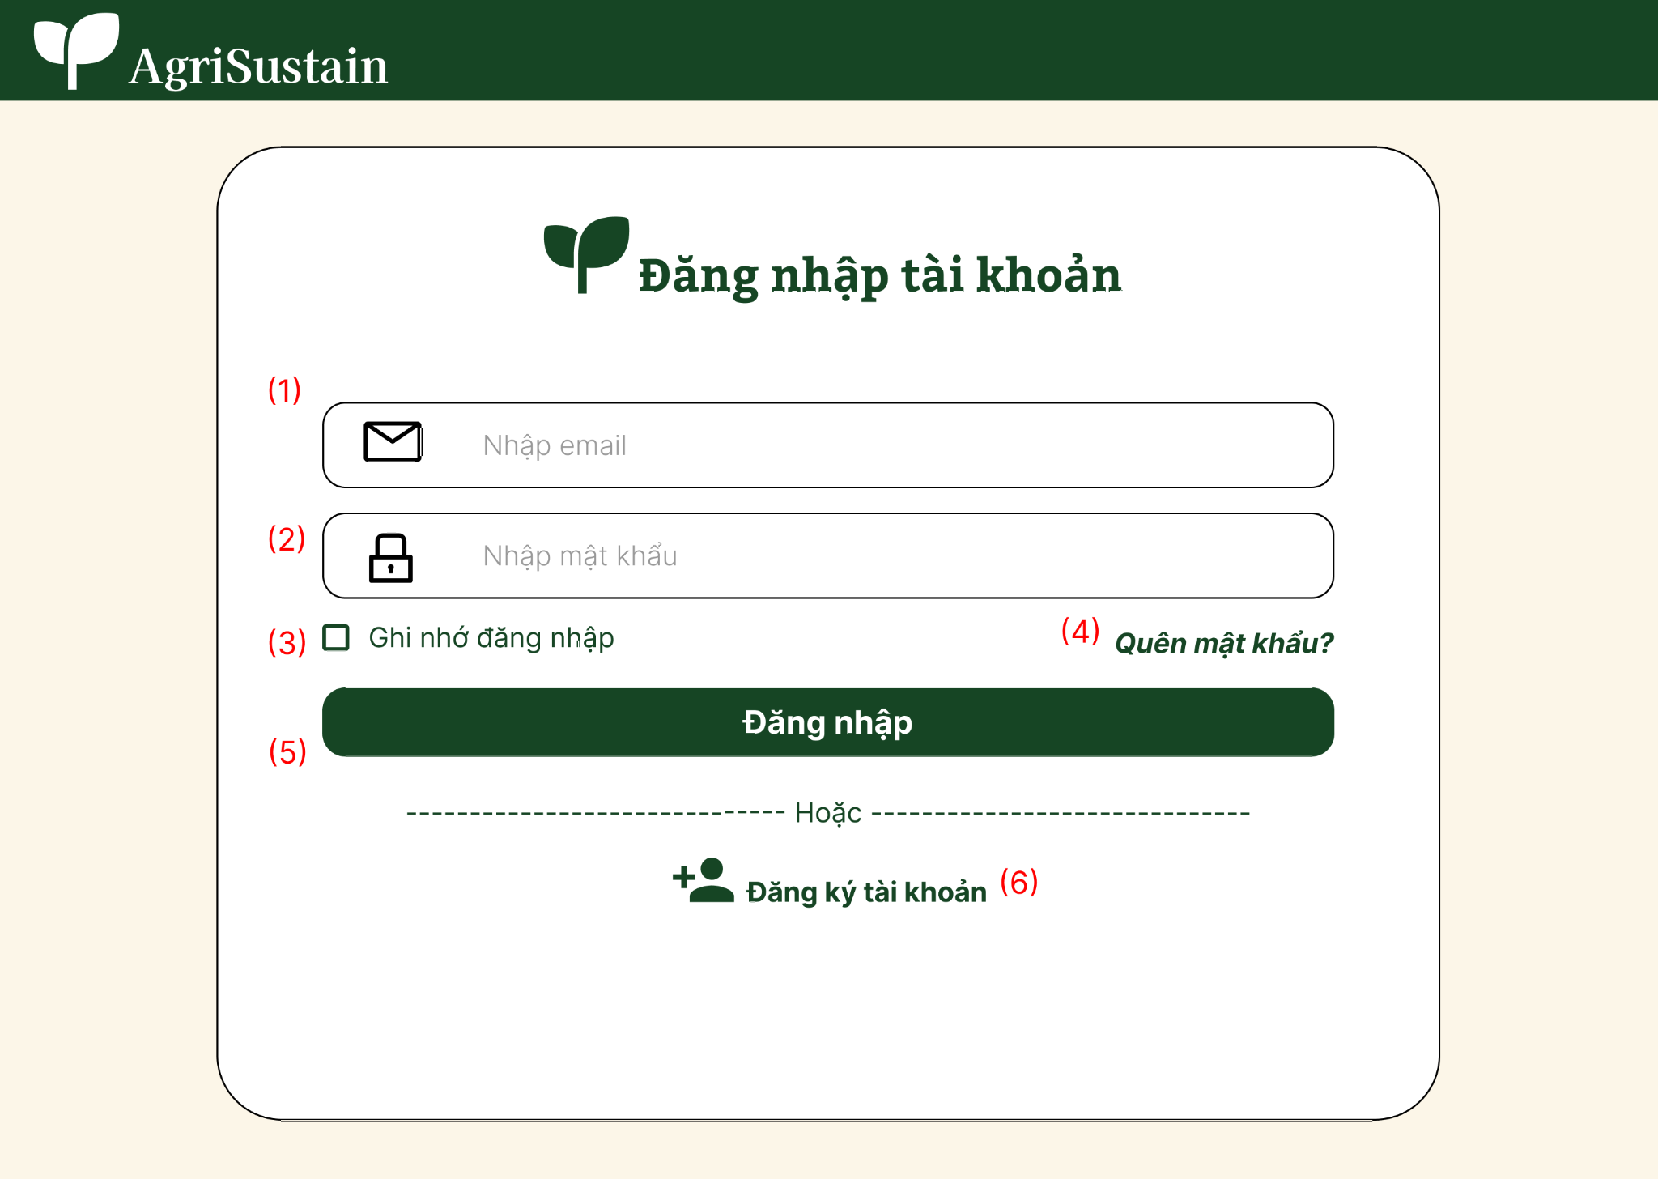

Field Name | Description
(1) Email | Textbox for entering the user's registered email address. Mandatory. Must follow a standard email format. The email is used to identify the user's account during authentication.
(2) Mật khẩu | Password input box for entering the user's account password. Mandatory. The entered password is securely verified against the stored password hash. The field provides a visibility toggle icon to show or hide the password.
(3) Ghi nhớ đăng nhập | Checkbox allowing the user to choose whether to keep the login session remembered on the current device. Optional.
(4) Quên mật khẩu? | Navigation hyperlink that redirects the user to the Password Recovery / Forgot Password screen to reset their password.
(5) Đăng nhập | Primary action button. Triggers validation of the Email and Password fields and submits the login request. If the credentials are valid and the account is active, the system authenticates the user, creates an authenticated session, identifies the user's role, and redirects the user to the appropriate page.
(6) Đăng ký tài khoản | Navigation hyperlink that redirects users who do not have an account to the Registration screen.

1.3 Change Password
1.3.1 Change Password

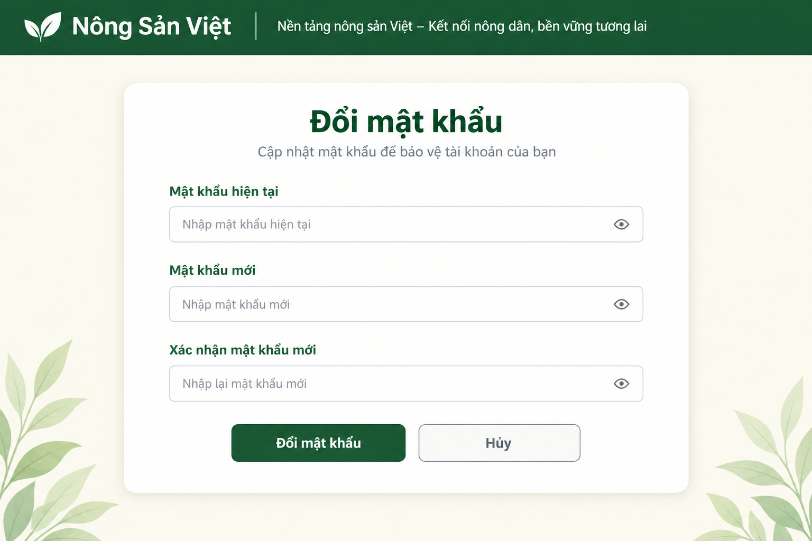

This screen allows an Authenticated User to change their account password. The user enters the current password, a new password, and confirms the new password. The system validates the current password and checks the new password against the password policy before updating the account.

Field Name | Description
Header | The system header displaying the Nông Sản Việt logo and platform slogan.
Page Title | Displays the title “Change Password”.
Subtitle | Displays the instruction “Update your password to protect your account”.
Current Password | The user's current account password. Data type: Password/String. The value is masked by default.
New Password | The new password entered by the user. Data type: Password/String. The value must satisfy the system password policy.
Confirm New Password | The new password entered again for confirmation. Data type: Password/String. The value must match the New Password field.
Password Visibility Icon | An eye icon that allows the user to show or hide the password value.
Change Password Button | The “Change Password” button. When selected, the system validates the current password and checks the new password against the password policy before updating it.
Cancel Button | The “Cancel” button. Cancels the password change operation and returns the user to the previous screen.
Validation Message | Displays validation errors when the current password is incorrect, the new password does not satisfy the password policy, or the confirmation password does not match.

1.4 Reset Password
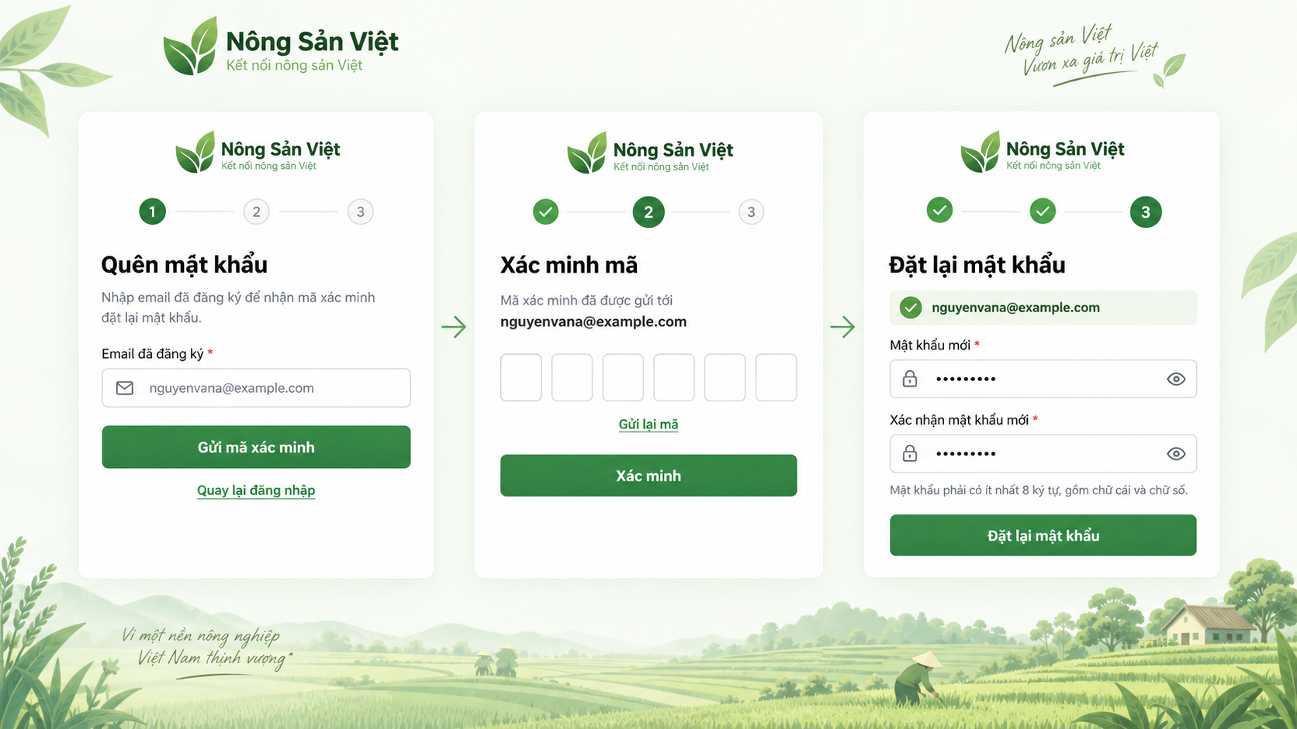

This screen allows Guest and registered users to recover access to their account when they forget their password. Users enter their registered email address, verify a one-time password (OTP) sent to that email, and create a new password. The system validates the OTP, checks that the new password satisfies the password policy, securely updates the password, and redirects the user to the Sign In screen after a successful reset.

Step | Fields / Controls
1. Forgot Password | Registered Email*, Send Verification Code, Back to Sign In
2. Verify Code | OTP Verification Code*, Verify Button, Resend Code, Back to Sign In
3. Reset Password | Verified Email (read-only), New Password*, Confirm New Password*, visibility icons, password-policy helper text, Reset Password Button

1.5 Logout

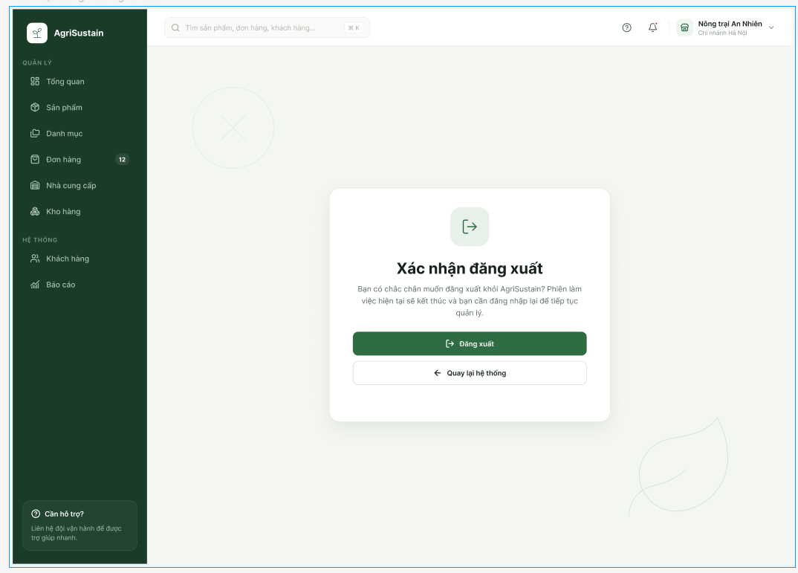

Field Name | Description
(1) Tiêu đề xác nhận đăng xuất | Displays the title "Xác nhận đăng xuất", informing the user that the system requires confirmation before ending the current session.
(2) Nút Đăng xuất | Primary action button allowing the user to confirm the logout operation. When selected, the system terminates the current authenticated session.
(3) Nút Quay lại hệ thống | Secondary action button allowing the user to cancel the logout operation and return to the system without terminating the current session.

1.6 Register Buyer B2B Account
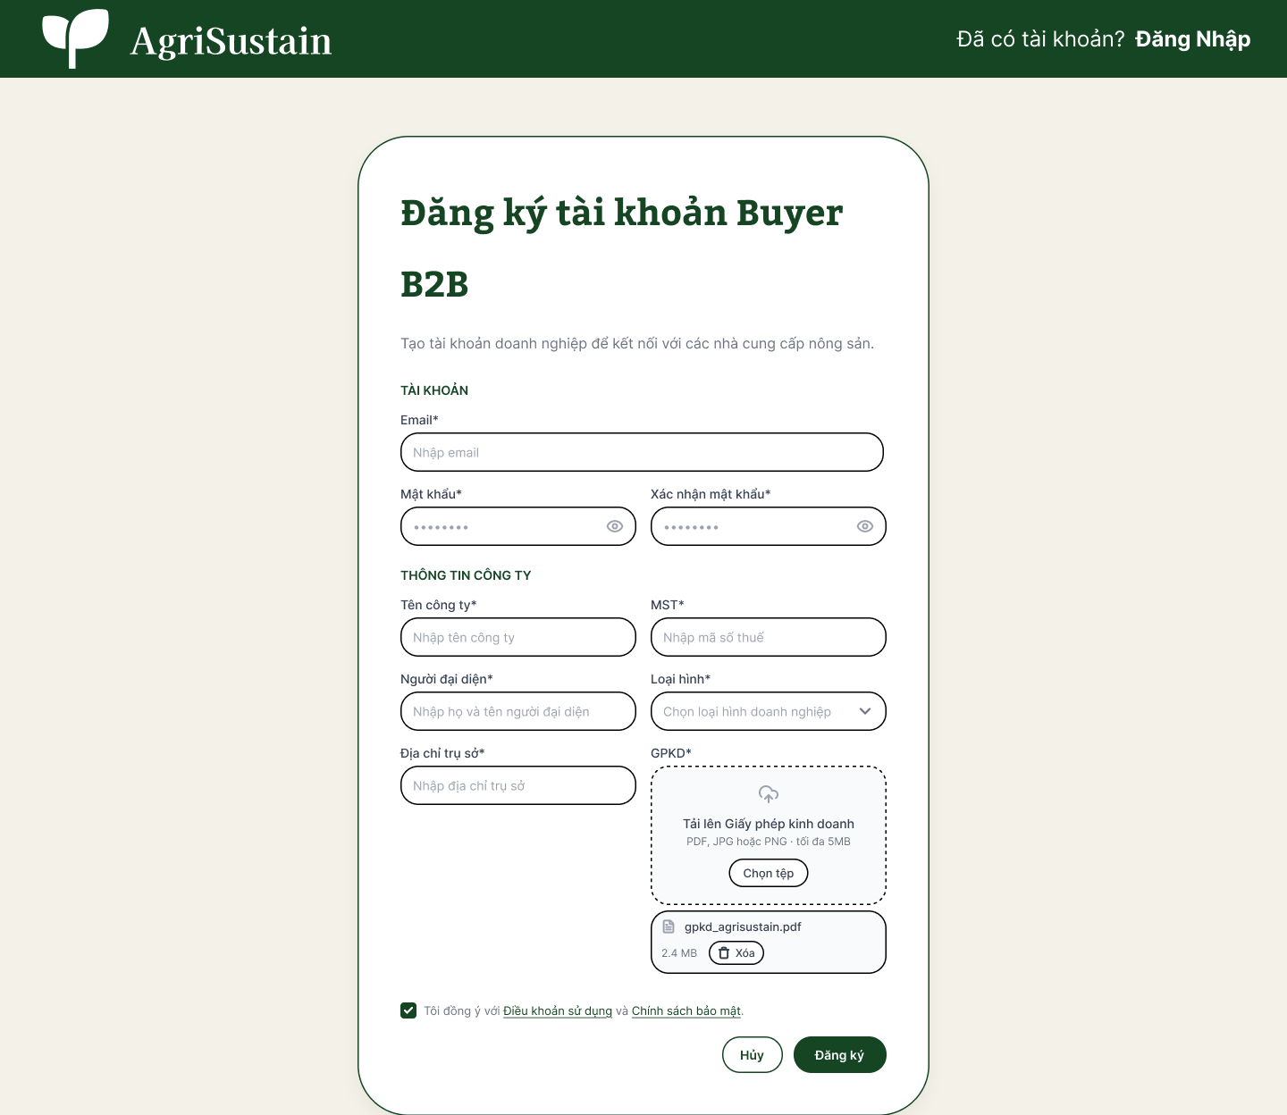

Field Name | Description
(1) Đã có tài khoản? Đăng Nhập | Navigation hyperlink located in the top header. Redirects existing registered users to the Sign In screen (SCR-06: User Login).
(2) Email* | Textbox for entering the enterprise contact email address. Mandatory, standard email format, globally unique across all system accounts.
(3) Mật khẩu* | Password input field with a visibility toggle icon. Mandatory, must satisfy the password policy (minimum 8 characters, containing at least one letter and one number).
(4) Xác nhận mật khẩu* | Password confirmation input field with a visibility toggle icon. Mandatory, must exactly match the value entered in Mật khẩu.
(5) Tên công ty* | Textbox for entering the registered enterprise or commercial entity name. Mandatory string, maximum length: 150 characters.
(6) MST* (Mã số thuế) | Textbox for entering the enterprise Tax Identification Number. Mandatory, valid Vietnamese Tax Code format (10 or 13 digits), globally unique across the platform.
(7) Người đại diện* | Textbox for entering the full name of the legal representative or corporate agent. Mandatory string, maximum length: 50 characters.
(8) Loại hình* | Dropdown selector for choosing the business operation model (e.g., Doanh nghiệp thu mua, Chuỗi siêu thị, Nhà máy chế biến, Nhà hàng / Catering). Mandatory.
(9) Địa chỉ trụ sở* | Textbox for entering the official registered headquarter address of the enterprise. Mandatory string, maximum length: 255 characters.
(10) GPKD* (Tải lên Giấy phép kinh doanh) | File upload component for attaching the business registration license / legal certification dossier. Mandatory. Supports PDF, JPG, or PNG formats up to 5 MB.
(11) Tệp đính kèm & Nút Xóa | Display card showing the uploaded file name (e.g., gpkd_agrisustain.pdf), file size (e.g., 2.4 MB), and a "Xóa" (Remove) button allowing the user to delete and re-upload the document.
(12) Đồng ý Điều khoản sử dụng & Chính sách bảo mật* | Checkbox confirming user acceptance of platform legal terms and privacy policies. Mandatory to check before submission.
(13) Hủy | Secondary action button. Cancels the registration operation, clears all entered data, and redirects back to the Home Page.
(14) Đăng ký | Primary action button. Validates form inputs, dispatches an OTP verification code via Gmail API, and submits the B2B account profile for administrative KYC review (UC-AUTH-02).

2. MarketPlace

2.1 Browse Marketplace

2.1.1 Browse Marketplace
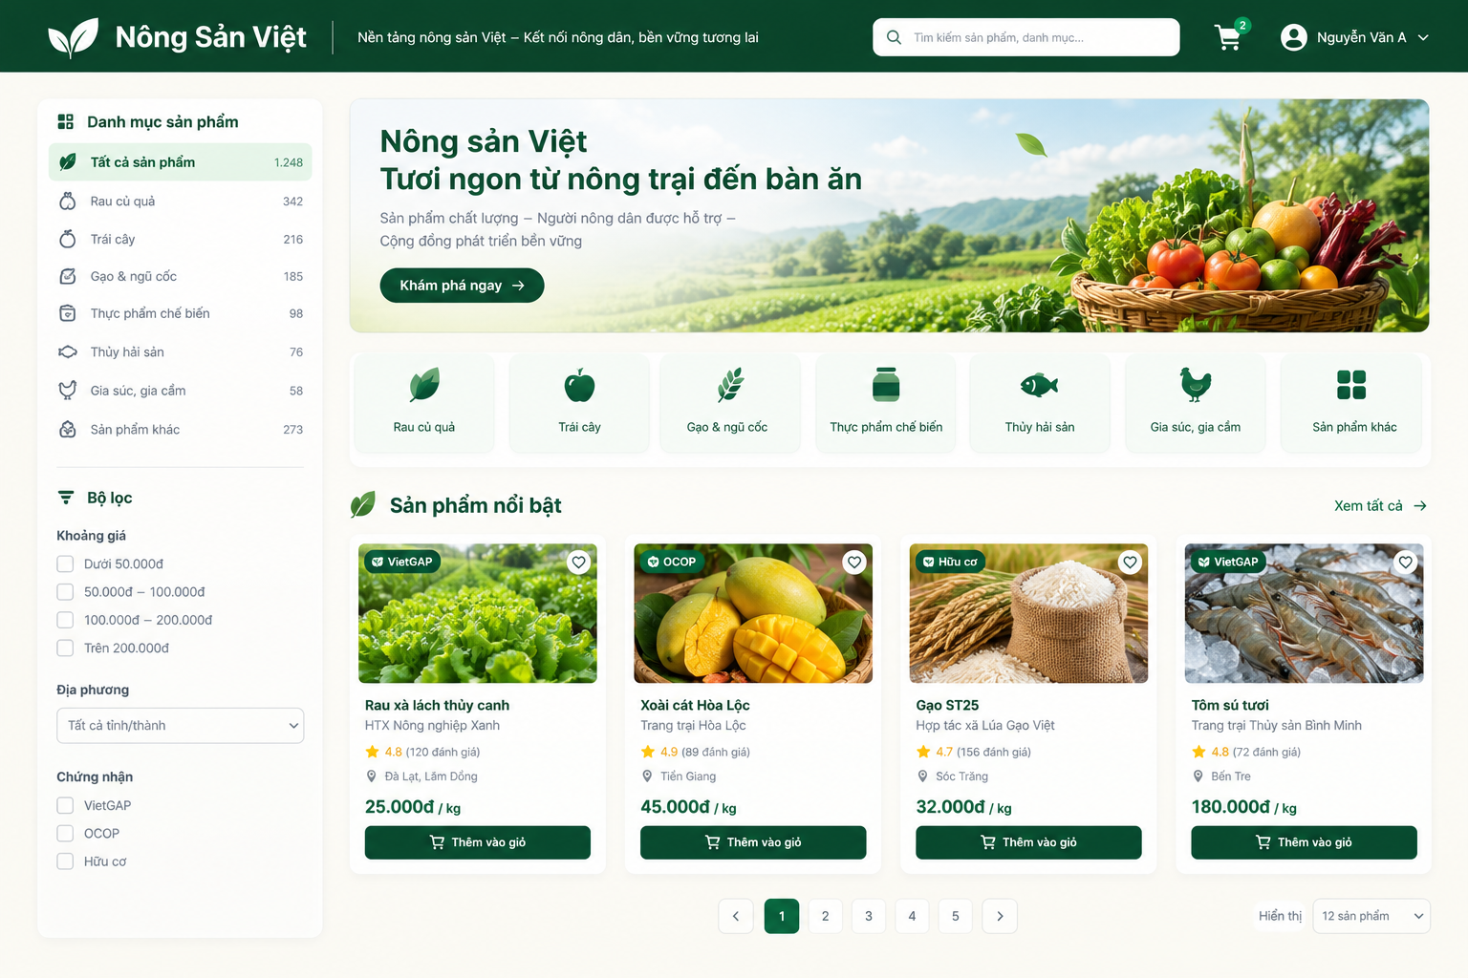

This screen allows Guest, Consumer, and Buyer B2B users to browse public agricultural products. Users can search for and filter products by name, category, supplier, region, season, or certification.

Field Name | Description
Header | The main system header containing the logo, slogan, search bar, shopping cart, and account information.
Search Product | A search field for entering a product name or category keyword.
All Products | Displays all publicly available products.
Product Category | Product categories such as Vegetables & Fruits, Fruits, Rice & Grains, Processed Food, Seafood, Livestock & Poultry, and Other Products.
Price Range | Filters products according to their price range.
Region | Filters products by province/city or production region.
Supplier | Filters products according to the Farmer/Supplier.
Season | Filters products according to the crop season.
Certification | Filters products by certification, such as VietGAP, GlobalGAP, Organic, or other supported certifications.
Product Image | The representative image of the product.
Product Name | The name of the publicly listed product.
Supplier/Farm Name | The name of the Farmer/Supplier providing the product.
Product Rating | The average rating and number of eligible reviews, if available.
Region | The production or supply region of the product.
Price | The current selling price and unit of the product.
Certification Badge | Displays verified certification badges when applicable.
View Product Detail | Allows the user to select a product and navigate to UC-MKT-02 – View Product Detail.
Add to Cart | Allows the user to add the product to the shopping cart when the function is available for the current actor/session.
Pagination | Allows the user to navigate between pages of product results.
Product Count | Displays the number of products or search results.

2.2 View Product Detail
2.1.1 View Product Detail

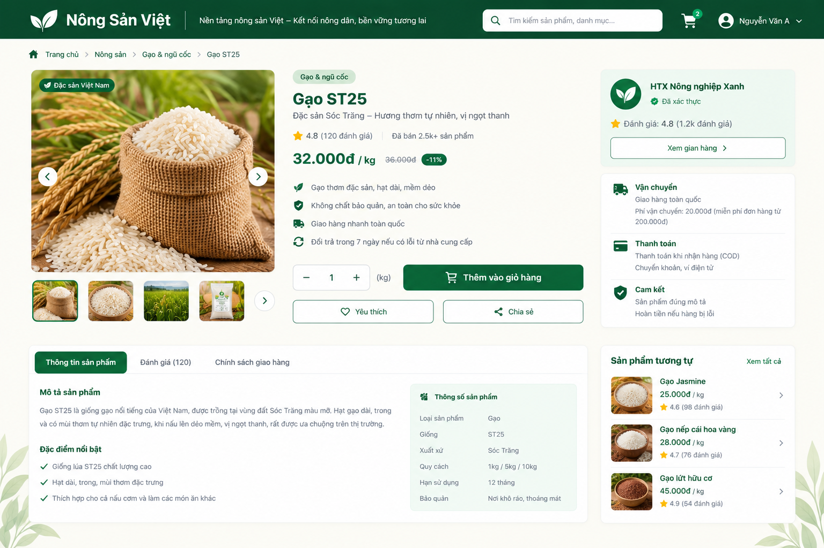
This screen allows Guest, Consumer, and Buyer B2B users to view detailed information about a publicly available product. The main information includes product description, price, available stock/batches, farm information, certificates, and eligible reviews.

Field Name | Description
Header | The Nông Sản Việt header containing the logo, slogan, search bar, shopping cart, and user account information.
Breadcrumb | Displays the navigation path from the Marketplace to the currently selected product.
Product Image Gallery | Displays the main product image and additional product images.
Product Name | The name of the selected product.
Category | The product category.
Short Description | A brief description of the product and its main characteristics.
Product Rating | The average product rating and number of eligible reviews.
Price | The current selling price and unit of the product.
Original Price | The original price when a promotional price is available.
Certification Badge | Displays verified product certification badges when available.
Available Stock | The quantity of the product currently available for purchase.
Available Batch | Information about available product batches when batch-level inventory is provided.
Unit | The product selling unit, such as kg, box, package, etc.
Quantity Selector | Allows the user to select the desired product quantity.
Farm Name | The name of the Farmer/Farm supplying the product.
Farm Verification | The verification status of the Farmer/Farm, when available.
Farm Rating | The Farm/Supplier rating or reputation information, when available.
View Farm | A link that allows the user to view the public Farm/Supplier profile.
Product Description | The full description of the product.
Origin | The origin or production region of the product.
Product Specifications | Product-related specifications such as variety, packaging, expiry period, or storage conditions when available.
Certificate Name | The name of the certification associated with the product, such as VietGAP, GlobalGAP, or Organic.
Verification Status | The verification status of the certificate.
Certificate Expiry | The expiration date of the certificate, when available.
Average Rating | The average rating of the product.
Review Count | The total number of eligible reviews displayed.
Review List | A list of eligible customer reviews.
Add to Cart | Allows a Consumer to add the product to the shopping cart when the product is available and the function is applicable to the current session.
Favorite | Allows the user to save the product as a favorite when the feature is supported.
Share | Allows the user to share the product link.
View Traceability | Navigates to the product traceability function when the product/batch supports traceability.

3. Farmer Sales

3.1 Process Order

3.1.1 Farmer Order Fulfillment Screen
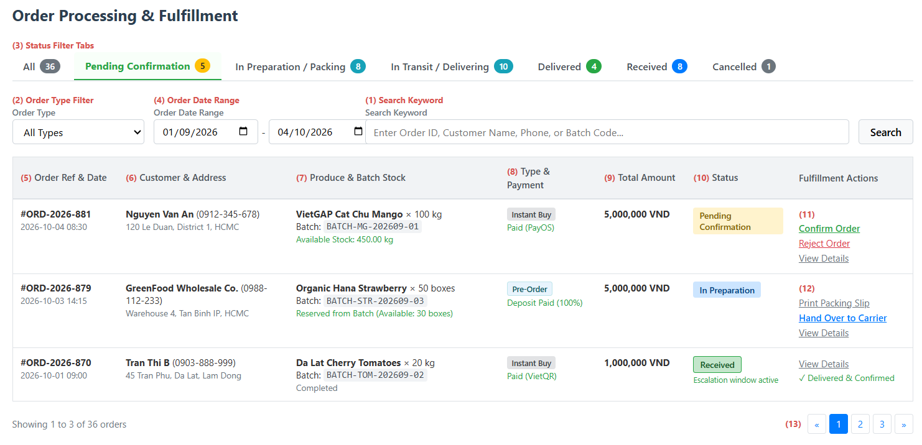
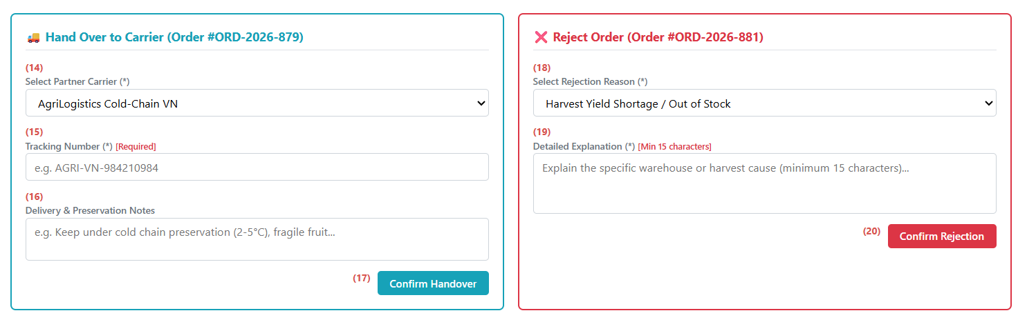
This screen allows the Farmer to:
- Monitor and browse incoming retail and wholesale orders sorted chronologically by submission time.
- Filter orders by fulfillment lifecycle tabs (including Delivered and Received), order classification (Instant Buy or Pre-order), date intervals, or keywords.
- Review customer shipping addresses, ordered items, linked harvest batch codes, and real-time batch stock levels.
- Confirm incoming orders after verifying physical stock against batch availability, advancing orders to preparation and packing.
- Reject orders with a required rejection reason and detailed explanation when produce fails dispatch standards, automatically restoring batch stock and routing buyer refunds.
- Print standardized packing slips and delivery receipts to assist parcel packaging and sorting.
- Record parcel handover to partner carriers by providing a valid carrier tracking number and preservation notes, transitioning orders to active transit.
- Track deliveries transitioning automatically to 'Delivered' upon logistics completion, and monitor orders marked as 'Received' once acknowledged by the buyer, which opens the 24-hour dispute window and unlocks review eligibility.
Field descriptions:
Field Name | Description
(1) Search Keyword | Text box to search orders by Order ID, customer name, recipient phone number, or linked batch code.
(2) Order Type Filter | Dropdown list to filter orders by purchase mode: All Types, Instant Buy, or Pre-Order.
(3) Status Filter Tabs | Navigation tabs filtering orders across all lifecycle states: All, Pending Confirmation, In Preparation / Packing, In Transit / Delivering, Delivered, Received, and Cancelled, with live counter badges.
(4) Order Date Range | Date selectors (From date – To date) to filter orders within a specific placement window.
(5) Order Ref & Date | Displays unique order identifier and formatted timestamp of order placement.
(6) Customer & Address | Displays recipient full name, contact phone number, and physical delivery address.
(7) Produce & Batch Stock | Displays ordered agricultural produce, quantity, sales unit, linked harvest batch code, and current available batch stock.
(8) Type & Payment | Displays order purchase classification (Instant Buy or Pre-Order) and payment confirmation status.
(9) Total Amount | Displays total payable order amount calculated from ordered quantities and applicable retail or wholesale tier prices.
(10) Status Badge | Visual color-coded tag showing current order status (Pending Confirmation, In Preparation, In Transit, Delivered, Received, Cancelled by Seller).
(11) Pending Confirmation Actions | Action links for new orders: Confirm Order (Validates batch inventory, deducts available batch quantity, and moves order to In Preparation / Packing), Reject Order (Opens rejection form to decline the order), View Details (Opens complete order and customer history dialog).
(12) In Preparation Actions | Action links for orders being prepared: Print Packing Slip (Generates and prints a standardized packaging receipt), Hand Over to Carrier (Opens the handover form to assign a carrier and record tracking details).
(13) Pagination Controls | Standard pagination buttons to navigate order list pages.
(14) Partner Carrier Dropdown | Dropdown list to select the shipping carrier partner assigned for parcel pickup. Mandatory field.
(15) Tracking Number Input | Text field to enter the shipping carrier's waybill tracking number. Mandatory field; cannot be left blank.
(16) Delivery Notes Textarea | Text area to record special delivery notes, temperature control ranges, or packaging instructions for the carrier.
(17) Confirm Handover Button | Validates tracking number presence, transitions order status to In Transit / Delivering, and dispatches a delivery alert to the buyer.
(18) Rejection Reason Dropdown | Dropdown list to select a predefined justification for declining an order (e.g., yield shortage, quality failure, force majeure).
(19) Detailed Explanation Textarea | Multi-line text field requiring a detailed explanation for order cancellation. Mandatory field with a minimum requirement of 15 characters.
(20) Confirm Rejection Button | Validates explanation inputs, updates order status to Cancelled by Seller, restores reserved quantities back to the harvest batch, and initiates buyer refund.

3.2 Information Farmer
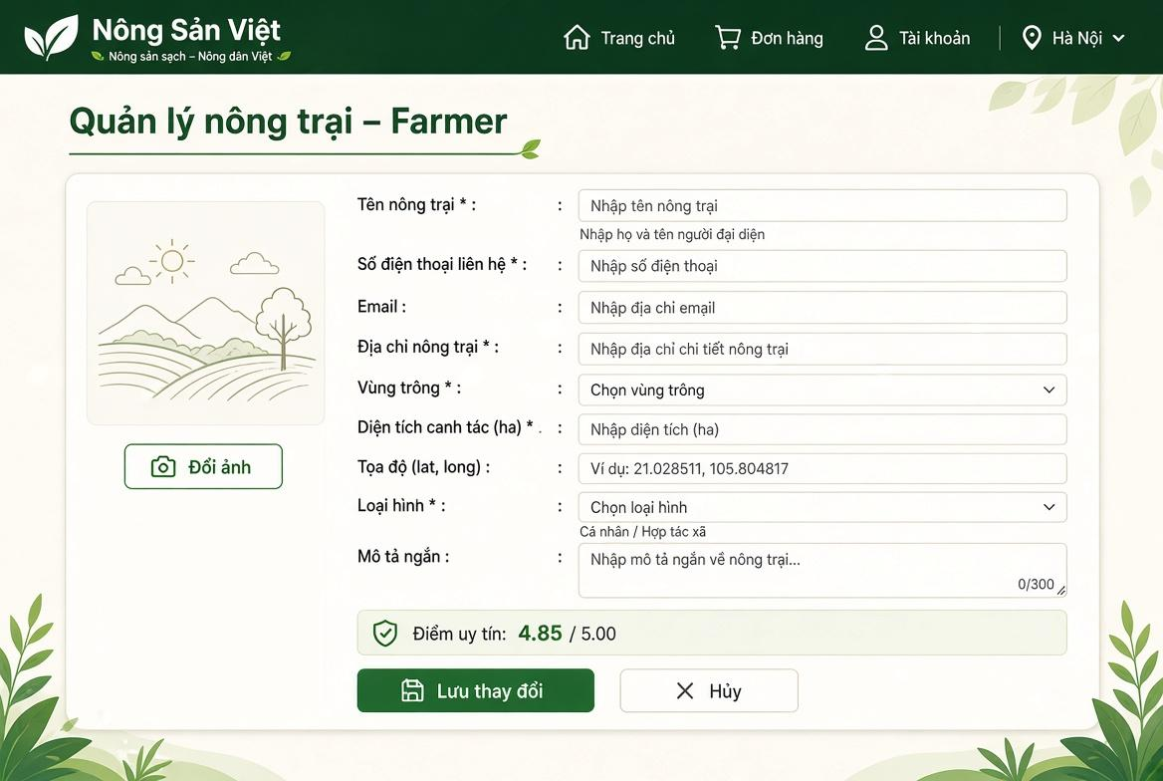

Field Name | Description
(1) Đổi ảnh | Button allowing the farmer to upload or replace the farm banner/avatar image. Max size: 5 MB.
(2) Tên nông trại * | Textbox for entering the official farm or agricultural cooperative brand name. Mandatory string, max length: 100 characters.
(3) Người đại diện * | Textbox for entering the legal representative's full name. Mandatory string, max length: 50 characters.
(4) Số điện thoại liên hệ * | Textbox displaying the primary contact telephone number of the production farm. Mandatory.
(5) Email | Textbox displaying the official operational email address. Standard email format.
(6) Địa chỉ nông trại * | Textbox for entering detailed physical address of the farm facility. Mandatory string, max length: 200 characters.
(7) Vùng trồng * | Dropdown selector for choosing the designated agricultural ecological zone (e.g., Da Lat, Mekong Delta, Red River Delta). Mandatory.
(8) Diện tích canh tác (ha) * | Numeric input field specifying the cultivated land size in hectares. Mandatory positive decimal number (>0).
(9) Tọa độ (lat, long) | Textbox for geographical GPS coordinates (latitude, longitude) for map identification. Format: xx.xxxxxx, yy.yyyyyy.
(10) Loại hình * | Dropdown selection for the legal production model: Cá nhân (Individual Farmer) or Hợp tác xã (Agricultural Cooperative).
(11) Mô tả ngắn | Multiline textarea for brief introduction of farming background and agricultural specialties, with a character counter (max: 300 characters).
(12) Điểm uy tín | Read-only rating badge showing the platform-calculated trust score (baseline: 5.00), dynamically updated based on order reviews and fulfillment compliance.
(13) Lưu thay đổi | Primary action button. Validates input values, uploads images, and saves updated farm records to the database.
(14) Hủy | Secondary action button. Discards current edits and reverts the form to its original values.

3.3 Manage Pre-Order Campaign

3.3.1 Pre-Order Campaign Management Screen
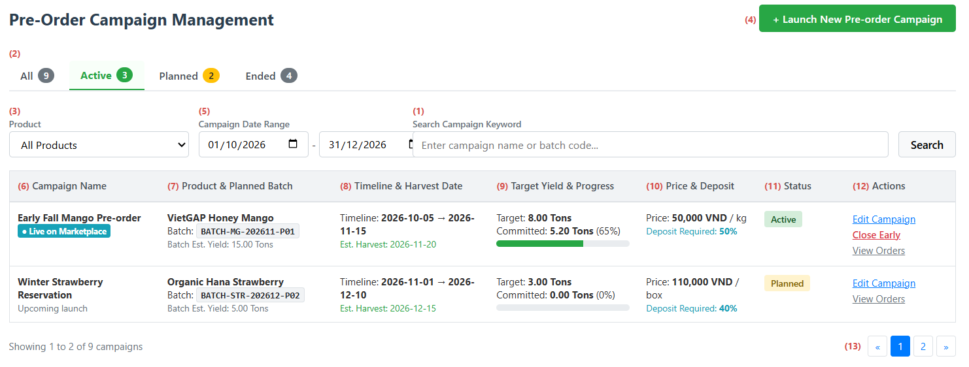
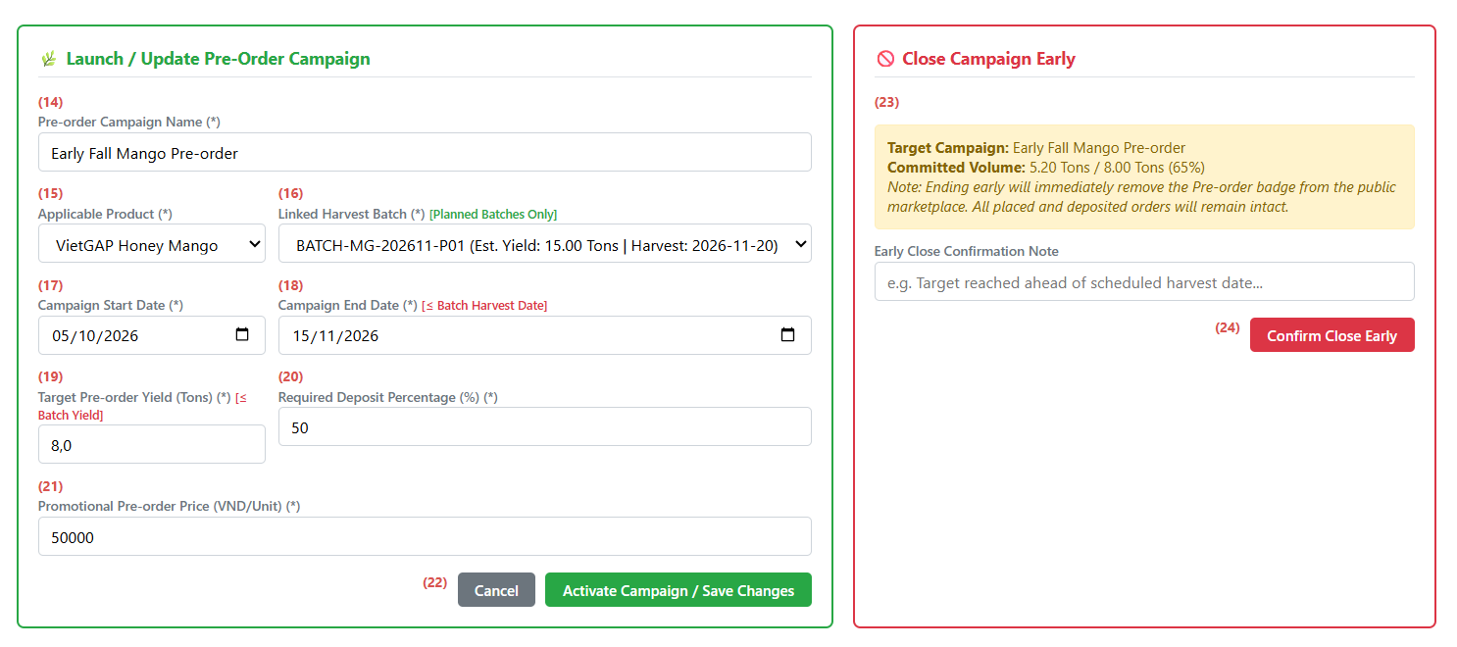
This screen allows the Farmer to:
- View and monitor all pre-order sales campaigns with linked products, target quotas, progress percentages, deposit policies, and campaign statuses.
- Filter campaigns by lifecycle stages (All, Active, Planned, Ended), product categories, date intervals, or keywords.
- Launch new pre-order campaigns linked to upcoming planned harvest batches to mobilize advance deposit capital before harvest.
- Configure campaign parameters including pre-order target yields, campaign timelines, promotional pricing, and required deposit percentages.
- Update active campaign terms, such as extending the end date or expanding target quotas within the remaining capacity of the planned batch, while keeping the linked harvest batch locked.
- Proactively close campaigns early upon fulfilling output quotas or when harvesting begins, removing marketplace pre-order tags while preserving deposited orders.
Field Name | Description
(1) Search Campaign Keyword | Text box to search campaigns by campaign title, product name, or linked batch code.
(2) Campaign Status Tabs | Navigation tabs filtering campaigns by operational status: All, Active, Planned, and Ended, with item count badges.
(3) Product Filter Dropdown | Dropdown list to filter campaigns associated with a specific agricultural product.
(4) Launch New Campaign Button | Action button opening the campaign setup form. Requires verified farm profile permissions.
(5) Campaign Date Range | Date pickers (From date – To date) to filter campaigns based on operational schedules.
(6) Campaign Name Display | Displays campaign title along with live marketplace visibility indicators.
(7) Product & Planned Batch | Displays product title, linked planned batch code, and total estimated harvest yield of the batch.
(8) Timeline & Harvest Date | Displays campaign operational start and end dates alongside the planned harvest completion date.
(9) Target Yield & Progress | Displays target pre-order volume, committed volume to date, and visual percentage progress bar.
(10) Price & Deposit Policy | Displays promotional pre-order unit price and required customer deposit percentage.
(11) Campaign Status Badge | Visual state indicator showing current campaign status: Active, Planned, or Ended.
(12) Row Action Links | Contextual actions: • Edit Campaign: Opens setup form to adjust timeline or increase target quotas. • Close Early: Opens confirmation panel to conclude an active campaign. • View Orders: Navigates to the pre-order fulfillment list.
(13) Pagination Controls | Standard pagination navigation buttons.
(14) Campaign Name Input | Text box to define the public title of the pre-order campaign. Mandatory field.
(15) Applicable Product Selector | Dropdown list to choose an approved agricultural product for the pre-order campaign. Mandatory field.
(16) Linked Harvest Batch Selector | Dropdown list displaying only batches in Planned status with future estimated harvest dates. Automatically locked during campaign editing. Mandatory field.
(17) Campaign Start Date Input | Date picker for campaign opening. Mandatory field.
(18) Campaign End Date Input | Date picker for campaign closure. Must occur after start date and on or before the estimated harvest date. Mandatory field.
(19) Target Pre-Order Yield Input | Numeric input for allocated pre-order volume. Must be greater than 0 and cannot exceed the total estimated yield of the linked batch. Mandatory field.
(20) Deposit Percentage Input | Numeric input specifying the advance deposit percentage required from buyers (e.g., 10% to 100%). Mandatory field.
(21) Promotional Pre-Order Price Input | Numeric input for the discounted unit price applied during the campaign. Mandatory field.
(22) Form Action Buttons | Submission controls: • Activate Campaign / Save Changes: Validates business rules, publishes the pre-order campaign, attaches marketplace flags, and refreshes the list. • Cancel: Clears unsaved changes.
(23) Early Closure Notice & Summary | Informational summary displaying current campaign commitments and outlining post-closure terms.
(24) Confirm Close Early Button | Action button that concludes the campaign early, updates status to Ended, removes marketplace pre-order tags, and preserves customer reservations.

4. Administration

4.1 User Management

4.1.1 User List
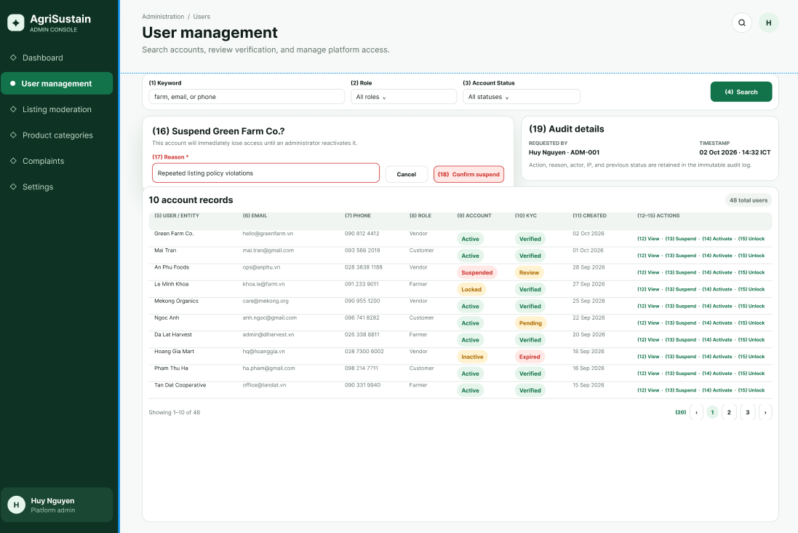
This screen allows the Administrator to:
- View User List: view registered user and organization accounts.
- Search Users: enter a keyword to search by Account ID, personal name, organization name, farm name, company name, email address, or phone number.
- Filter Users by Role: filter accounts by Consumer, Farmer, Buyer, Bank, Certifier, or Administrator role.
- Filter Users by Account Status: filter accounts by Active, Pending, Rejected, or Suspended status.
- View User Details: open the User Details screen of a selected account.
- Suspend / Activate Account: suspend an active account or reactivate a suspended account after confirmation.
- Unlock Account: clear the temporary security lock and reset the failed-login counter when applicable.
- Navigate User Records: move between pages of user records.

Field Name | Description
Search Keyword | Optional text input, maximum 100 characters. Searches by Account ID, personal or organization name, Farm Name, Company Name, email address, or phone number.
Role Filter | Dropdown: All, Consumer, Farmer, Buyer, Bank, Certifier, Administrator. Default: All.
Account Status Filter | Dropdown: All, Active (Approved), Pending, Rejected, Suspended. Default: All.
User / Entity Name | Read-only. Displays Full Name, Farm Name, Company Name, or organization name based on the account role.
Email | Read-only registered email address.
Phone Number | Read-only verified contact phone number.
Role | Read-only role badge.
Account Status | Read-only badge: Active, Pending, Rejected, or Suspended.
KYC Status | Read-only verification badge for roles that require legal verification.
Created Date | Read-only account creation date and time in dd/MM/yyyy HH:mm format.
View Details Action | Opens the User Details screen for the selected account.
Suspend / Activate Action | Suspends or reactivates an account after confirmation. An Administrator cannot suspend their own account.
Unlock Account Action | Clears the temporary security lock and resets the failed-login counter.
Pagination | Displays 10 records per page by default.

4.1.2 User Details
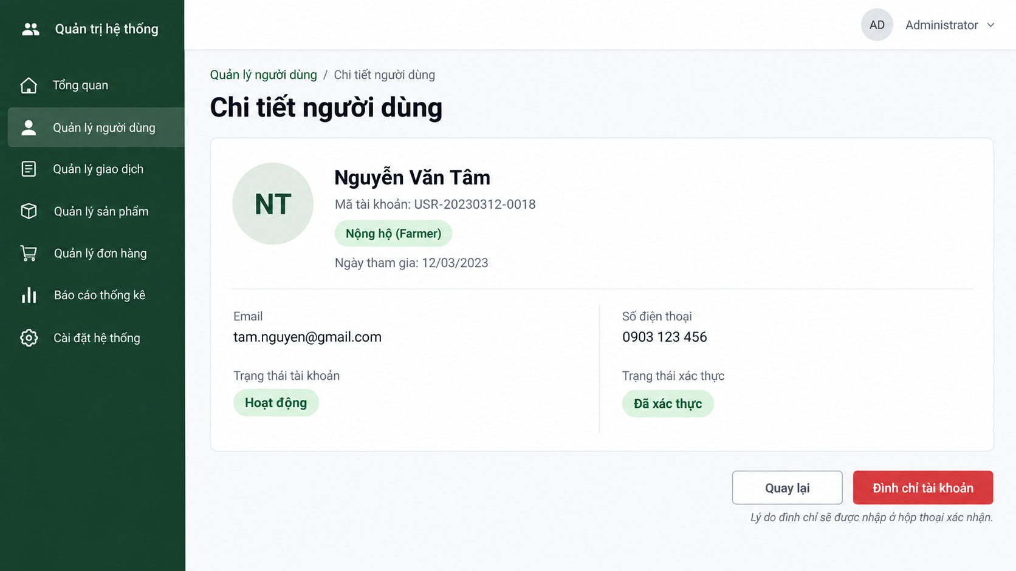
This screen allows the Administrator to:
- View User Details: view the selected account’s identity, contact information, role, account status, and verification status.
- Return to User List: return to the User List screen without changing data.
- Suspend / Activate Account: change the account status after confirmation and providing a reason.
- Unlock Account: unlock the account when it has been temporarily locked due to failed sign-in attempts.
Field Name | Description
User Avatar | Displays the user initials or profile image; read-only.
Full Name / Entity Name | The registered personal name or organization/farm name; read-only.
Account ID | System-generated unique account identifier; read-only.
Role | User role: Consumer, Farmer, Buyer, Bank, Certifier, or Administrator; read-only.
Joined Date | Account creation date in dd/MM/yyyy format; read-only.
Email | Registered email address; read-only.
Phone Number | Registered phone number; read-only.
Account Status | Displays Active, Pending, Rejected, or Suspended.
Verification Status | Displays the account/KYC verification result, such as Verified or Not Verified.
Suspend / Activate Account | Opens a confirmation dialog requiring an administrative reason before changing status. The displayed action depends on the current status.
Unlock Account | Displayed only when the account is locked due to failed sign-in attempts; unlocks the account after confirmation.
Back | Returns to the User List screen without changes.

4.2 Product Management

4.2.1 Product Category List
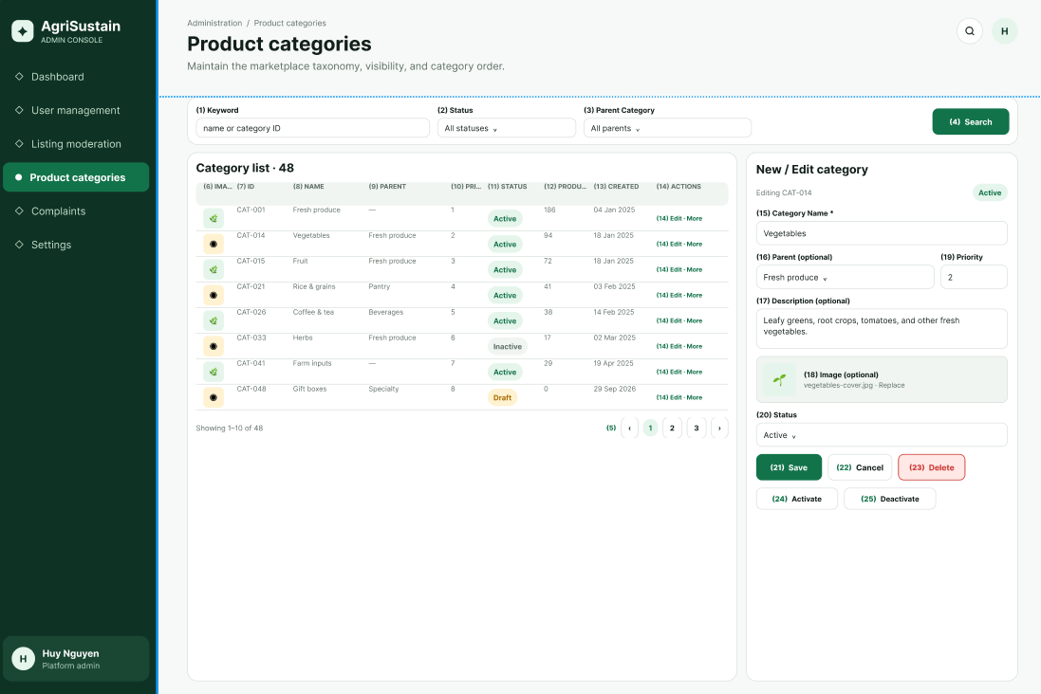

This screen allows the Administrator to:
- View Category List: view all product categories and their current information.
- Search Categories: enter a keyword to search categories by name.
- Filter Categories: filter categories by status or parent category.
- View Category Details: open the Category Details screen for a selected category.
- Create Category: navigate to the Category Details screen to create a new category.
- Update Category: navigate to the Category Details screen to update an existing category.
- Activate / Deactivate Category: change the availability status of a category.
- Delete Category: delete a category only when it does not contain active products.
- Navigate Category Records: move between pages of category records.
Field Name | Description
Search Keyword | Optional text input, maximum 100 characters. Searches by Category Name.
Status Filter | Dropdown: All, Active, Inactive. Default: All.
Parent Category Filter | Dropdown to filter by a parent category or show only Root Categories. Default: All.
Category Icon | Read-only thumbnail preview of the category image.
Category ID | Read-only system-generated category identifier.
Category Name | Read-only display name of the product category.
Parent Category | Read-only parent category name. Displays Root if the category has no parent.
Priority (Display Order) | Read-only non-negative integer used to determine the category order on the Marketplace.
Status | Read-only badge: Active or Inactive.
Product Count | Read-only number of products currently assigned to the category.
Created Date | Read-only category creation date and time.
New Category Button | Opens Product Category Details in create mode.
Edit Action | Opens Product Category Details for the selected category.
Activate / Deactivate Action | Changes category visibility on the Marketplace after confirmation.
Pagination | Displays 10 records per page by default.

4.2.2 Product Category Details
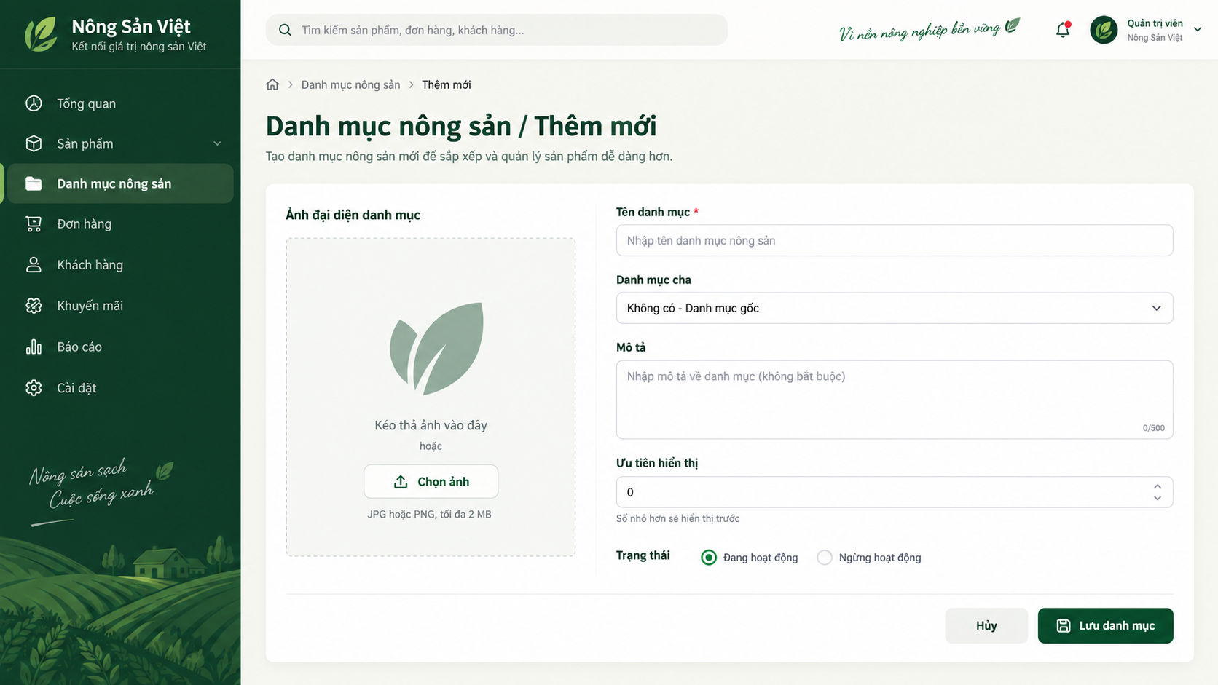
This screen allows the Administrator to:
- Create Category: create a new product category by entering valid category information.
- Update Category: update information of an existing product category.
- Select Parent Category: assign the category to a parent category where applicable.
- Upload Category Image: upload a supported image for the category.
- Set Category Priority: define the display order of the category.
- Activate / Deactivate Category: define whether the category is available for use.
- Cancel: return to the Category List screen without saving changes.

Field Name | Description
Category Name | Required text input, 2–100 characters. Must be unique, case-insensitively, within the same Parent Category.
Parent Category | Optional dropdown of active categories. Default: None (Root Category).
Description | Optional text area, maximum 500 characters.
Category Image | Optional image upload. Accepted formats: JPG, JPEG, PNG. Maximum file size: 2 MB.
Priority (Display Order) | Optional non-negative integer. Default value: 0. Lower values are displayed first.
Status | Required dropdown: Active or Inactive. Default for a new category: Active.
Save Button | Validates all inputs and creates or updates the category.
Cancel Button | Cancels changes and returns to Product Category List.

4.2.3 Product Listing Moderation Screen
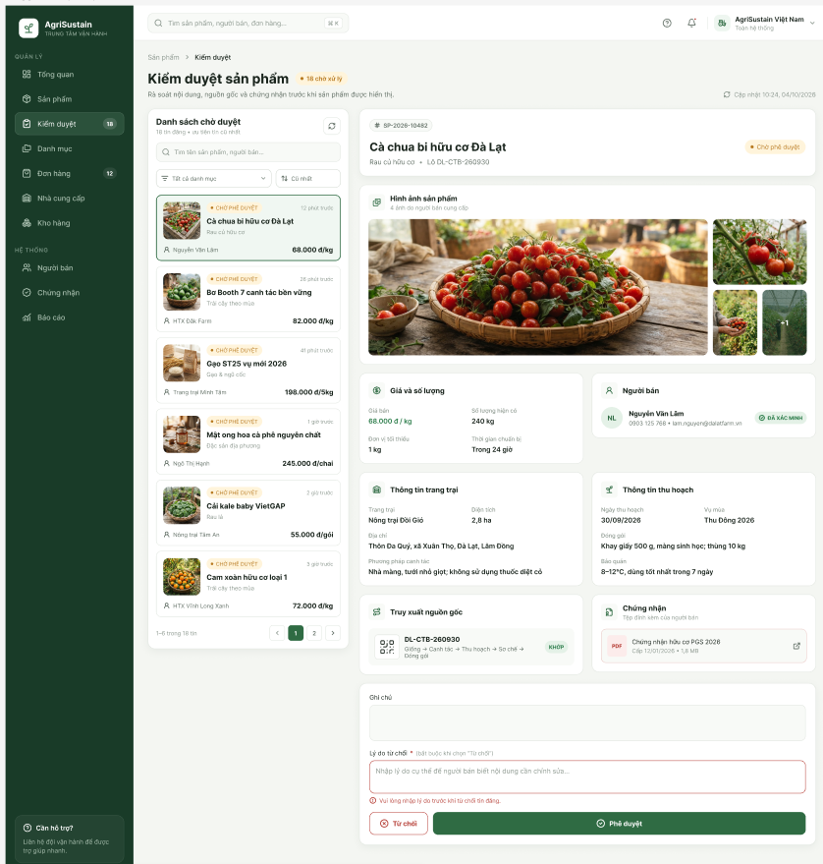

Field Name | Description
Product Listing Queue | Displays the list of submitted product listings awaiting moderation, including product images, product names, categories, prices, seller names, submission times, and approval statuses.
Category Filter | Allows the Administrator to filter product listings by product category.
Product Details | Displays detailed information about the selected product, including product name, product code, category, origin, and current moderation status.
Product Images | Displays the product images submitted by the Seller, allowing the Administrator to visually inspect the product before approval.
Price and Quantity Information | Displays the product's selling price, available quantity, minimum order quantity, and expected delivery information.
Seller Information | Displays the Seller's name, contact information, and verification status so that the Administrator can check the supplier's credibility.
Farm Information | Displays farm details, including farm name, cultivation area, farm location, and farming methods.
Harvest Information | Displays harvest details, including harvest date, season, product quantity, and storage conditions.
Traceability Information | Displays the product's traceability QR code and origin information, including the cultivation and harvesting process.
Certification Information | Displays certificates and supporting documents submitted by the Seller, allowing the Administrator to review product quality information.
Rejection Reason | Allows the Administrator to enter a mandatory reason when rejecting a product listing. The system validates that a rejection reason has been provided before submission.
Reject Button | Allows the Administrator to reject the selected product listing. The system updates the product status to Rejected and records the rejection reason.
Approve Button | Allows the Administrator to approve the selected product listing. The system updates the product status to Approved, allowing the product to be displayed on the Marketplace according to its visibility settings.

4.3 Complaint Management

4.3.1 Complaint Resolution Screen
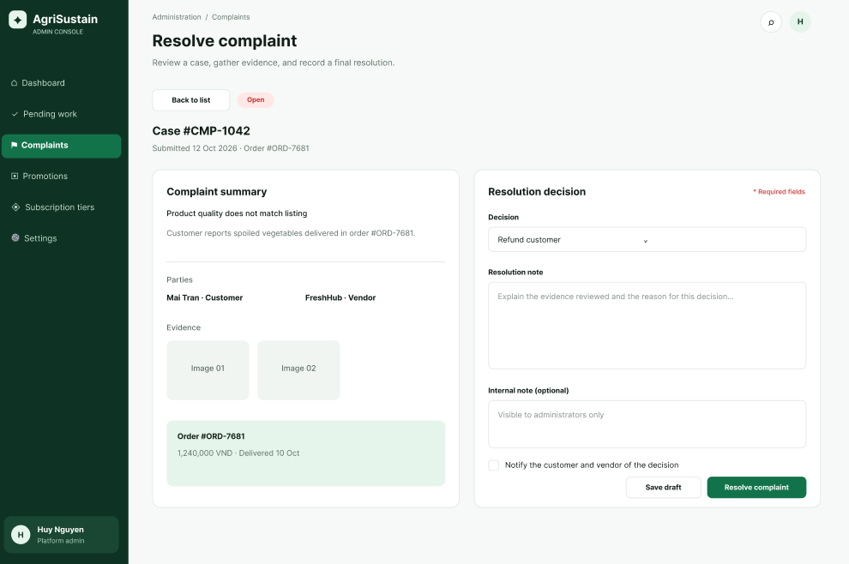
This screen allows the Administrator to:
- View and filter submitted complaint cases.
- Open a complaint to review its summary, evidence, and related order information.
- Record a resolution, request additional information, or keep the case unchanged by cancelling.
- Confirm a decision so that the complaint status, audit log, and notifications are updated.
Mapped use case: UC-ADM-06 - Resolve Complaint.
Field Description
Field Name | Description
(1) Status | Optional filter. Enumerated complaint status; initial value is All Statuses.
(2) Type | Optional filter. Enumerated complaint type; initial value is All Types.
(3) Search | Optional text input used to search by complaint ID or order ID.
(4) Complaint List | Read-only paginated list showing complaint ID, related order ID, complainant, current status, and available action.
(5) View | Opens the selected complaint details.
Resolution Information
(6) Complaint Details and Resolution | Read-only complaint description, submitted evidence references, and related order information displayed for review.
(7) Resolution | Required enumerated decision selected by the Administrator.
(8) Reason | Required text area explaining the selected decision.
(9) Request Information | Changes the case to a waiting-for-information status and notifies the relevant party.
(10) Confirm Resolution | Validates required resolution information, updates the complaint status, and records the action in the audit log.

4.4 Promotion and Voucher Management

4.4.1 Promotion and Voucher List
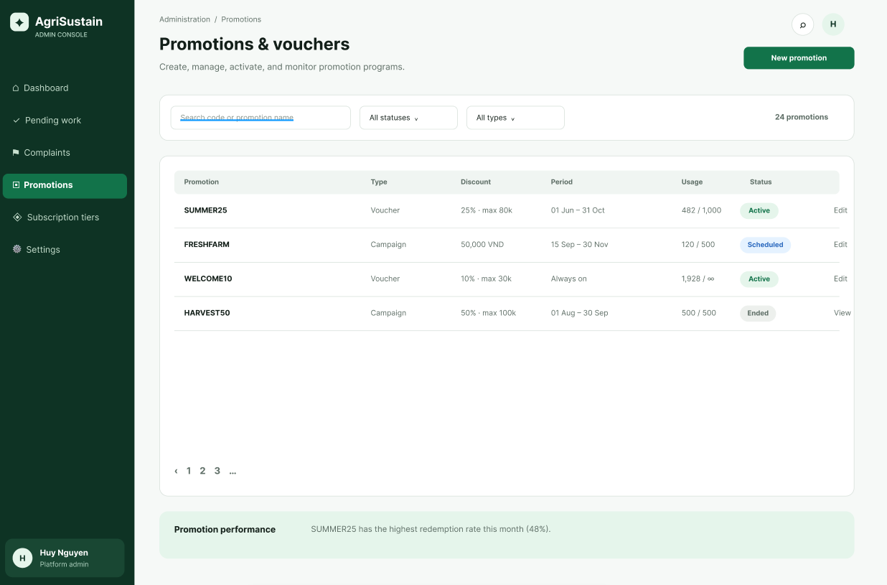
This screen allows the Administrator to:
- View, search, and filter promotions and vouchers by status, type, name, or code.
- Create a new promotion or voucher and update its discount rule, eligibility, usage limit, and validity period.
- Activate or deactivate an existing item.
- Save validated changes and record the action in the audit log.
Mapped use case: UC-ADM-07 - Manage Promotions and Vouchers.
Field Description
Field Name | Description
(1) New Promotion/Voucher | Opens an empty promotion or voucher form.
(2) Status | Optional status filter; initial value is All Statuses.
(3) Item Type | Optional item-type filter; initial value is All Types.
(4) Search | Optional text input used to search by promotion name or voucher code.
(5) Edit | Opens the selected item for update.
(6) Activate/Deactivate | Changes the selected item status after confirmation.
Promotion or Voucher Details
(7) Detail Fields | Required and optional fields for name or code, discount rule, eligibility conditions, usage limit, and validity period. The system validates the values before saving.
(8) Save | Creates or updates the item when all required details are valid.

4.5 Platform Dashboard and Pending Work

4.5.1 Platform Dashboard
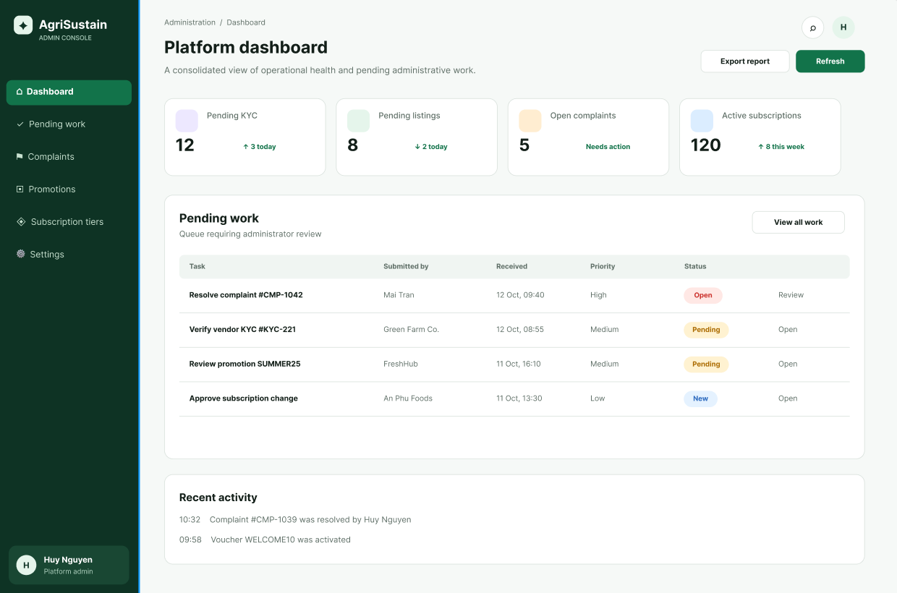
This screen allows the Administrator to:
- View the current platform summary and pending-work counts.
- Filter or refresh the displayed information.
- Open a pending-work item and navigate to its relevant management screen.
- See an empty-state message when no pending work is available.
Mapped use case: UC-ADM-01 - View Platform Dashboard and Pending Work.
Field Description
Field Name | Description
(1) Date Range | Optional date filter applied to dashboard summary data.
(2) Refresh | Requests the latest available dashboard and pending-work information.
(3)-(6) Summary Cards | Read-only counts for the named platform metrics. Selecting a card opens the related detail view when available.
(7) Pending Work | Read-only list of actionable items available to the Administrator, including work type, reference, and creation time.
(8) View Details | Opens the selected item's details or directs the Administrator to the relevant management screen.

4.6 Subscription Tier Management

4.6.1 Subscription Tier List
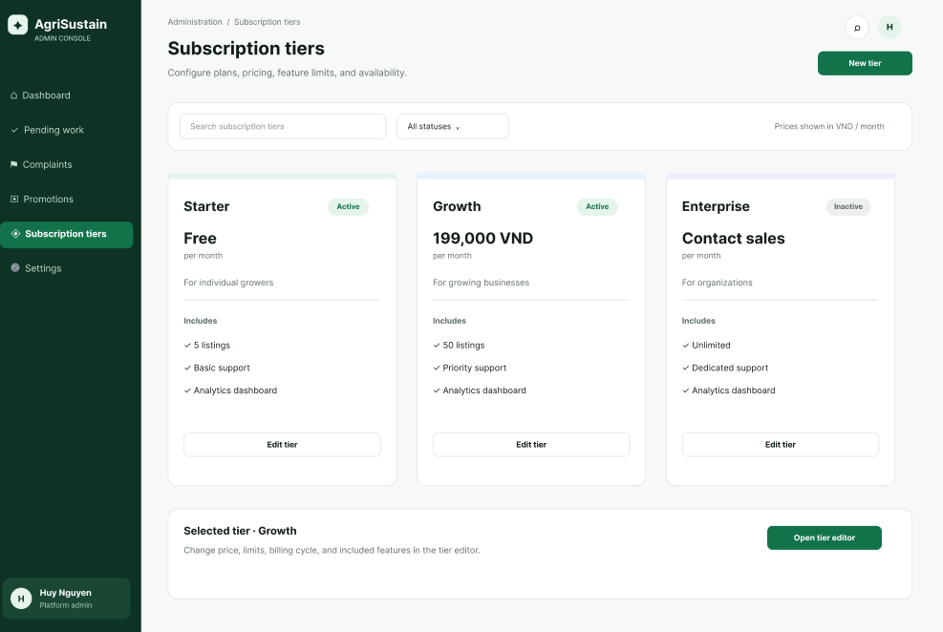
This screen allows the Administrator to:
- View, search, and filter subscription tiers.
- Create or edit a tier's name, price, billing period, benefits, and usage limits.
- Activate or deactivate a subscription tier.
- Save validated changes and record the action in the audit log.
Mapped use case: UC-ADM-09 - Manage Subscription Tiers.
Field Description
Field Name | Description
(1) New Tier | Opens an empty subscription-tier form.
(2) Status | Optional status filter; initial value is All Statuses.
(3) Search | Optional text input used to search by subscription-tier name.
(4) Edit | Opens the selected tier for update.
(5) Activate/Deactivate | Changes the selected tier status after confirmation.
Subscription Tier Details
(6) Detail Fields | Required and optional fields for tier name, price, billing period, benefits, usage limits, and status. The system validates values before saving.
(7) Save | Creates or updates the subscription tier when all required details are valid.

4.7 Moderate Product Review

4.7.1 List Default
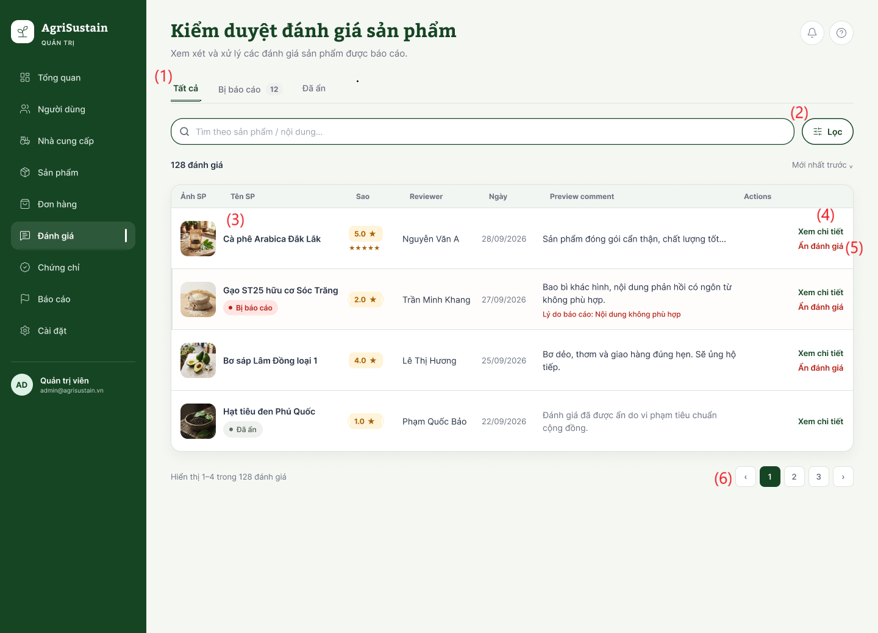
This screen allows the Administrator to:
- Filter Reviews by Status: Filter evaluations across moderation stages (Tất cả, Bị báo cáo, Đã ẩn) with real-time counter badges.
- Filter and Search Reviews: Filter records using advanced parameters or search by product name/comment keywords.
- Inspect Review Details: View full evaluation context including product thumbnail, product name, compliance badges, rating stars, reviewer name, submission date, and preview comment.
- View Full Feedback Dossier: Open detailed inspection modals showing the full comment text, evidence photos, and linked purchase order reference.
- Hide Violating Review: Hide inappropriate, offensive, or policy-violating comments from the public marketplace after providing a moderation reason.
- Navigate Review Records: Move between pages of evaluation records using pagination controls.

Field Description Table
Field Name | Description
(1) Bộ lọc trạng thái (Tabs) | Status filter tab group allowing the Administrator to switch between: Tất cả (All reviews - default active), Bị báo cáo (12) (Reviews flagged or reported by users for policy violations, with a dynamic count badge), and Đã ẩn (Reviews hidden/delisted from the public marketplace).
(2) Lọc | Action filter button that opens advanced filtering options to narrow down reviews by specific criteria such as star ratings (1–5 stars), submission date range, or agricultural product category.
(3) Thẻ danh sách đánh giá | Summary record row displaying key evaluation attributes: product thumbnail (Ảnh SP), product name (Tên SP) with compliance badges (e.g., red Bị báo cáo badge or gray Đã ẩn badge), star rating badge (Sao), reviewer full name (Reviewer), submission date (Ngày), and customer feedback text snippet (Preview comment) including violation reasons in red when applicable.
(4) Xem chi tiết | Row-level action link that opens a modal dialog displaying comprehensive review details, full customer feedback, attached verification photos, and linked order transaction references.
(5) Ẩn đánh giá | Contextual action button allowing the Administrator to hide an offensive, fraudulent, or policy-violating review. Clicking opens a confirmation modal requiring a mandatory moderation reason before removing the review from public display. This action is automatically hidden/revoked for items already in "Đã ẩn" status.

4.8 Seller & Buyer KYC Review Screen

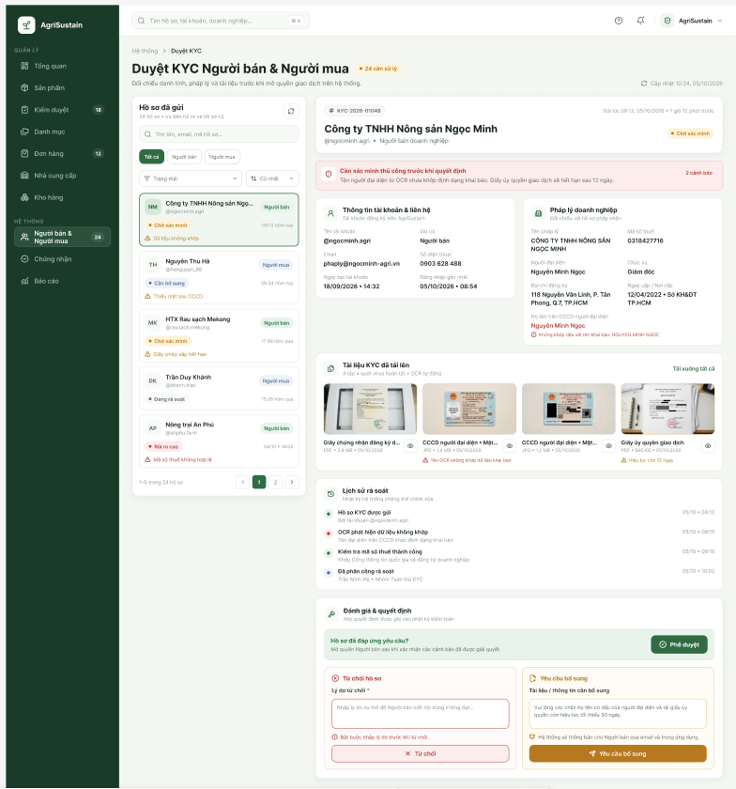

Field Name | Description
KYC Application List | Displays the list of submitted KYC applications, including the applicant's name, applicant type, application status, submission time, and related warnings.
Status Filter | Allows the Administrator to filter KYC applications according to their current verification status.
Selected KYC Application | Displays the selected applicant's KYC application, including the application code, applicant name, account information, and current verification status.
Account Information | Displays the applicant's account and contact information, including name, email, phone number, account type, account creation date, and verification-related information.
Business Information | Displays business-related information for the applicant, including business name, tax code, legal representative, business address, and business registration information.
Submitted KYC Documents | Displays the documents submitted by the applicant for KYC verification, such as identity documents, business registration documents, certificates, and other supporting documents.
Document Preview / Download | Allows the Administrator to preview submitted KYC documents and download the available documents for detailed verification.
Review Decision Section | Provides the Administrator with the available actions for the selected KYC application, including approving, rejecting, or requesting additional information.
Approve Button | Allows the Administrator to approve the KYC application when the submitted information and documents satisfy the verification requirements.
Reject Application Section | Allows the Administrator to enter a mandatory rejection reason before rejecting the KYC application.
Reject Button | Allows the Administrator to reject the KYC application after providing the required rejection reason.
Request Additional Information Section | Allows the Administrator to specify the additional information or documents required from the applicant before the KYC application can be approved.
Request Additional Information Button | Allows the Administrator to send a request for additional or corrected information to the Seller/Buyer.

5.Product Management

5.1 Manage Product Listing

5.1.1 Farmer Product Management Screen
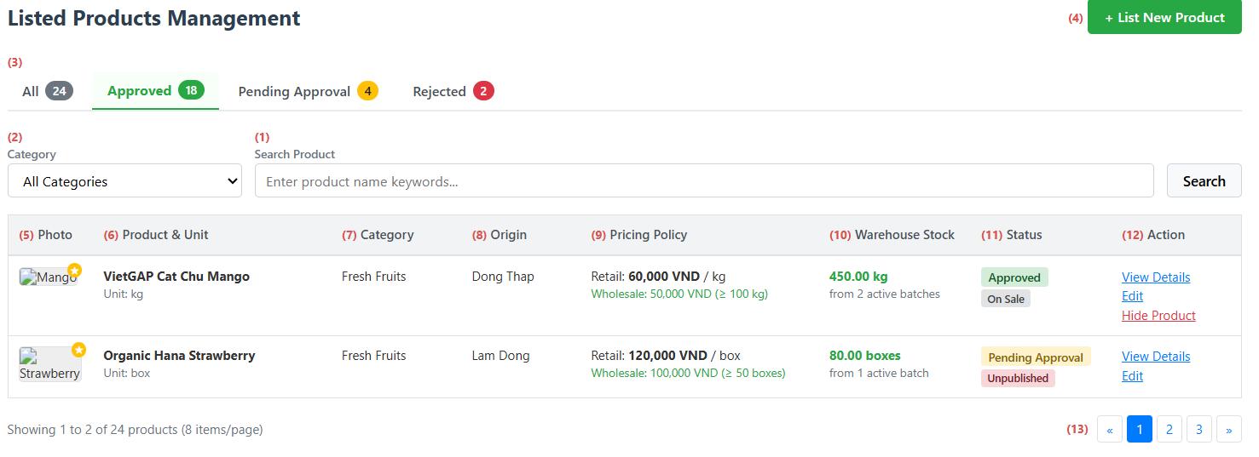
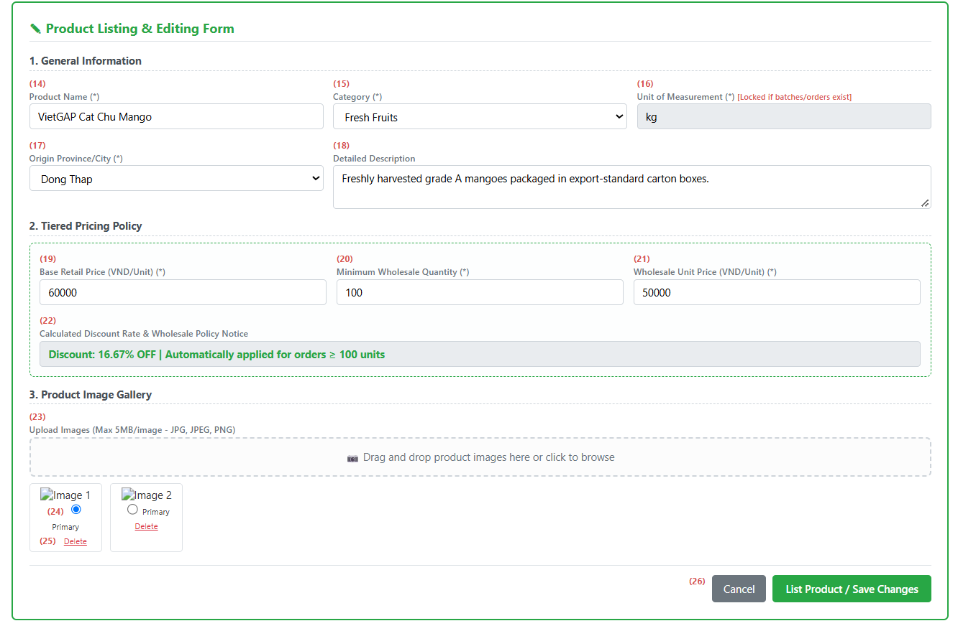

This screen allows the Farmer to:
- View all farm produce listings with images, base retail prices, tiered wholesale pricing, real-time inventory aggregated from harvest batches, and moderation statuses.
- Filter products by approval status tabs and active categories, or search by product name keywords.
- Open the integrated form to register a new agricultural listing with general specifications, tiered wholesale volume rules, and product photos.
- Inspect complete product details and traceable harvest batches.
- Edit existing product information while enforcing business locks on the unit of measurement if batches or orders exist.
- Toggle product publication visibility to hide or show items on the marketplace catalog.
- Manage product gallery images, ensuring at least one valid photo is designated as the primary image.
Field Name | Description
(1) Product Keyword Search | Search input to filter products by title or keyword.
(2) Category Filter | Dropdown list to filter products by agricultural category.
(3) Status Filter Tabs | Navigation tabs filtering listings by approval status: All, Approved, Pending Approval, and Rejected, complete with item count badges.
(4) Add New Product Button | Button that opens the product registration form. Requires an approved farm profile.
(5) Primary Image Thumbnail | Displays the designated primary photo thumbnail for visual identification.
(6) Product Name & Unit | Displays product title and its assigned sales unit of measurement.
(7) Category | Displays the agricultural category group to which the product belongs.
(8) Origin | Displays the cultivation province or city where the produce is harvested.
(9) Pricing Policy | Displays base retail price and discounted wholesale tier pricing applicable from the minimum quantity threshold.
(10) Available Warehouse Stock | Real-time available inventory aggregated automatically from linked active harvest batches. Displays zero if no batches are linked.
(11) Status Badges | Displays content moderation status (Approved, Pending Approval, Rejected) and marketplace visibility (On Sale, Unpublished/Hidden).
(12) Row Actions | Contextual action links:  • View Details: Displays full product profile, image gallery, and traceable harvest batches.  • Edit: Loads product details into the form for updating.  • Hide/Show Product: Prompts confirmation dialog to toggle marketplace visibility.
(13) Pagination Controls | Pagination navigation displaying 8 products per page.
(14) Product Name Input | Text field to enter the agricultural product title. Mandatory field.
(15) Category Dropdown | Dropdown to classify product under an active category. Mandatory field.
(16) Unit of Measurement Input | Packaging unit (e.g., kg, ton, box). Read-only and locked against changes if the product already has linked batches or orders.
(17) Origin Province/City Selector | Dropdown list to select harvest origin province or city. Mandatory field.
(18) Description Editor | Multi-line text field to provide cultivation notes, storage tips, or packaging specifications.
(19) Base Retail Price Input | Numeric input for base retail unit price. Must be greater than 0. Mandatory field.
(20) Minimum Wholesale Quantity Input | Numeric threshold for bulk purchases. Must be greater than 1. Mandatory field.
(21) Wholesale Unit Price Input | Numeric unit price applied when ordering at or above the wholesale quantity threshold. Must be strictly lower than the base retail price. Mandatory field.
(22) Calculated Discount Rate & Notice | Display box showing calculated wholesale discount percentage and explanatory notice on automated cart price adjustments.
(23) Image Upload Dropzone | File upload box supporting JPG, JPEG, and PNG formats up to 5MB per file.
(24) Primary Image Selector | Radio button to designate exactly one image as the primary display photo. Mandatory requirement.
(25) Delete Image Action | Removes an image from the gallery. If deleted image was primary, another image must be selected as primary before saving.
(26) Form Action Buttons | Submission controls:  • List Product / Save Changes: Validates inputs, saves the product in Pending Approval and Unpublished status, and submits for moderation.  • Cancel: Discards unsaved changes and closes the form.

6.Consumer Ordering

6.1Checkout and Place Retail Order

6.1.1 Retail Checkout Screen
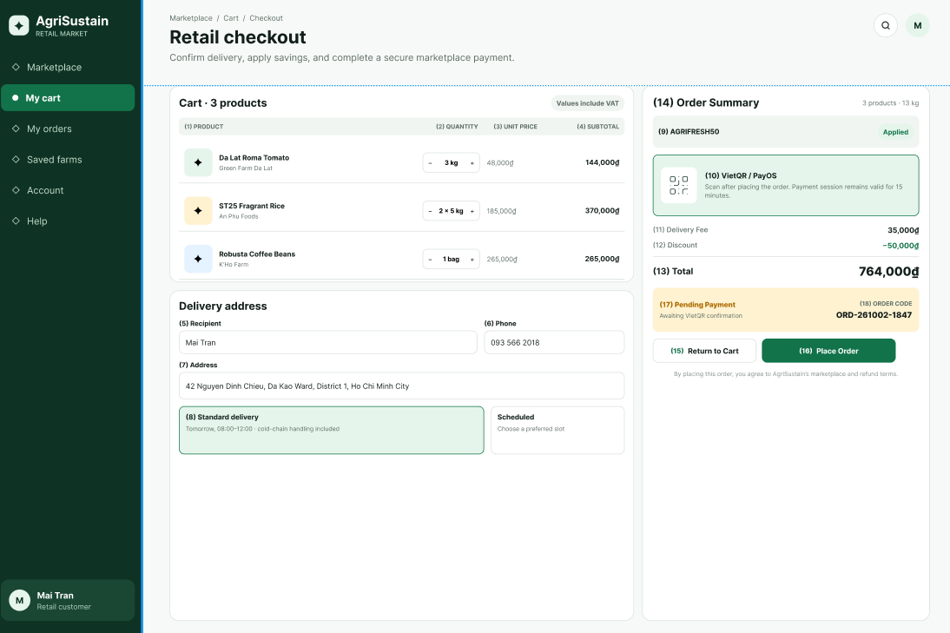
This screen allows the Consumer to:
- Review Order Items: view selected products, quantities, prices, farmers, and subtotals.
- Select or Enter Delivery Address: choose a saved delivery address or enter a new address.
- Select Delivery Method: choose an available delivery service.
- Apply Voucher: enter or select a valid voucher for the order.
- Redeem Reward Points: use available reward points where applicable.
- Select Payment Method: choose VietQR / PayOS or another supported payment method.
- Add Order Notes: provide optional instructions for the order.
- Review Payment Summary: view subtotal, delivery fee, voucher discount, point discount, and final amount.
- Place Order: confirm the order; the system validates information, reserves stock, creates the order, and redirects the Consumer to the payment process.

Field Name | Description
Order Item List | Read-only list of selected cart items, including product image, product name, unit of measure, farmer name, Batch Code, unit price, quantity, and item subtotal.
Saved Address Selector | Allows the Consumer to select a saved delivery address or enter a new address.
Recipient Name | Required text input, 2–100 characters.
Recipient Phone Number | Required text input. Must match the configured Vietnamese phone-number format.
Province / City | Required dropdown used for delivery-area selection and delivery-fee calculation.
District | Required dropdown based on the selected Province / City.
Ward | Required dropdown based on the selected District.
Address Detail | Required text area for house number, street, or delivery instructions. Maximum 255 characters.
Delivery Method | Required selection: Standard Delivery or Fresh Produce Express Delivery. Displays estimated delivery time and fee.
Voucher Code | Optional text input or voucher selector. The system validates voucher eligibility before applying a discount.
Reward Points Redemption | Optional input or checkbox. Displays available Reward Points Balance and applies an eligible points discount.
Payment Method | Required selection: VietQR or PayOS.
Order Notes | Optional text area for special delivery instructions. Maximum 300 characters.
Subtotal | Read-only total price of all selected order items before discounts and delivery fees.
Delivery Fee | Read-only fee calculated from the delivery address and selected delivery method.
Voucher Discount | Read-only discount amount from an eligible voucher. Default value: 0 VND.
Reward Points Discount | Read-only discount amount converted from redeemed reward points. Default value: 0 VND.
Total Amount | Read-only final amount: Subtotal + Delivery Fee − Voucher Discount − Reward Points Discount.
Return to Cart Button | Returns to Shopping Cart without creating an order.
Place Order Button | Revalidates stock, creates an order with PendingPayment status, reserves Product Batch inventory, removes successfully ordered items from the cart, and redirects to UC-CON-03 – Pay Retail Order by VietQR or PayOS.

6.2 Information Consumer

6.2.1 Information Consumer

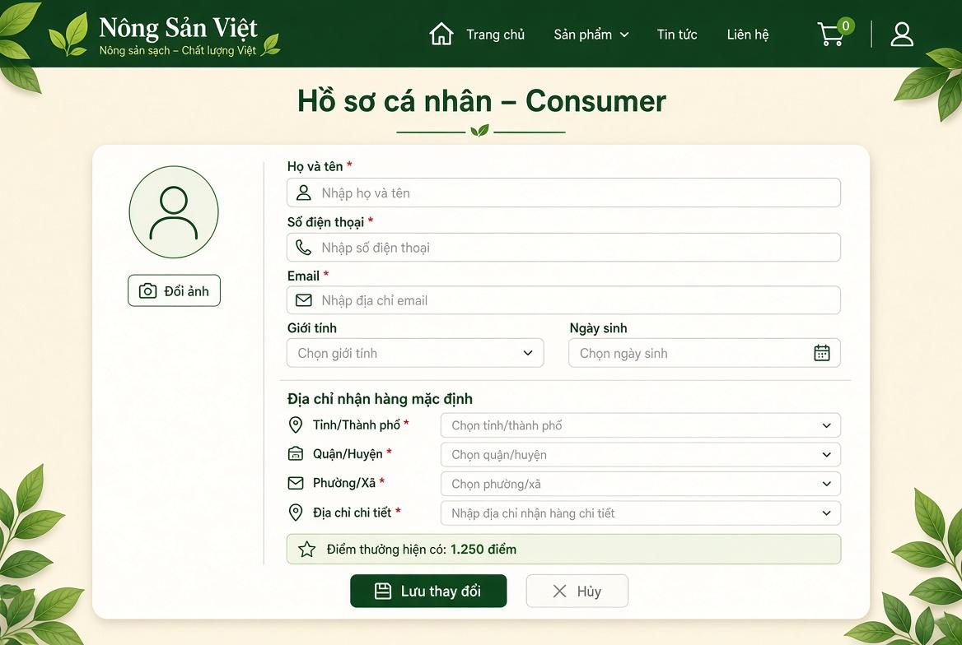

Field Name | Description
(1) Đổi ảnh | Button allowing the consumer to upload or update their personal profile avatar. Accepts .png, .jpg, .jpeg up to 5 MB.
(2) Họ và tên | Textbox displaying and updating the consumer's full name. Mandatory field, max length: 50 characters.
(3) Số điện thoại | Textbox displaying the registered phone number. Mandatory field, requires verification when changed.
(4) Email | Textbox displaying the primary email address. Mandatory, unique across the platform.
(5) Giới tính | Dropdown list for selecting gender (Male, Female, Other). Optional.
(6) Ngày sinh | Datepicker control for picking the user's date of birth in DD/MM/YYYY format. Optional.
(7) Tỉnh/Thành phố * | Dropdown selection for province or municipality. Mandatory for calculating regional delivery routes.
(8) Quận/Huyện * | Dropdown selection dynamically populated based on the chosen Province/City. Mandatory.
(9) Phường/Xã * | Dropdown selection dynamically populated based on the chosen District. Mandatory.
(10) Địa chỉ chi tiết * | Textbox for entering specific house number and street address. Mandatory string, max length: 150 characters.
(11) Điểm thưởng hiện có | Read-only badge/text displaying the current accumulated reward point balance available for order checkout discounts.
(12) Lưu thay đổi | Primary action button. Submits the form, validates all fields, and updates profile data in the database.
(13) Hủy | Secondary action button. Discards all unsaved edits and restores original profile values.

6.3Track Retail Order

6.3.1 History Order
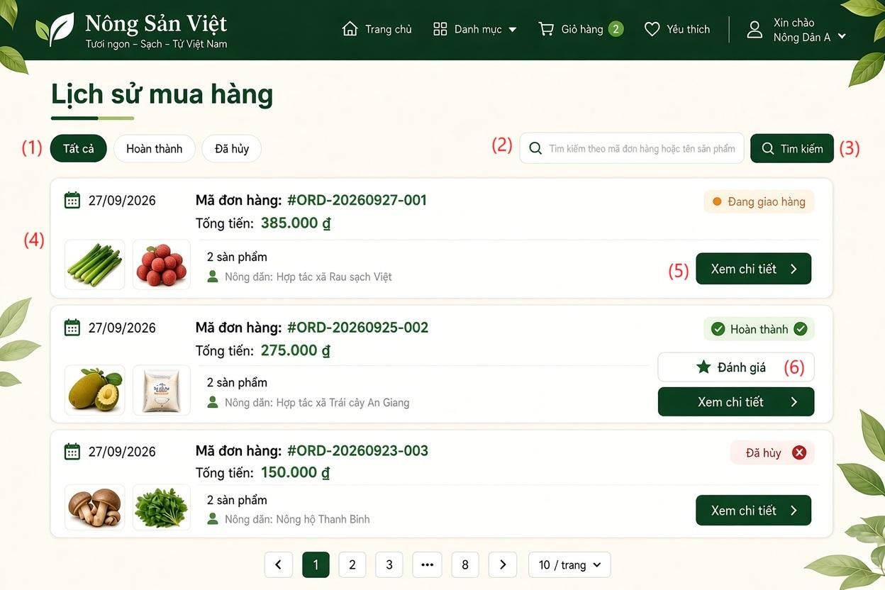

Field Name | Description
(1) Bộ lọc trạng thái đơn hàng (Tabs) | Status filter tab group allowing the user to filter orders by: All (Tất cả), Completed (Hoàn thành), and Cancelled (Đã hủy). Clicking a tab reloads the matching order list.
(2) Ô tìm kiếm | Search input text field allowing consumers to look up orders by Order ID (e.g., #ORD-xxxxxx-xxx) or by Product Name keywords.
(3) Nút tìm kiếm | Action button executing the filter query based on the entered keyword and refreshing the order cards display.
(4) Thẻ danh sách đơn hàng | Summary card displaying key information of each order: Order Date, Order Code & Total Amount,Item Summary,Status Badge
(5) Xem chi tiết | Primary row action button. Navigates the consumer to the Order Detail & Fulfillment Tracking Screen (SCR-16).
(6) Đánh giá | Contextual action button visible only for orders in "Completed" status. Clicking it opens the Product Review modal to submit star ratings and feedback comments.
(7) Thanh phân trang (Pagination) | Navigation control with Next/Previous arrows and explicit page numbers to navigate across order records. Dropdown selector allowing the user to choose the number of records displayed per page (e.g., 10 / trang)

6.3.1 Order Detail
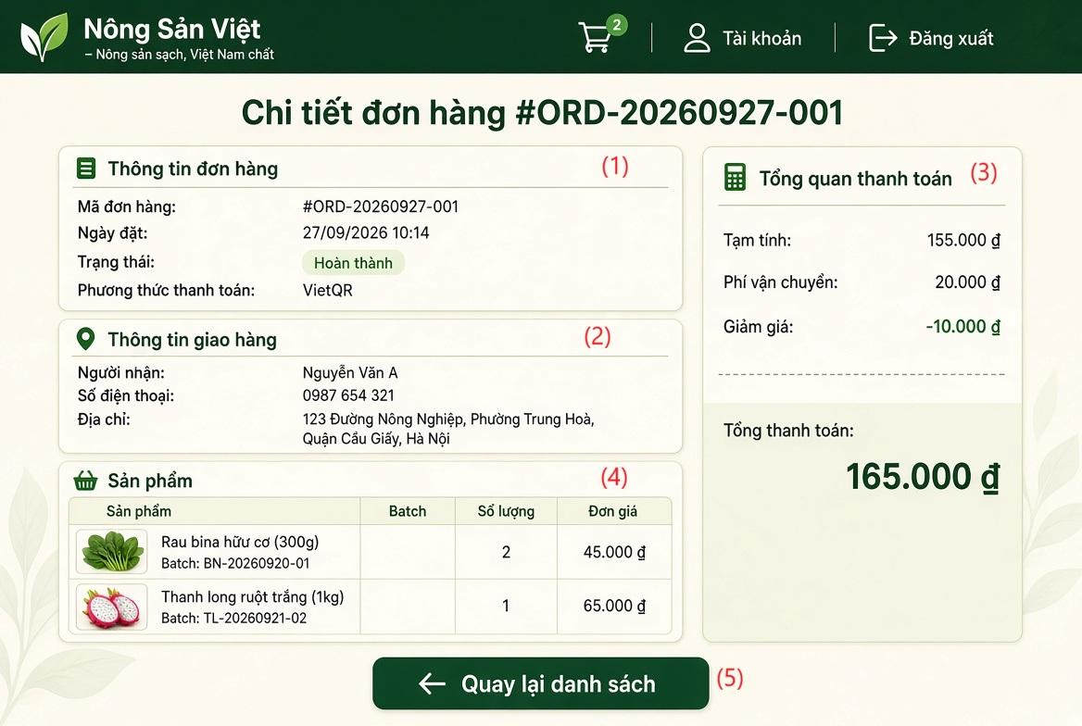

Field Name | Description
(1) Thông tin đơn hàng (Order Information) | Information panel displaying basic order identifiers and statuses
(2) Thông tin giao hàng | Panel displaying recipient contact and delivery location details
(3) Tổng quan thanh toán | Financial ledger breakdown for the order transaction
(4) Sản phẩm | Tabular list of agricultural goods purchased in the order
(5)"Quay lại danh sách" | Primary navigation action button that returns the consumer to the Order History & Overview Screen (SCR-12 / SCR-16) without altering data.

6.4 Manage Shopping Cart

6.4.1 Shopping Cart Screen
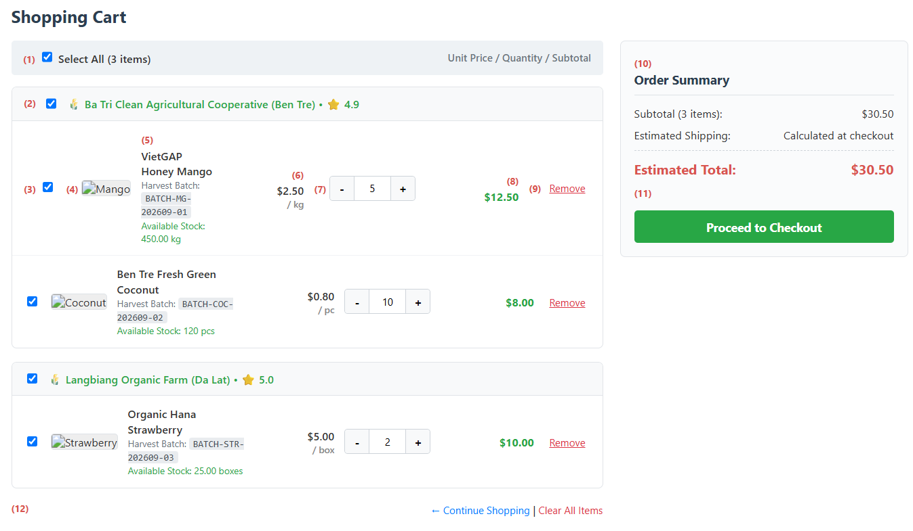
This screen allows the Consumer to:
- View Cart Items: View all items added to the cart, organized and grouped by Farm/Cooperative.
- Select Items for Checkout: Select or deselect individual items, all items from a specific farm, or all items in the cart.
- Adjust Item Quantities: Increase, decrease, or manually input quantities with real-time validation against available batch inventory.
- Remove Items: Delete individual unwanted items or clear the entire shopping cart.
- Review Summary & Checkout: Monitor order subtotals and estimated total cost in real time, then proceed to the Retail Checkout screen.
Field Name | Description
(1) Select All Checkbox | Toggles selection for all items across all farms in the cart simultaneously.
(2) Farm Header & Group Selection | Displays farm/cooperative name, reputation score, and a checkbox to select or deselect all items from that specific farm.
(3) Item Selection Checkbox | Checkbox to include or exclude a specific item from the order subtotal and checkout.
(4) Product Thumbnail | Displays thumbnail image of the agricultural product.
(5) Product Details & Batch Info | Displays product name, unit of measure, linked harvest batch code, and current available batch stock. Warns if stock is insufficient.
(6) Unit Price | Listed retail selling price per unit at the time of adding to the cart.
(7) Quantity Controls | Decrement (-), increment (+), and numeric input to adjust order quantity. Minimum is 1; maximum cannot exceed available batch stock.
(8) Item Subtotal | Line item subtotal, automatically calculated as unit price multiplied by selected quantity.
(9) Remove Item Action | Removes the specific item from the cart after user confirmation.
(10) Order Cost Summary | Displays item subtotal, estimated shipping notice, and estimated total payable amount.
(11) Proceed to Checkout Button | Validates stock availability for selected items and navigates to the Retail Order Placement screen (UC-CON-02).
(12) Secondary Action Links | Quick navigation links to return to the Marketplace for shopping or clear all items from the cart.

6.5 Submit Product Review

6.5.1 Product Review Screen
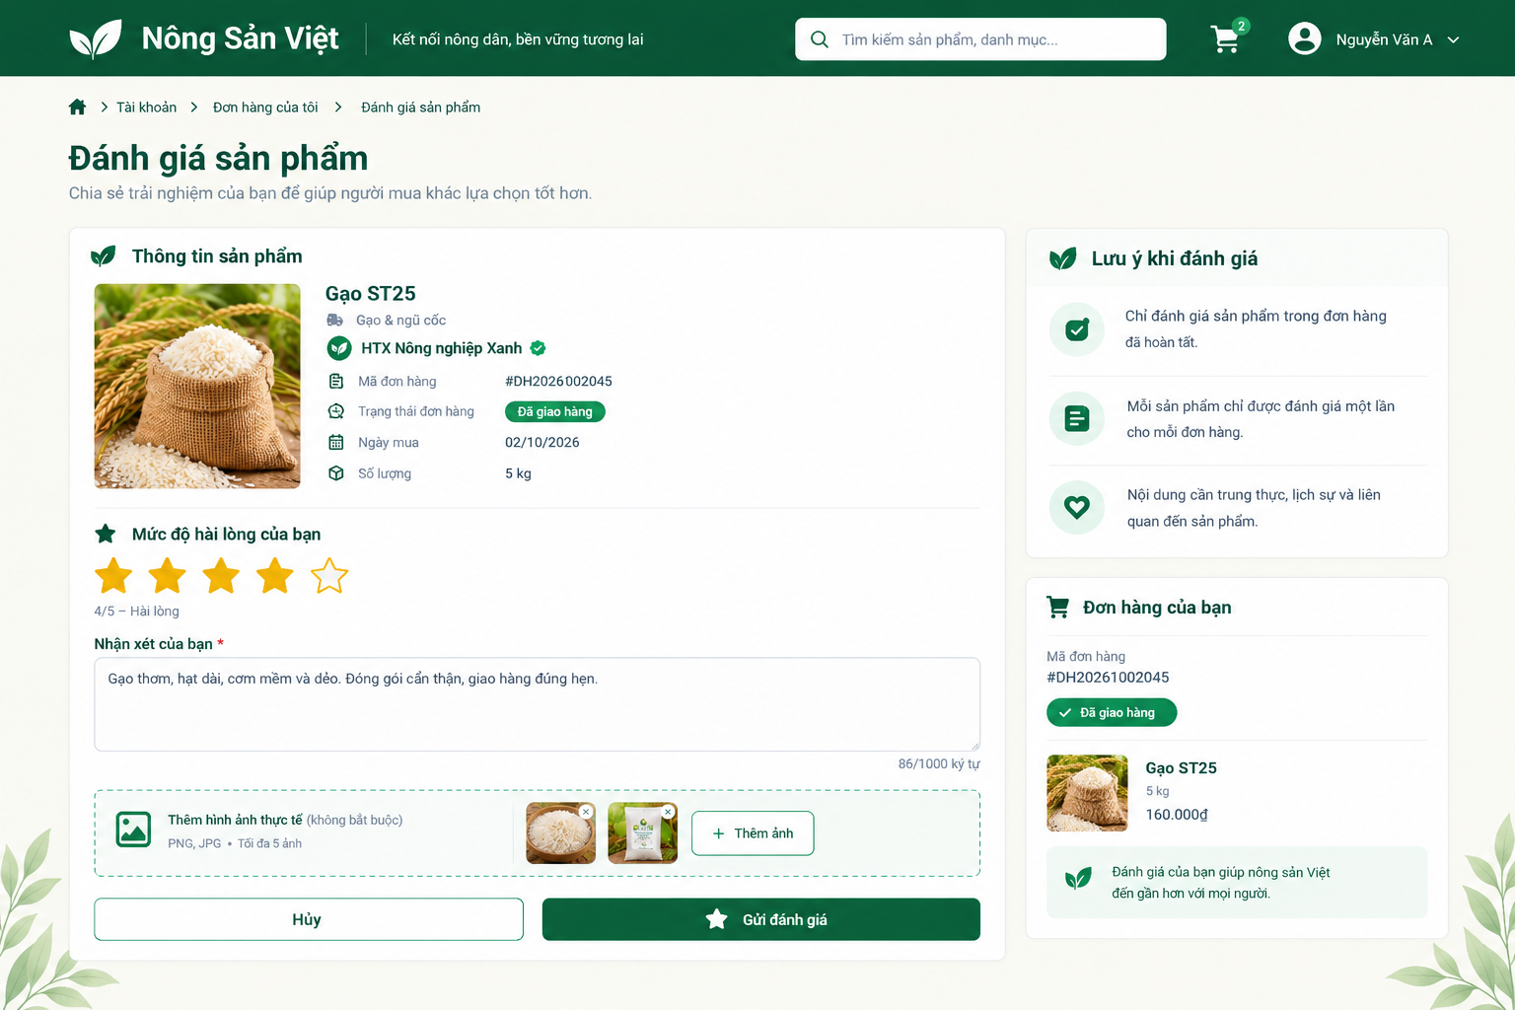
This screen allows the Consumer to:
- View the purchased product and its related order information.
- Select a star rating and enter a review comment.
- Attach product photos and remove selected photos before submission.
- Submit the review or cancel and return to the previous screen.

Field Name | Description
Product Information | Read-only panel showing the product image, name, category, supplier, order code, order status, purchase date, and purchased quantity.
Star Rating | Required rating control. Accepts an integer from 1 to 5. Selected stars are highlighted.
Rating Description | Read-only text showing the selected score and its corresponding satisfaction level. Updates when the Consumer changes the rating.
Review Comment | Required text area for product feedback. Maximum length: 1,000 characters.
Character Counter | Displays the current number of characters entered against the 1,000-character limit.
Add Photos | Optional image-upload control. Accepts PNG and JPG files, with a maximum of 5 images.
Photo Preview / Remove | Displays thumbnails of selected images. The remove icon deletes an image from the pending upload list.
Review Guidelines | Read-only panel explaining review eligibility, the one-review restriction, and expectations for honest, polite, product-related feedback.
Your Order | Read-only summary showing the related order code, delivery status, product image, product name, quantity, and price.
Cancel Button | Leaves the review form without submitting the entered feedback.

6.6 Submit Order Complaint

6.6.1 Order Complaint Screen
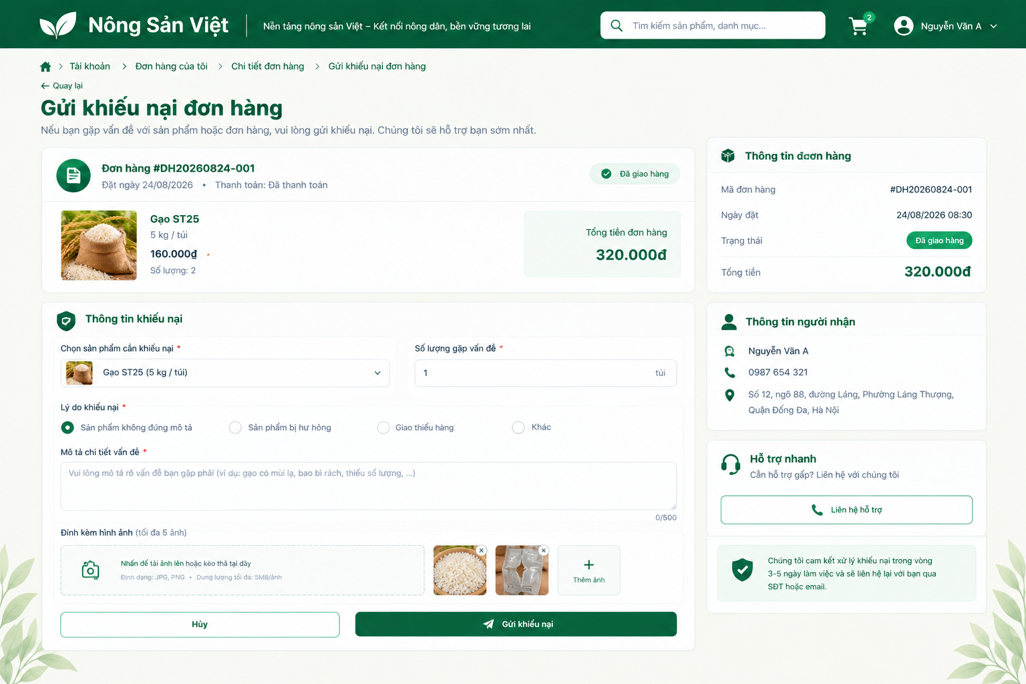
This screen allows the Consumer to:
- Review the selected order and recipient information.
- Select the affected product and specify the affected quantity.
- Choose a complaint reason, describe the issue, and attach supporting images.
- Submit the complaint, cancel, or contact support.

Field Name | Description
Back Link | Returns to the previous order-detail screen.
Order Summary | Read-only panel showing the order code, order date, payment status, delivery status, ordered product, unit price, quantity, and total amount.
Product Selection | Required dropdown listing products from the selected order. Displays the selected product’s name, image, and packaging or unit information.
Affected Quantity | Required numeric input specifying the quantity involved in the complaint. Must be greater than zero and must not exceed the purchased quantity of the selected item.
Complaint Reason | Required radio-button group. Options: Product Not as Described, Damaged Product, Missing Items, and Other. Only one option can be selected.
Issue Description | Required text area describing the problem. Maximum length: 500 characters.
Character Counter | Displays the current description length against the 500-character limit.
Evidence Upload | Supports click-to-upload and drag-and-drop. Accepts JPG and PNG files, with a maximum of 5 images and 5 MB per image.
Evidence Preview / Remove | Displays uploaded-image thumbnails. Each thumbnail includes a remove control for deleting the selected attachment before submission.
Add Image Button | Opens the file selector to attach additional evidence within the upload limits.
Order Information | Read-only sidebar showing the order code, order date and time, current status, and total amount.
Recipient Information | Read-only panel showing the recipient’s name, phone number, and delivery address.
Contact Support Button | Opens the available support channel for assistance with the order complaint.
Processing Notice | Displays the stated complaint-handling period of 3–5 working days and indicates that follow-up will be provided by phone or email.
Cancel Button | Leaves the form without submitting the complaint.
Submit Complaint Button | Validates the selected product, affected quantity, reason, description, attachments, and complaint eligibility before recording the complaint.

8. Farm Management

8.1 Manage Farm and Crop Seasons

8.1.1 Crop Season Management Screen
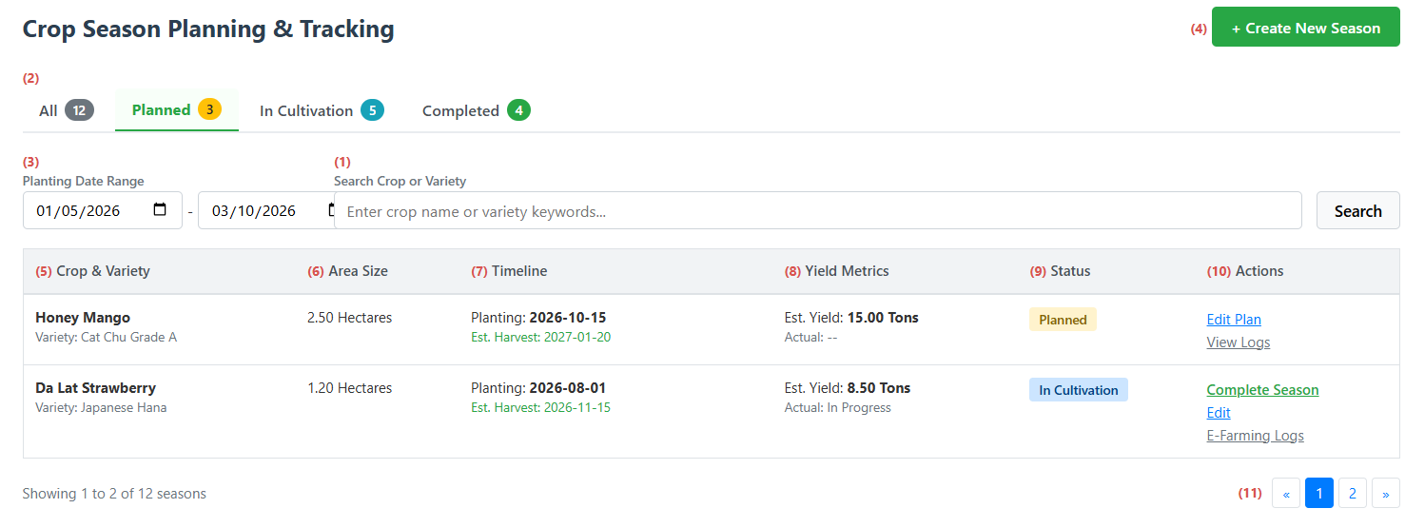
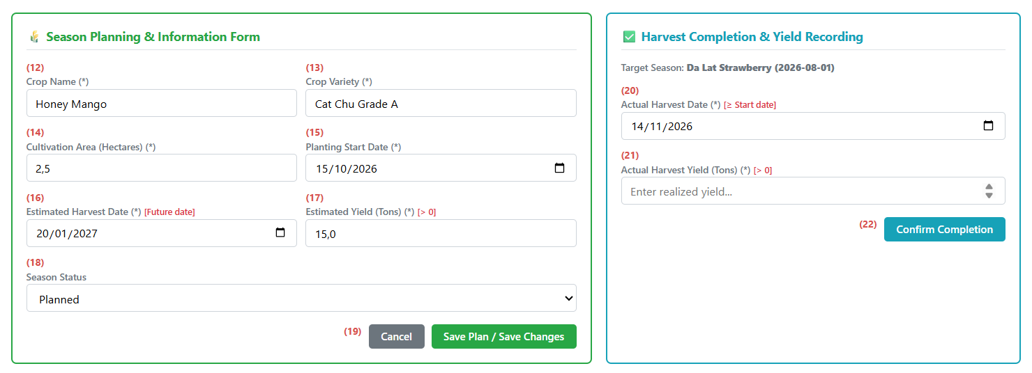

This screen allows the Farmer to:
- View and track all farm crop seasons with cultivation schedules, estimated harvest dates, and yield metrics.
- Filter seasons by lifecycle status tabs (Planned, In Cultivation, Completed) or search by crop name and variety.
- Create a new cultivation season by specifying crop variety, land area, planting date, estimated harvest date, and expected yield.
- Update season parameters or advance progress from planning to active cultivation.
- Close completed seasons by recording the actual harvest date and final realized yield to allocate inventory for sale and traceability.
Field Name | Description
(1) Crop Keyword Search | Text input to search seasons by crop name or plant variety keywords.
(2) Status Filter Tabs | Navigation tabs filtering seasons by lifecycle stage: All, Planned, In Cultivation, and Completed, with item count badges.
(3) Planting Date Range | Date pickers (From date – To date) to filter seasons based on planting commencement.
(4) Create New Season Button | Action button opening the season planning form. Requires verified farm status.
(5) Crop & Variety | Displays agricultural crop title and designated botanical variety.
(6) Area Size | Displays cultivated farm area allocated for the season (in hectares).
(7) Timeline | Displays planting start date and estimated harvest completion date.
(8) Yield Metrics | Displays estimated planned yield and final realized harvest yield.
(9) Status Badge | Visual state indicator showing current season progress (Planned, In Cultivation, or Completed).
(10) Row Actions | Contextual action links:  • Edit Plan / Edit: Loads season data into the planning form for modification.  • Complete Season: Opens the harvest completion dialog to log actual yield.  • E-Farming Logs: Navigates to cultivation activity logging for traceability.
(11) Pagination Controls | Standard pagination navigation buttons.
(12) Crop Name Input | Text box to specify the agricultural commodity title. Mandatory field.
(13) Crop Variety Input | Text box to specify the cultivation variety or cultivar. Mandatory field.
(14) Cultivation Area Input | Numeric input for cultivated land area. Must be greater than 0. Mandatory field.
(15) Planting Start Date Input | Date selector for planting commencement. Mandatory field.
(16) Estimated Harvest Date Input | Date selector for expected harvest. Must be set after the planting start date and in the future. Mandatory field.
(17) Estimated Yield Input | Numeric input for expected harvest output in tons. Must be greater than 0. Mandatory field.
(18) Season Status Selector | Dropdown selector to set initial status (Planned) or advance progress (In Cultivation).
(19) Form Action Buttons | Submission controls:  • Save Plan / Save Changes: Validates timeline and yields, saves season record, and refreshes the list.  • Cancel: Clears unsaved changes.
(20) Actual Harvest Date Input | Date selector for completed harvest. Must not be earlier than the planting start date. Mandatory field.
(21) Actual Harvest Yield Input | Numeric input for actual achieved output in tons. Must be greater than 0. Mandatory field.
(22) Confirm Completion Button | Validates harvest dates and yield, marks the season status as Completed, and enables batch inventory allocation.

8.2 Record E-Farming Logs

8.2.1 Digital Field Log Screen
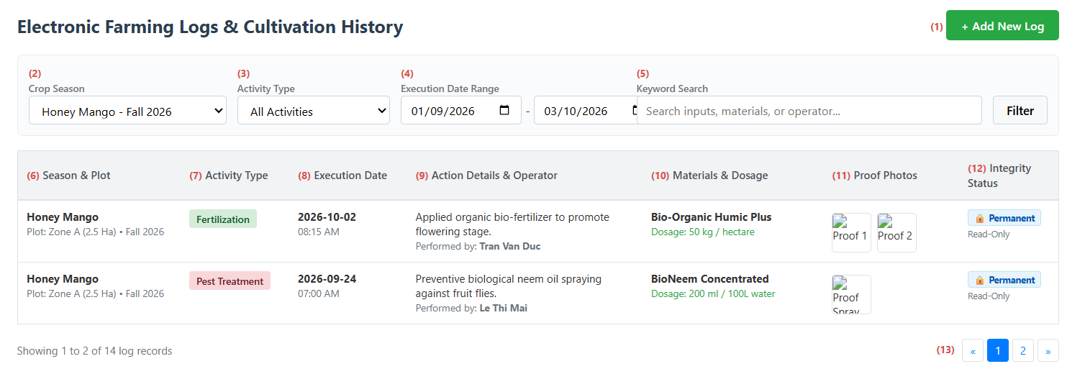
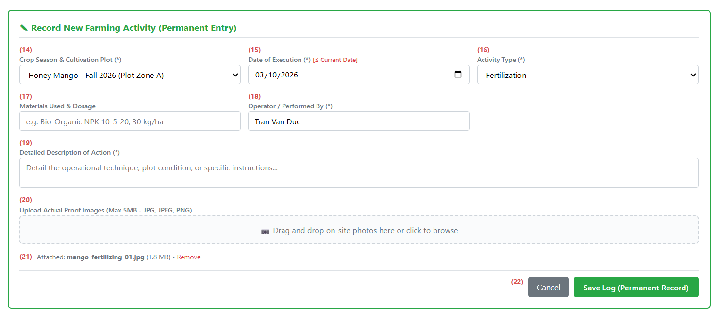
This screen allows the Farmer to:
- View the complete chronological cultivation timeline of all agricultural activities performed within each crop season.
- Filter cultivation logs by active crop seasons, specific activity classifications, and date intervals.
- Open the logging form to submit new cultivation events including seeding, irrigation, fertilization, pest treatments, or harvesting.
- Record materials applied, dosage metrics, operational descriptions, and designated operators for each activity.
- Upload authentic on-site proof images to satisfy GAP and organic quality traceability requirements.
- Enforce data immutability by permanently locking recorded logs against editing or deletion, ensuring transparent and tamper-proof traceability records for consumers and B2B buyers.
Field Name | Description
(1) Add New Log Button | Action button displaying the farming log entry form.
(2) Crop Season Filter | Dropdown list to filter the timeline by specific crop seasons and plots.
(3) Activity Type Filter | Dropdown list to filter logs by task classification: All, Fertilization, Pest Treatment, Irrigation, Sowing, or Harvesting.
(4) Execution Date Range | Dual date selector (From date – To date) to filter logged activities over a specific timeframe.
(5) Keyword Search Input | Text box to search logs by materials used, dosages, or operator names.
(6) Season & Plot Info | Displays crop name, cultivation plot identifier, farm area, and season year.
(7) Activity Type Tag | Visual color-coded tag indicating the type of agricultural action executed.
(8) Execution Date Display | Displays the recorded date and time when the agricultural activity was physically performed.
(9) Action Details & Operator | Displays the detailed operational description and the full name of the operator who executed the work.
(10) Materials & Dosage Display | Displays input product names (fertilizers, biological agents, pesticides) and applied dosage quantities.
(11) Proof Photos Gallery | Displays clickable image thumbnails of on-site proof photos uploaded during logging.
(12) Integrity Status Badge | Displays read-only immutability status indicating the record is locked and cannot be edited or deleted.
(13) Pagination Controls | Standard pagination buttons to browse chronological cultivation records.
(14) Target Crop Season Selector | Dropdown list to select the active crop season for which the log is being recorded. Mandatory field.
(15) Execution Date Input | Date picker for the activity execution date. Must not be set to a future date. Mandatory field.
(16) Activity Type Selector | Dropdown list to categorize the farming activity. Mandatory field.
(17) Materials & Dosage Input | Text field to specify brand names of fertilizers, pesticides, or biological inputs along with applied dosages.
(18) Performed By Input | Text field to record the identity of the technician or worker executing the activity. Mandatory field.
(19) Detailed Description Textarea | Multi-line text field detailing operational techniques and plot observations. Mandatory field.
(20) Proof Image Upload Dropzone | File upload area supporting JPG, JPEG, and PNG formats up to 5MB per image.
(21) Uploaded Image Preview & Remove | File attachment indicator displaying uploaded file details with a remove link prior to submission.
(22) Form Action Buttons | Submission controls:  • Save Log: Validates mandatory inputs, verifies non-future dates, saves the immutable record, and refreshes the timeline.  • Cancel: Discards uncommitted entries.

9. Farm Management

9.1 Manage Product Batch and Traceability

9.1.1 Batch & Traceability QR Generator Screen
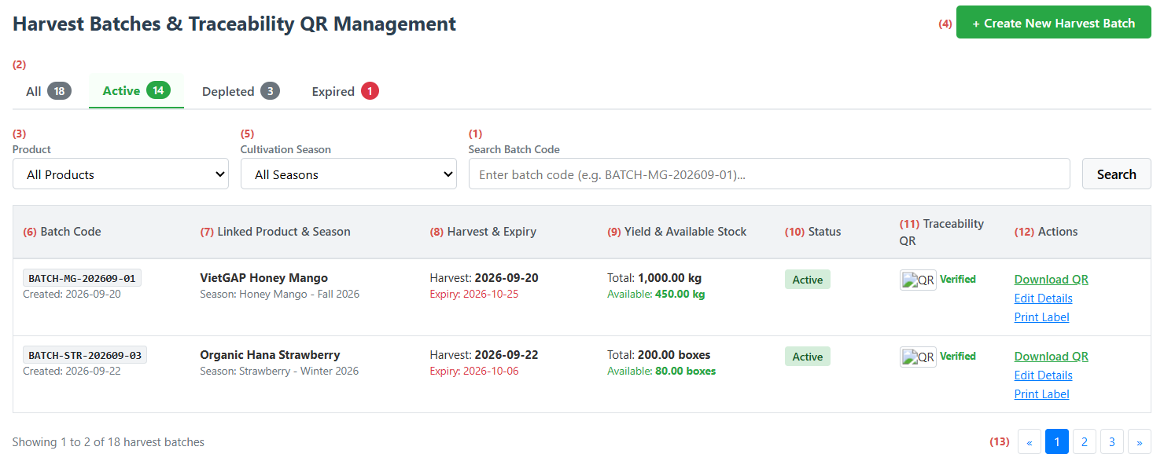
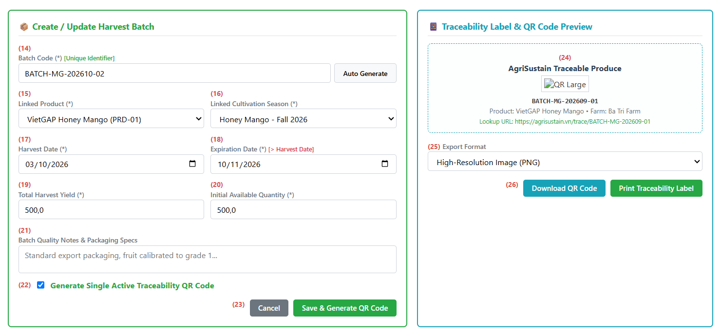

This screen allows the Farmer to:
- View and monitor all harvested agricultural batches with linked products, cultivation seasons, shelf-life dates, and available stock levels.
- Filter harvest batches by status tabs (Active, Depleted, Expired), linked products, crop seasons, or search by batch code keywords.
- Create new harvest batches by entering or auto-generating unique batch codes, setting harvest yields, and defining available inventory.
- Request the issuance of a unique, tamper-proof traceability QR code strictly tied to each harvest batch.
- Download high-resolution QR code graphics or print standardized packaging labels in PNG or PDF format for physical labeling.
- Update batch expiration dates and quality notes while keeping the issued batch codes and traceability QR identifiers permanently locked against modification.
Field Name | Description
(1) Search Batch Code Input | Text box to search batches by specific batch code or product keyword.
(2) Batch Status Tabs | Navigation tabs filtering batches by lifecycle state: All, Active, Depleted, and Expired, complete with item count badges.
(3) Product Filter Dropdown | Dropdown list to filter batches linked to a specific agricultural product.
(4) Create New Harvest Batch Button | Action button displaying the batch creation form. Requires verified farm KYC permissions.
(5) Cultivation Season Filter | Dropdown list to filter batches associated with a particular cultivation season.
(6) Batch Code Display | Displays the unique harvest batch code and timestamp of creation.
(7) Linked Product & Season Display | Displays product title and corresponding crop season name linked to the batch.
(8) Harvest & Expiry Timeline | Displays actual harvest date and the produce shelf-life expiration date.
(9) Yield & Available Stock Display | Displays total realized harvest yield and real-time remaining stock available for purchase.
(10) Batch Status Badge | Visual state tag indicating whether the batch is Active, Depleted (stock = 0), or Expired.
(11) Traceability QR Thumbnail | Displays a thumbnail of the active QR code and verified status tag.
(12) Row Action Links | Contextual action links:  • Download QR: Downloads the individual QR code graphic.  • Edit Details: Opens the form to update expiration dates or notes.  • Print Label: Opens the label layout for physical parcel packaging.
(13) Pagination Controls | Standard pagination navigation buttons.
(14) Batch Code Input & Auto-Generate | Text field to enter a unique batch code or click Auto Generate to create a syntax-compliant code. Must be unique across the platform.
(15) Linked Product Selector | Dropdown list to select the agricultural product to which the batch belongs. Mandatory field.
(16) Linked Cultivation Season Selector | Dropdown list to select the cultivation season that yielded this harvest. Mandatory field.
(17) Harvest Date Input | Date picker for the harvest date (or planned harvest date for pre-order batches). Mandatory field.
(18) Expiration Date Input | Date picker for produce shelf life. Must occur strictly after the harvest date. Mandatory field.
(19) Total Harvest Yield Input | Numeric input for total output harvested. Must be greater than 0. Mandatory field.
(20) Initial Available Quantity Input | Numeric input for initial stock available for sale. Must be greater than 0 and less than or equal to total yield. Mandatory field.
(21) Quality Notes Textarea | Multi-line text field to specify packaging grades, quality ratings, or storage guidelines.
(22) Generate QR Code Checkbox | Selection option prompting the system to generate and activate a single unique traceability QR code upon saving.
(23) Batch Form Submission Buttons | Submission controls:  • Save & Generate QR Code: Validates data, creates the batch record, generates the unique QR code, and refreshes the list.  • Cancel: Discards uncommitted entries.
(24) Traceability Label Preview Box | Interactive preview box showing QR code, batch code, farm origin, and public verification URL.
(25) Export Format Selector | Dropdown list to select the file format for export (High-Resolution PNG or Multi-label PDF).
(26) Download & Print Action Buttons | Action controls:  • Download QR Code: Saves the QR graphic file to local device.  • Print Traceability Label: Launches browser print command with pre-formatted packaging sticker layout.

10. B2B Contract Management

10.1 Manage Offtake Contract

10.1.1 Farmer Offtake Contracts Screen
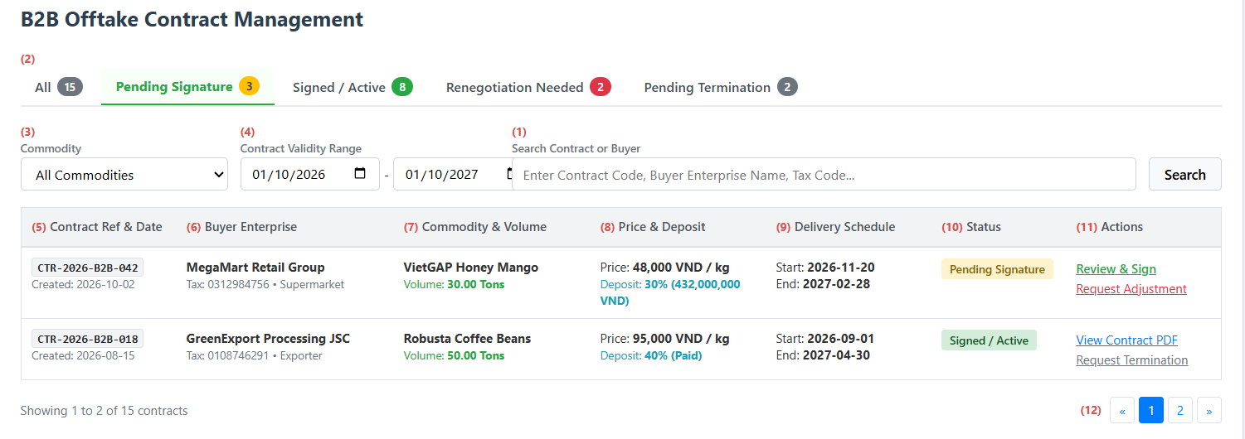
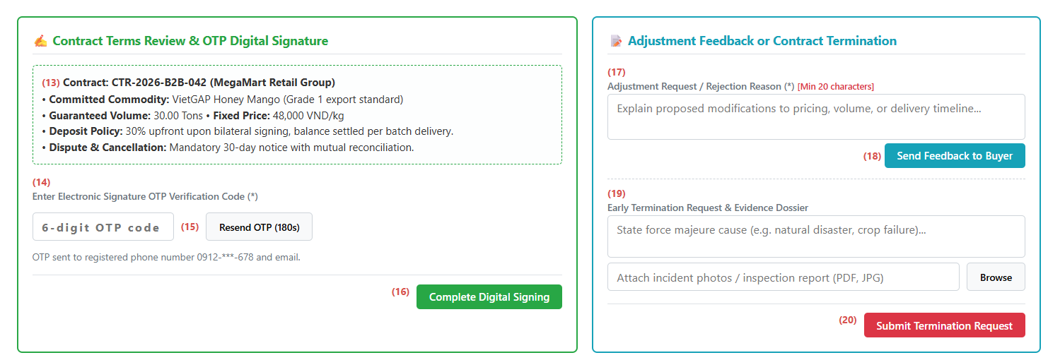
This screen allows the Farmer to:
- View and monitor all long-term agricultural offtake contracts with wholesale B2B corporate buyers, including committed volumes, pricing frameworks, deposit terms, and delivery schedules.
- Filter and search contracts by contract code, buyer enterprise name, tax code, commodity type, validity period, and contract status.
- Review detailed contractual terms, buyer legal credentials, guaranteed seasonal quantities, and payment milestones.
- Complete legally binding electronic contract signatures via two-factor OTP verification sent to registered contact channels.
- Reject contract proposals or request adjustments to price, delivery timeline, or deposit conditions by providing detailed feedback notes.
- Submit early contract termination requests with attached force majeure evidence and damage assessments for partner and administrative reconciliation.
Field Name | Description
(1) Search Contract or Buyer Input | Text box to search contracts by unique Contract Code, Buyer Company Name, or Tax Code.
(2) Contract Status Tabs | Navigation tabs filtering contracts by lifecycle status: All, Pending Signature, Signed / Active, Renegotiation Needed, and Pending Termination, complete with counter badges.
(3) Commodity Filter Dropdown | Dropdown list to filter contracts associated with a specific agricultural commodity.
(4) Contract Validity Range | Date pickers (From date – To date) filtering contracts according to execution timeline.
(5) Contract Ref & Date Display | Displays unique contract identifier and official proposal creation timestamp.
(6) Buyer Enterprise Information | Displays purchasing enterprise legal name, tax code, and buyer industry category.
(7) Commodity & Volume Display | Displays committed crop produce specifications and total guaranteed seasonal purchase tonnage.
(8) Price & Deposit Framework | Displays agreed fixed unit price framework and required advance deposit percentage along with calculated amount.
(9) Delivery Schedule Display | Displays committed delivery start and end schedule across the cultivation season.
(10) Contract Status Badge | Visual state indicator showing current contract status (Pending Signature, Signed / Active, Renegotiation Needed, or Pending Termination).
(11) Row Actions | Contextual actions:  • Review & Sign: Loads contract terms and prompts the digital signature panel.  • Request Adjustment: Opens the renegotiation feedback section.  • View Contract PDF: Downloads or previews the signed bilateral contract document.  • Request Termination: Opens the contract liquidation request section.
(12) Pagination Controls | Standard pagination buttons to navigate across contract pages.
(13) Contract Terms Summary Box | Structured text summary displaying verified buyer details, fixed prices, guaranteed volume, deposit clauses, and dispute terms.
(14) Electronic Signature OTP Input | Six-digit numeric input box to enter the time-sensitive one-time verification password. Mandatory field.
(15) Resend OTP Action | Trigger button with countdown timer (180 seconds) to request a new verification code if the previous code expires.
(16) Complete Digital Signing Button | Action button validating the entered OTP, recording electronic signature confirmation, updating contract status to Signed / Active, and notifying the buyer.
(17) Adjustment Reason Textarea | Multi-line text field to state proposed term adjustments or rejection grounds. Mandatory field with a 20-character minimum requirement.
(18) Send Feedback to Buyer Button | Action button updating status to Renegotiation Needed and transmitting change requests to the buyer enterprise.
(19) Termination Dossier & Evidence | Text field and file upload selector to record termination causes and attach supporting evidence photos or damage reports.
(20) Submit Termination Request Button | Action button updating contract status to Pending Termination, alerting the buyer enterprise and platform administrator for deposit and yield settlement.

11. B2B Contract Management

11.1 View Revenue and Cash-Flow Dashboard

11.1.1 Farmer Revenue & Analytics Screen
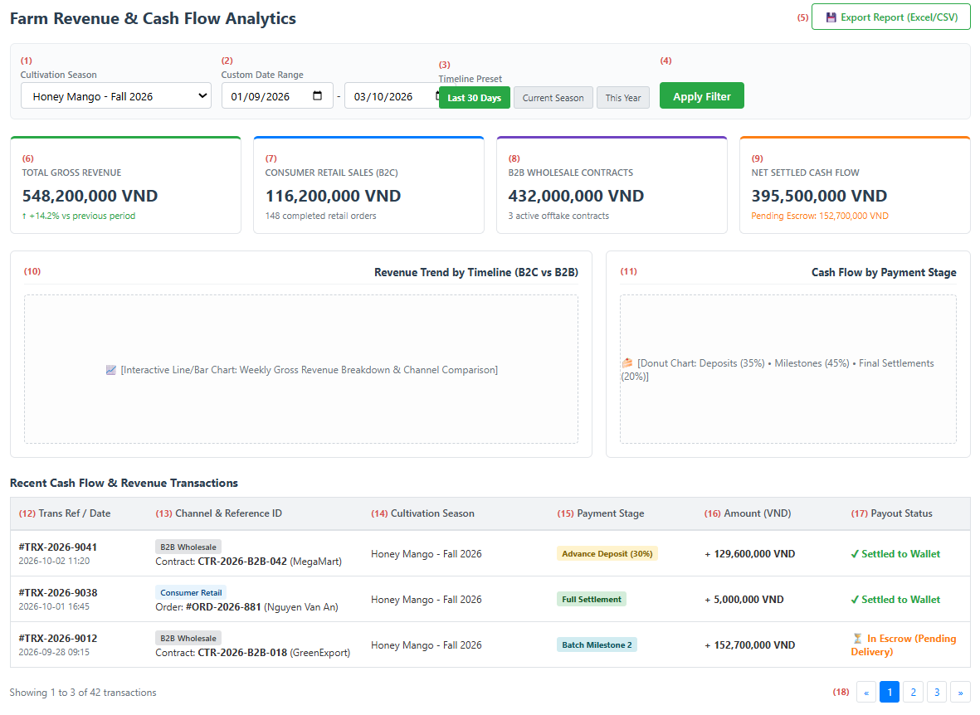
This screen allows the Farmer to:
- Monitor overall financial performance, gross revenue, and net settled cash flow across farming cycles.
- Track sales turnover broken down by consumer retail orders (B2C) and corporate wholesale offtake contracts (B2B).
- Filter revenue analytics and transaction histories by cultivation season, custom date intervals, or quick timeline presets.
- Analyze visual revenue distribution charts comparing monthly growth trends and cash flow allocations across payment stages (advance deposits, milestone installments, final settlements).
- Inspect detailed cash flow transaction ledgers with linked crop seasons, sales channels, order or contract references, and settlement statuses.
- Export structured revenue and transaction reports to Excel or CSV spreadsheets for financial auditing and farming expense planning.
Field Name | Description
(1) Cultivation Season Filter | Dropdown list to filter financial metrics and cash flow transactions by specific cultivation season. Default is All Seasons.
(2) Custom Date Range Selector | Date pickers (From date – To date) to filter financial data within a specific timeframe. Must ensure start date is prior to end date.
(3) Timeline Preset Buttons | Quick-selection buttons to switch between common reporting windows: Last 30 Days (default), Current Season, or This Year.
(4) Apply Filter Button | Executes dynamic calculation and updates KPI summary cards, visual charts, and transaction ledgers in real time.
(5) Export Report Button | Action button generating and downloading structured spreadsheet files (Excel/CSV) containing transaction ledgers and revenue breakdowns.
(6) Total Gross Revenue Card | Summary card displaying total cumulative sales revenue across all channels during the selected period.
(7) Consumer Retail Sales Card | Summary card displaying total sales turnover and completed order count generated through the consumer retail channel (B2C).
(8) B2B Wholesale Contracts Card | Summary card displaying contract turnover and active offtake contract counts generated through wholesale corporate buyers (B2B).
(9) Net Settled Cash Flow Card | Summary card displaying actual net cash disbursed to the farm wallet alongside funds currently held in platform escrow pending delivery.
(10) Revenue Trend Chart View | Visual graphical area displaying sales growth trajectories and channel comparisons over weekly or monthly intervals.
(11) Payment Stage Breakdown Chart | Visual chart illustrating percentage distribution across payment stages: advance deposits, delivery milestones, and final settlements.
(12) Trans Ref & Date Display | Displays unique system transaction reference code and recorded transaction timestamp.
(13) Channel & Reference ID | Displays sales channel classification (Consumer Retail or B2B Wholesale) along with linked order ID or offtake contract code.
(14) Cultivation Season Display | Displays the specific crop season associated with the transacted agricultural produce.
(15) Payment Stage Tag | Visual indicator showing the payment phase: Advance Deposit, Milestone Installment, or Full Settlement.
(16) Transaction Amount Display | Displays monetary value credited or deposited for the corresponding transaction.
(17) Payout Status Badge | Displays disbursement state: Settled to Wallet or In Escrow (held pending buyer receipt confirmation).
(18) Table Pagination Controls | Standard pagination buttons to navigate chronological financial transaction pages.

11.2 Create Offtake Contract Proposal

11.2.1 Offtake Contract Basic Information Screen
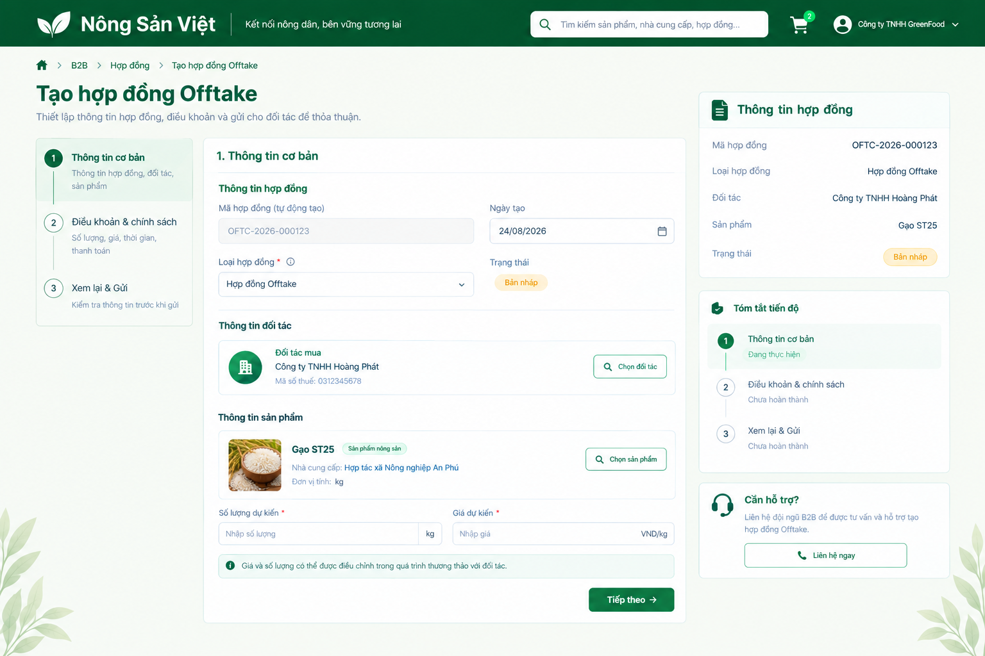
This screen allows the user to:
- Enter the basic information of an offtake contract proposal.
- Select a partner and an agricultural product.
- Specify the proposed quantity and unit price.
- Review the current proposal summary and continue to the terms and policies step.

Field Name | Description
Contract Creation Steps | Shows three stages: Basic Information, Terms and Policies, and Review and Send. Highlights the current stage.
Contract Code | Read-only text field containing the automatically generated contract identifier.
Creation Date | Date field displaying the proposal’s creation date in DD/MM/YYYY format. Includes a calendar control.
Contract Type | Required dropdown identifying the contract type. The illustrated selection is Offtake Contract.
Contract Status | Read-only badge showing the current proposal status. The illustrated initial status is Draft.
Partner Information | Displays the selected partner’s organization name and tax identification number.
Select Partner Button | Opens the partner-selection interface and updates the selected partner information.
Product Information | Displays the selected product’s image, name, category, supplier, and unit of measure.
Select Product Button | Opens the product-selection interface and updates the product information.
Proposed Quantity | Required numeric input. Must be greater than zero. Displays the selected product’s unit beside the input.
Proposed Unit Price | Required numeric input for the proposed price per unit. Must be greater than zero. Displays the currency and pricing unit, such as VND/kg.
Negotiation Notice | Read-only text explaining that the proposed price and quantity may be adjusted during negotiation.
Contract Summary | Read-only sidebar summarizing the contract code, type, selected partner, product, and current status.
Progress Summary | Shows the current stage and completion state of the remaining proposal-creation stages.
Contact Support Button | Opens the available B2B support channel for assistance with contract creation.
Next Button | Validates the required basic information and proceeds to the Terms and Policies stage while retaining the entered values.

11.3 Sign Offtake Contract

11.3.1 Offtake Contract Review and Approval Screen
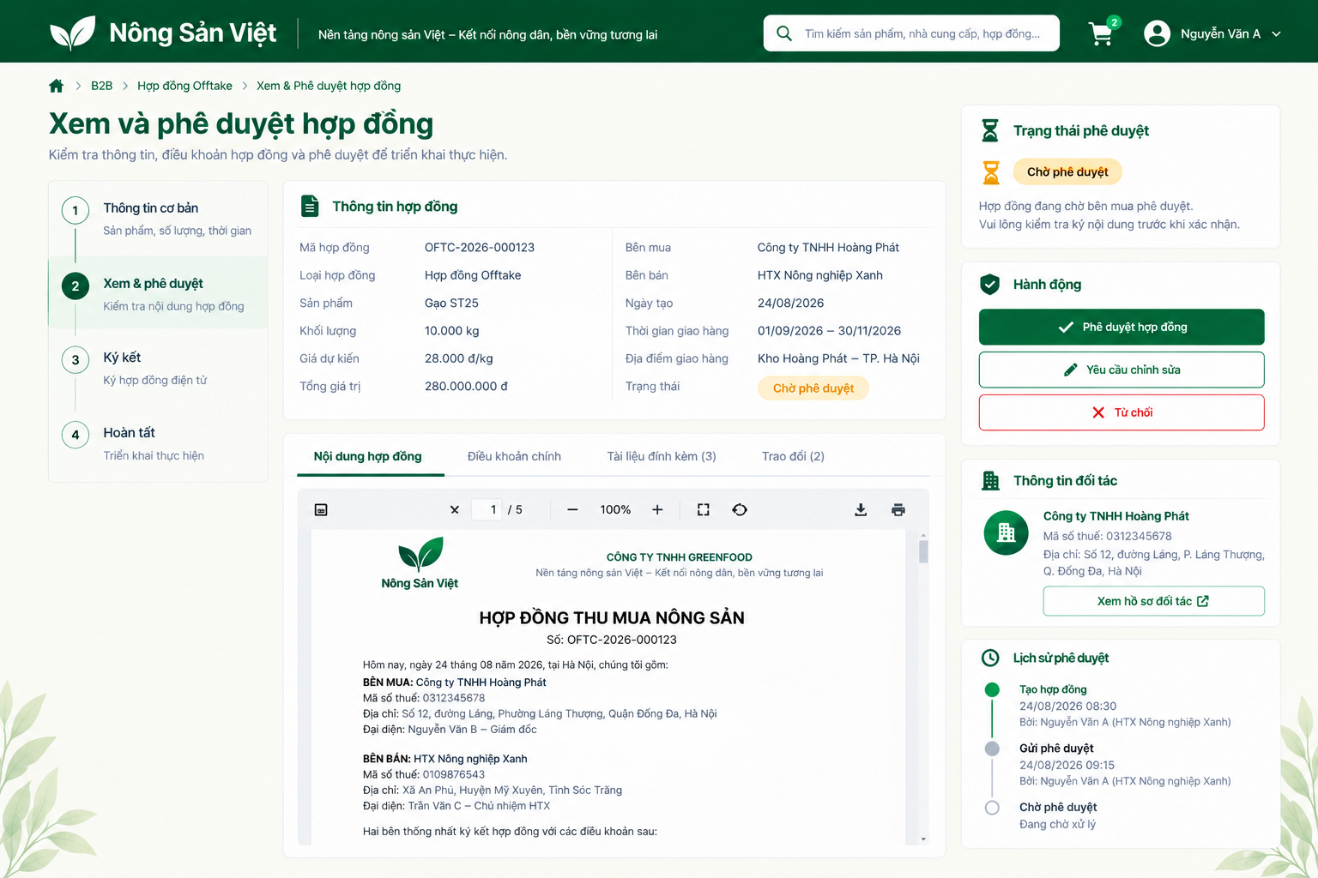
This screen allows the authorized contract party to:
- Review contract information, terms, attachments, and discussions.
- Read the contract document using the embedded document viewer.
- Approve the contract, request revisions, or decline the proposal.
- View partner information and approval history before proceeding to signing.

Field Name | Description
Contract Process Steps | Shows four stages: Basic Information, Review and Approval, Signing, and Completion. Highlights Review and Approval as the current stage.
Contract Identification | Read-only information showing the contract code and contract type.
Product and Quantity | Displays the contracted product and proposed quantity with its unit of measure.
Proposed Unit Price | Read-only monetary value showing the proposed price per product unit.
Total Contract Value | Read-only monetary value showing the proposed total contract amount.
Contract Parties | Displays the buyer’s and seller’s organization names.
Creation Date | Displays the contract creation date in DD/MM/YYYY format.
Delivery Period | Displays the proposed start and end dates of the delivery period.
Delivery Location | Displays the agreed or proposed delivery destination.
Contract Status | Read-only badge showing the current approval status.
Contract Content Tab | Opens the full contract document in the embedded viewer.
Main Terms Tab | Shows the principal terms of the selected contract.
Attachments Tab | Shows related contract documents. The tab label includes the number of attachments.
Discussion Tab | Opens contract-related exchanges between the parties. The tab label includes the number of discussion entries.
Document Viewer | Displays the contract document with page navigation, zoom, fullscreen, rotation, download, and print controls.
Approval Status Panel | Shows the current approval state and identifies the party whose confirmation is pending.
Approve Contract Button | Records approval by the authorized party and advances the contract toward the signing stage. Approval alone does not represent completion of electronic signing.
Request Revision Button | Initiates a request to amend the contract before approval.
Reject Button | Initiates rejection of the proposal, subject to the user’s authorization and the current contract state.
Partner Information | Read-only panel showing the partner’s organization name, tax identification number, and address.
View Partner Profile Button | Opens the selected partner’s profile.
Approval History | Displays a chronological list of contract events, including the action, date and time, responsible user, and current pending stage.

11.4 Track B2B Order and Contract Progress

11.4.1 Offtake Contract Management Screen
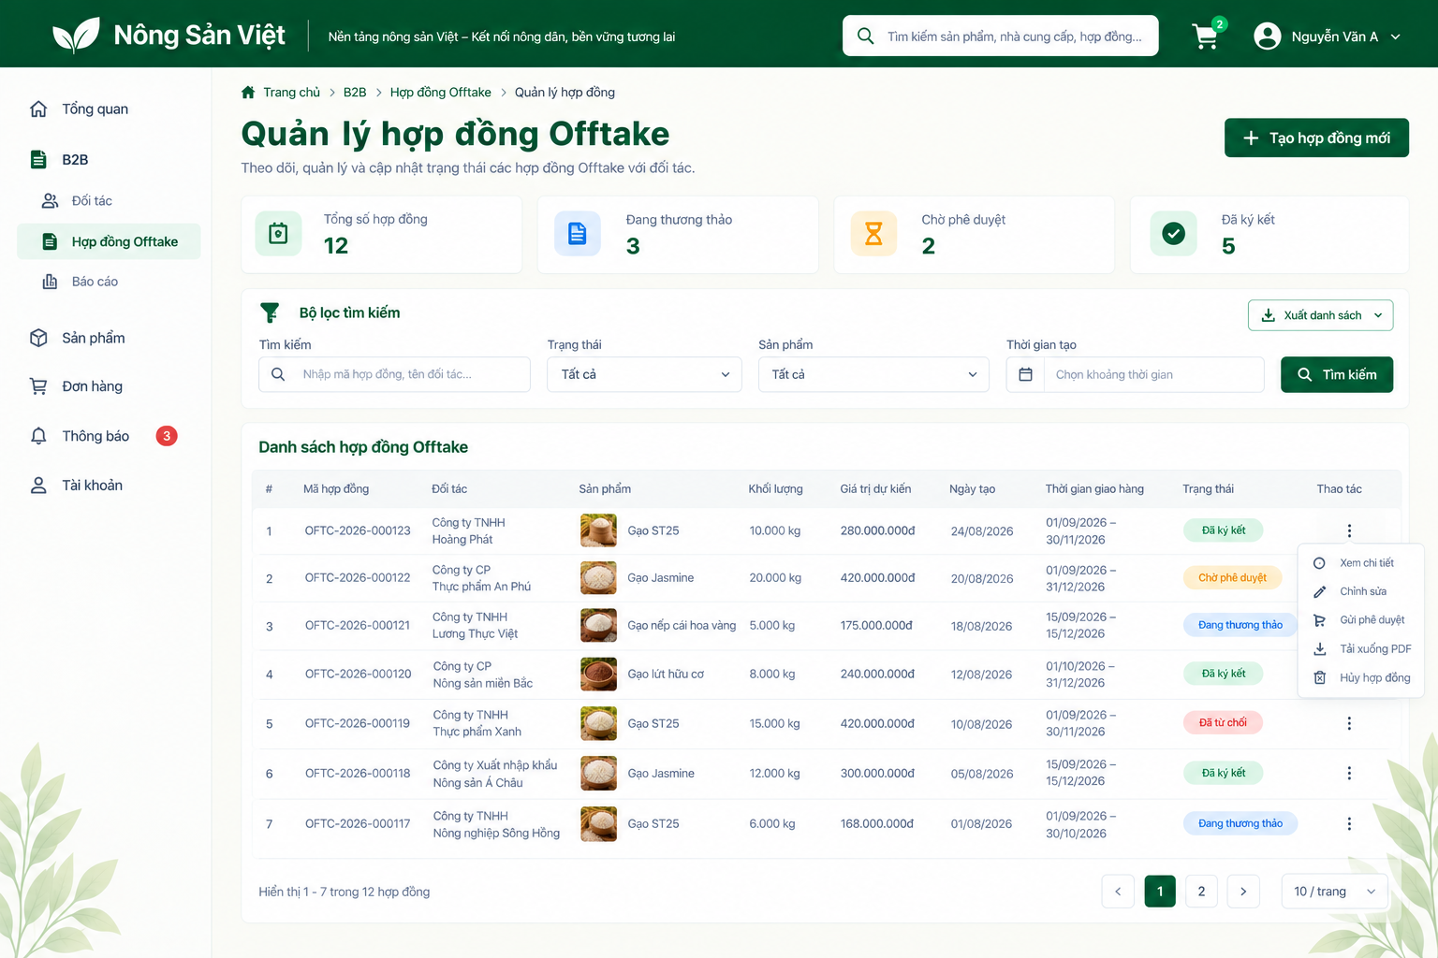
This screen allows the user to:
- View contract counts and current contract statuses.
- Search and filter contracts by keyword, status, product, and creation period.
- Review contract summaries and open individual contract details.
- Access available contract actions, export the list, and navigate between result pages.

Field Name | Description
Sidebar Navigation | Provides access to Overview, B2B Partners, Offtake Contracts, Reports, Products, Orders, Notifications, and Account. Highlights Offtake Contracts as the current section.
Create New Contract Button | Opens the offtake contract proposal creation workflow.
Total Contracts | Read-only summary card showing the total number of contracts accessible to the user.
Under Negotiation | Read-only summary card showing the number of contracts currently under negotiation.
Pending Approval | Read-only summary card showing the number of contracts awaiting approval.
Signed Contracts | Read-only summary card showing the number of signed contracts.
Search Keyword | Optional text input for searching by contract code or partner name. Initially empty.
Status Filter | Dropdown filtering contracts by status. Default: All. Statuses shown in the mockup include Under Negotiation, Pending Approval, Signed, and Rejected.
Product Filter | Dropdown filtering contracts by product. Default: All.
Creation Date Range | Optional date-range selector filtering contracts by creation date.
Search Button | Applies the entered keyword and selected filters to the contract list.
Export List Button | Opens the available export options for the contract list.
Contract List | Read-only table showing row number, contract code, partner, product image and name, quantity, estimated value, creation date, delivery period, status, and available actions.
Contract Status Badge | Uses a text label and color to identify each contract’s current status.
Actions Menu | Opens the selected contract’s contextual actions. Availability depends on user permissions and contract status.
View Details | Opens the selected contract’s details for further review and tracking.
Edit | Opens the editing workflow when changes are permitted for the selected contract.
Submit for Approval | Initiates submission of an eligible contract for partner approval.
Download PDF | Downloads the selected contract document in PDF format.
Cancel Contract | Initiates the contract-cancellation workflow when permitted.
Result Count | Displays the currently visible record range and the total number of matching contracts.
Pagination | Provides previous-page, next-page, and numbered-page controls.
Page Size | Dropdown controlling the number of contracts per page. The illustrated selection is 10 records per page.

12. B2B Procurement

12.1 Search Suppliers and Production Regions
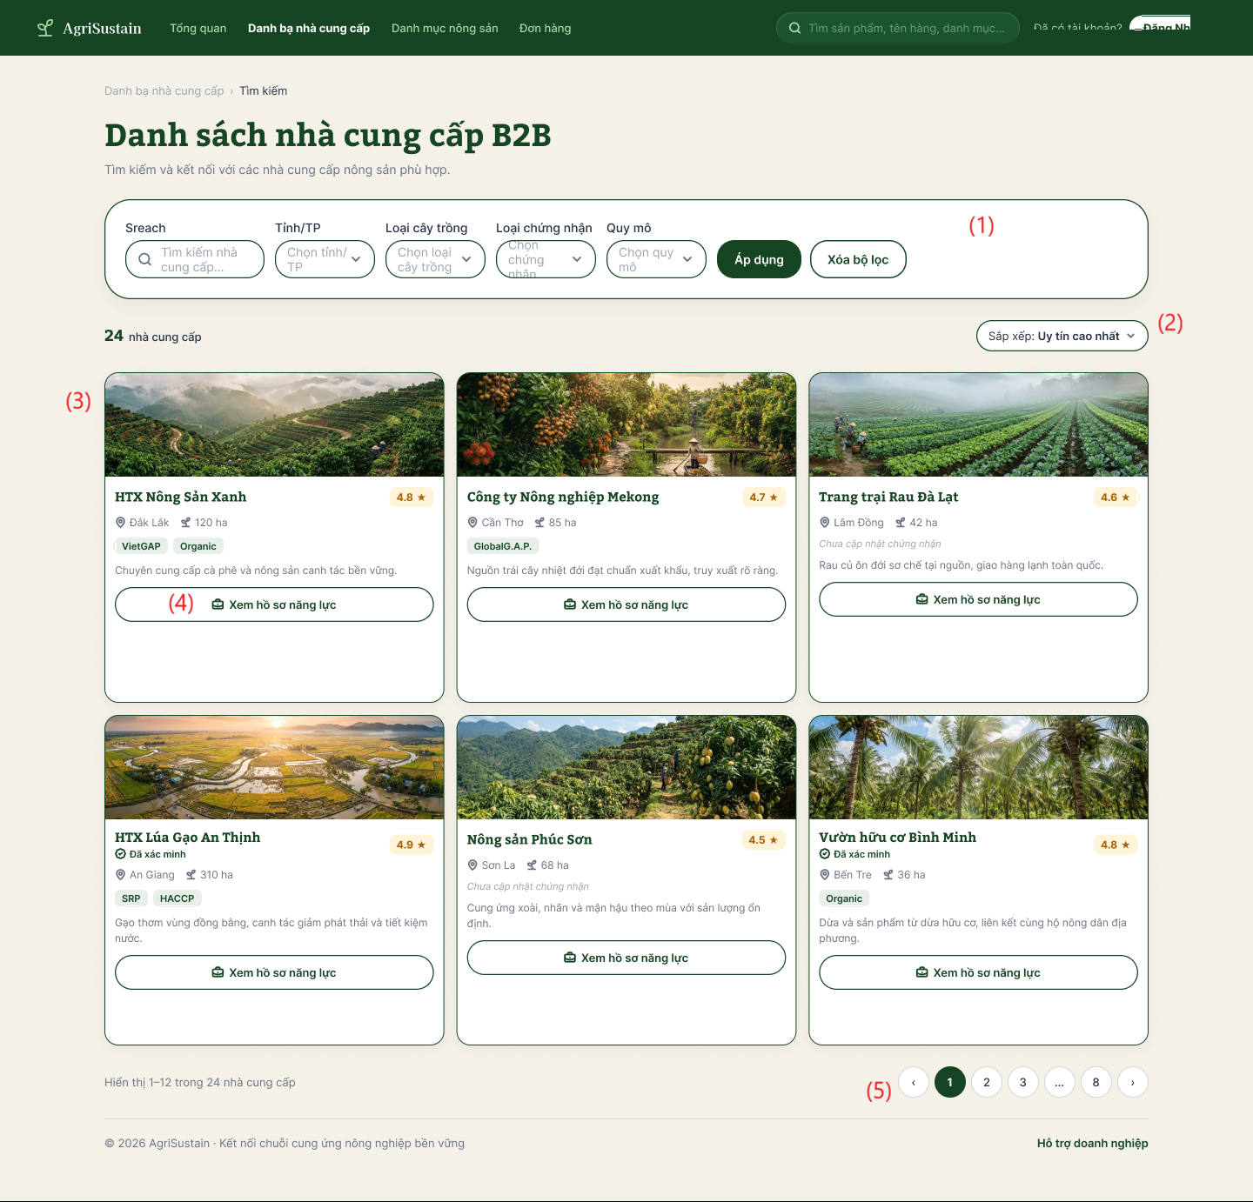

This screen allows the Buyer to:
- Search and Filter Suppliers: Filter agricultural suppliers by keywords, province/city, crop categories, certified quality standards (VietGAP, GlobalG.A.P., Organic), and cultivation scale.
- Apply and Reset Filters: Execute multi-criteria search queries or reset all active filter facets to default values.
- Sort Supplier Listings: Sort matching supplier cards by key reputation and operational metrics (e.g., Uy tín cao nhất / Highest reputation).
- Inspect Supplier Overview Cards: View summary metrics for each supplier, including farm banner, legal brand name, verification status, province, total farm area (ha), certification badges, and operational description.
- Navigate to Capacity Profile: Access comprehensive supplier capacity and production calendar dossiers via the dedicated profile action link.
- Paginate Directory Records: Navigate between pages of directory results using pagination controls.
Field Description Table
Field Name | Description
(1) Bộ công cụ tìm kiếm và lọc | Search and filter toolbar containing multiple criteria controls:  • Sreach (Tìm kiếm nhà cung cấp...): Keyword input textbox to search suppliers by farm or cooperative name.  • Tỉnh/TP: Dropdown selector to filter suppliers by geographical province or municipality (e.g., Đắk Lắk, Cần Thơ, Lâm Đồng).  • Loại cây trồng: Dropdown selector to filter by crop categories or agricultural specialties.  • Loại chứng nhận: Dropdown selector to filter suppliers holding specific credentials (VietGAP, GlobalG.A.P., Organic, HACCP).  • Quy mô: Dropdown selector to filter suppliers based on land area / production scale thresholds.  • Áp dụng: Action button executing the filter query combining all selected parameters.  • Xóa bộ lọc: Action button resetting all input fields and dropdowns to display the default supplier list.
(2) Sắp xếp (Dropdown) | Sorting selector allowing users to reorder the displayed supplier list (default: Sắp xếp: Uy tín cao nhất / Highest reputation score), with alternative options such as newest registration or largest cultivation scale.
(3) Thẻ nhà cung cấp | Summary supplier card displaying essential enterprise metrics:  • Ảnh đại diện / Banner: Landscape photograph showing the production farm or cultivation facility.  • Tên nhà cung cấp & Điểm đánh giá: Registered farm/cooperative name (e.g., HTX Nông Sản Xanh) with verification badge (Đã xác minh) and numerical trust rating (e.g., 4.8 ★).  • Địa bàn & Quy mô: Location and total active farmland area (e.g., Đắk Lắk · 120 ha).  • Huy hiệu chứng nhận: Badges highlighting verified quality credentials (e.g., VietGAP, Organic, GlobalG.A.P.).  • Mô tả ngắn: Brief introductory statement of farming specialties and supply capacity.
(4) Xem hồ sơ năng lực | Primary card action button. Redirects the user directly to the selected supplier's comprehensive Farm Capacity & Credibility Profile screen (SCR-18 / UC-B2B-02) to view crop calendars, expected seasonal yields, and initiate bulk procurement or offtake proposals.
(5) Thanh phân trang | Pagination control displaying the active page indicator (1), available page buttons (2, 3, ..., 8), and directional navigation arrows (<, >). Includes a result counter showing the range of items currently displayed (e.g., Hiển thị 1–12 trong 24 nhà cung cấp).

13. Certification

13.1 Submit Certificate Dossier
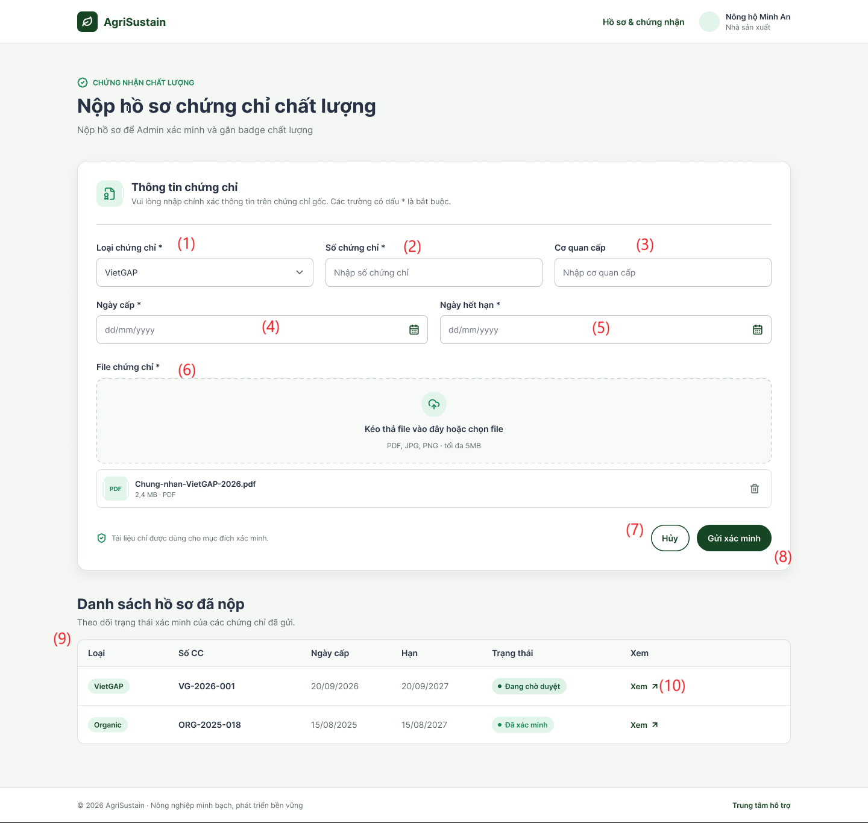
This screen allows the Farmer to:
- Select Certification Standard: Choose an accredited certification type from system-supported standards.
- Input Credential Metadata: Provide legal certificate identification numbers, issuing authorities, issue dates, and valid expiry dates.
- Upload Verification Dossiers: Attach scanned digital proofs or legal accreditation documents (PDF, JPG, PNG).
- Submit for Moderation: Dispatch the completed dossier to Administrators for formal verification and quality badge awarding.
- Monitor Dossier Status: Track active review stages (Đang chờ duyệt, Đã xác minh) and validity timeframes of previously submitted certificates.
- Inspect Uploaded Certificates: Open and review attached certificate documents directly from the submission ledger.

Field Description Table
Field Name | Description
(1) Loại chứng chỉ * | Dropdown selector allowing the Farmer to choose an accredited standard (e.g., VietGAP, GlobalG.A.P., Organic, OCOP). Mandatory field.
(2) Số chứng chỉ * | Text input box for entering the official legal accreditation number/code issued by the certification authority. Mandatory string; must be unique per certification type across the platform.
(3) Cơ quan cấp | Text input box for specifying the official issuing department, accreditation body, or quality assurance organization. Mandatory string.
(4) Ngày cấp * | Date picker input to specify the official issuance date of the certificate in dd/MM/yyyy format. Mandatory; cannot be set to a future date.
(5) Ngày hết hạn * | Date picker input to define the expiration date of the credential in dd/MM/yyyy format. Mandatory; must be set to a valid future date strictly occurring after the issue date.
(6) File chứng chỉ * | Drag-and-drop file upload zone supporting PDF, JPG, and PNG files up to 5 MB. Displays an uploaded file card with file name (e.g., Chung-nhan-VietGAP-2026.pdf), file size (e.g., 2.4 MB), and a trash bin icon to remove or replace the attached file.
(7) Hủy | Secondary action button. Discards unsaved edits, clears entered form controls, and reverts the view without creating a dossier record.
(8) Gửi xác minh | Primary action button. Validates all mandatory inputs, ensures unique certificate numbering, stores document files, transitions status to PendingReview (Đang chờ duyệt), and notifies platform Administrators.
(9) Danh sách hồ sơ đã nộp | Summary monitoring table displaying all submitted certificate dossiers owned by the Farmer, structured by columns: Standard Type (Loại), Certificate Number (Số CC), Issue Date (Ngày cấp), Expiry Date (Hạn), Verification Lifecycle (Trạng thái), and Inspection Link (Xem).
(10) Xem (Action) | Hyperlink action button with an external view icon that opens the uploaded proof document file in a new browser tab for preview and verification.

14. B2B Membership

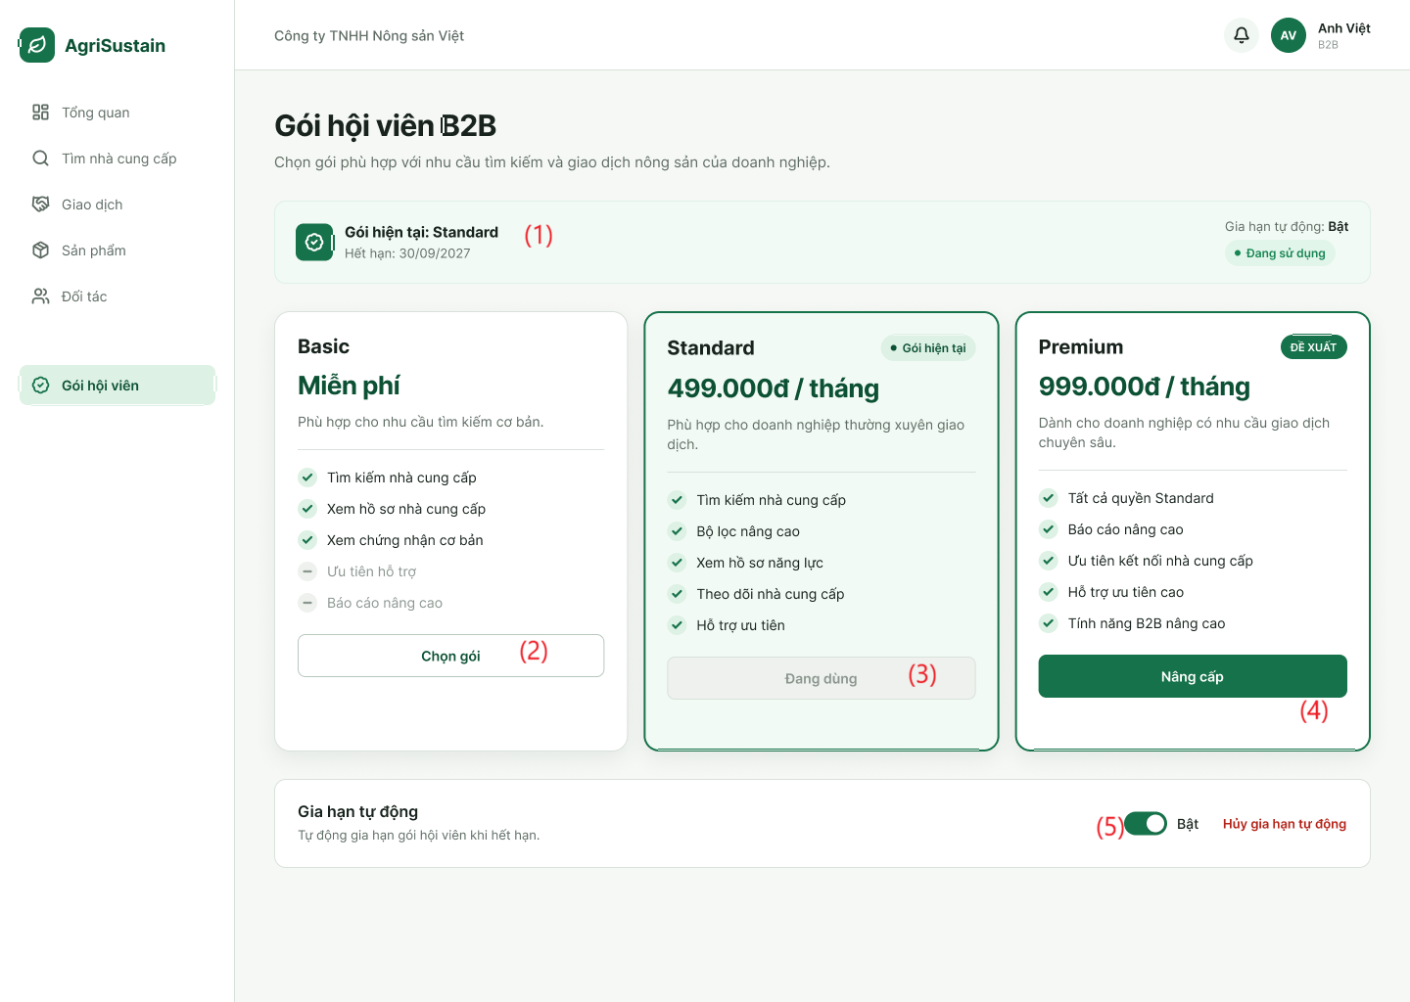

This screen allows the Buyer to:

- View Active Subscription Status: Monitor current membership tier, validity period, expiry date, and active status.
- Compare Subscription Tiers: Inspect pricing, billing frequency, and feature entitlements across available plans (Basic, Standard, Premium).
- Select or Upgrade Plan: Initiate plan upgrades or renewals to access expanded capabilities via PayOS / VietQR payment integration.
- Manage Auto-Renewal: Toggle automated periodic plan renewal on or off according to operational requirements.

Field Description Table
Field Name | Description
(1) Thẻ trạng thái gói hiện tại | Information card displaying the active membership status: current tier name (Gói hiện tại: Standard), expiration date (Hết hạn: 30/09/2027), operational badge (Đang sử dụng), and auto-renewal state indicator (Gia hạn tự động: Bật).
(2) Chọn gói | Primary action button on the entry-level tier (Basic - Miễn phí). Allows the Buyer to select or downgrade to the free plan offering standard search and basic certificate viewing without priority support or advanced reports.
(3) Đang dùng | Disabled status button indicating that the Standard tier (499.000đ / tháng) is the buyer's currently activated and operational plan.
(4) Nâng cấp | Primary action button on the top-tier plan (Premium - 999.000đ / tháng). Triggers an automated VietQR / PayOS payment flow to complete subscription purchase and activate premium B2B capabilities immediately upon transaction confirmation.
(5) Công tắc Gia hạn tự động | Interactive toggle switch control allowing the user to turn automatic billing renewal on or off (Bật / Tắt). Includes a contextual action link (Hủy gia hạn tự động) to stop recurring charges while retaining access benefits until the existing term expires.

15. Traceability
15.1 View Product Traceability
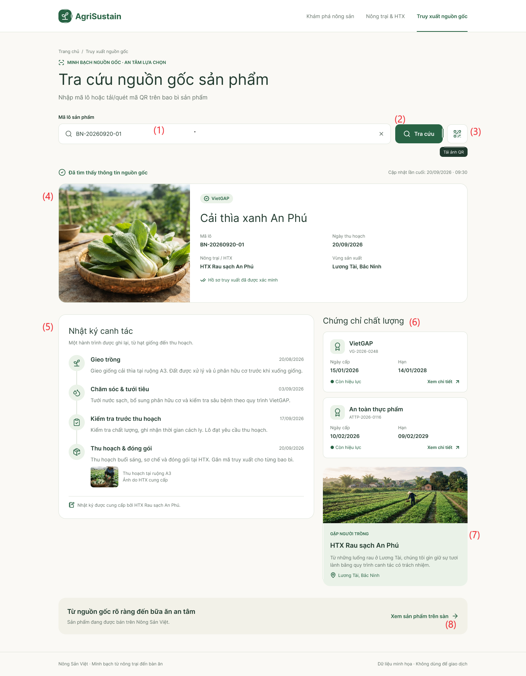

This screen allows the User to:

- Lookup Traceability Data: Search batch records by manually entering a batch identifier or scanning/uploading a physical packaging QR code.
- Inspect Batch Overview: View essential product metadata, batch number, harvest date, producer cooperative, and regional origin.
- Review Chronological Cultivation Logs: Track immutable day-to-day farming actions (sowing, watering, quality inspection, harvesting/packing) along with actual field photographs.
- Verify Safety Certifications: Inspect awarded credentials (VietGAP, Food Safety), validity periods, issuing codes, and open detailed accreditation documents.
- Review Farm Producer Information: View the supplying cooperative's profile, operational mission, and geographical production base.
- Navigate to Marketplace Listing: Access the public commercial listing on the e-commerce marketplace to purchase verified produce.

Field Description Table
Field Name | Description
(1) Ô nhập mã lô (Mã lô sản phẩm) | Search text input field allowing the user to enter a unique batch code (e.g., BN-20260920-01). Includes a clear icon (x) to quickly reset the input string.
(2) Tra cứu | Primary action button. Submits the entered batch code, queries backend traceability registries, increments the scan counter, and renders the corresponding origin timeline.
(3) Tải ảnh QR / Quét mã QR | Secondary action button with a QR icon. Opens the device camera to scan physical packaging QR codes or allows uploading a saved QR image file for decoding.
(4) Thẻ tổng quan sản phẩm & Lô hàng | Summary profile card displaying key produce attributes: produce photography, product title (e.g., Cải thìa xanh An Phú), verified standard badge (VietGAP), batch number (Mã lô), harvest date (Ngày thu hoạch), supplier cooperative (Nông trại / HTX), production region (Vùng sản xuất), and verification seal (Hồ sơ truy xuất đã được xác minh).
(5) Nhật ký canh tác | Vertical interactive timeline displaying sequential, immutable farming activities:  • Stage titles and dates (e.g., Gieo trồng, Chăm sóc & tưới tiêu, Kiểm tra trước thu hoạch, Thu hoạch & đóng gói).  • Technical activity notes (seed varieties, organic fertilizer applications, isolation/withdrawal periods).  • On-site proof photographs provided by the producer.
(6) Chứng chỉ chất lượng | Dedicated accreditation panel listing verified credentials:  • Certificate badges (VietGAP, An toàn thực phẩm) with registration code (e.g., VG-2026-0248).  • Effective dates (Ngày cấp, Hạn) and active validity status badges (Còn hiệu lực).  • External action link (Xem chi tiết ↗) to open official certification documents.
(7) Gặp người trồng (Thông tin HTX) | Producer background card showing the cooperative brand name (e.g., HTX Rau sạch An Phú), sustainable cultivation commitment, representative field photo, and facility location (Lương Tài, Bắc Ninh).
(8) Xem sản phẩm trên sàn | Navigation hyperlink leading directly to the official product sales listing on the AgriSustain Marketplace (SCR-03 / UC-MKT-02), enabling users to purchase verified batches.

12. Background Job Inventory

12.1 Expire Password Reset Tokens (JOB-01)
Trigger: Scheduled — Runs every 15 minutes.
Purpose: Invalidate expired password-reset OTPs and security tokens across the platform to mitigate brute-force and token replay vulnerabilities.
Processing steps:
- Query active token records / OTP verification caches where expiration timestamp < CurrentTimestamp().
- Transition matching tokens/OTPs to Expired or remove unconsumed transient session tokens.
- Log the total number of invalidated tokens per execution cycle.

Failure behavior:
Scenario | System behavior
Database / Cache timeout | Write an error log and retry upon the next 15-minute scheduled run.
No expired tokens found | Complete execution cleanly with zero modifications.

12.2 Auto-Cancel Unpaid Retail Orders (JOB-02)
Trigger: Scheduled — Runs every 30 minutes.
Purpose: Automatically cancel retail orders that remain unpaid beyond the configured payment time limit (e.g., 15–30 minutes) and restore reserved batch inventory to ensure active stock availability.
Processing steps:
- Scan the Orders table for records where OrderType = 'Retail', OrderStatus = 'PendingPayment', and elapsed time exceeds the allowed checkout window.
- For each identified order within an atomic transaction:
  - Update OrderStatus to 'Cancelled'.
  - Read ordered items from OrderItems and restore QuantityAvailable back into the respective ProductBatches.
  - Log transaction detail in FinancialTransactions or audit history.
  - Enqueue a notification to Notifications informing the Consumer of order expiration.
- Commit the transaction and log the count of cancelled orders and restocked quantities.
Failure behavior:
Scenario | System behavior
Stock rollback or database transaction error | Roll back the affected order transaction, write an error log with contextual IDs (OrderID), and proceed to the next record. Failed orders are evaluated on the next run.
No unpaid expired orders found | Terminate successfully without action.

12.3 Reconcile Payment Status (JOB-03)
Trigger: Scheduled — Runs every 15 minutes.
Purpose: Re-check and reconcile pending VietQR / PayOS payment transactions when inbound payment webhooks are delayed, dropped, or network-interrupted.

Processing steps:
- Query Orders and FinancialTransactions where PaymentMethod IN ('VietQR', 'PayOS'), OrderStatus = 'PendingPayment', and creation time is between 5 and 60 minutes ago.
- Call the VietQR/PayOS query transaction status API using GatewayTransactionRef or Order Code.
- If payment gateway returns PAID:
  - Update transaction status to Success.
  - Update Orders.OrderStatus to 'Paid'.
  - Dispatch an order payment confirmation alert to the Consumer and Farmer.
- If payment gateway returns FAILED or EXPIRED:
  - Mark transaction as Failed.
  - Trigger cancellation and inventory release logic.

Failure behavior:
Scenario | System behavior
Payment Gateway API unreachable | Log gateway communication failure and retry during the next 15-minute window.
Order already reconciled via Webhook | Skip processing gracefully to prevent duplicate updates.

12.4 Pre-Order Campaign Status Update (JOB-04)
Trigger: Scheduled — Runs every hour.
Purpose: Automatically activate, close, or mark agricultural pre-order campaigns as completed based on configured start times, end times, target capacity limits, and campaign rules.
Processing steps:
- Query pre-order campaign entities and associated CropSeasons:
  - Activate campaigns scheduled to start (StartTime <= CurrentTimestamp()) whose status is Scheduled.
  - Close campaigns where EndTime <= CurrentTimestamp() or reserved volume reaches maximum campaign capacity.
  - Mark campaigns as completed once harvest fulfillment commences or status updates to Harvested.
- Update campaign status flags and restrict public pre-order cart submissions for closed/completed campaigns.
- Notify relevant Farmers regarding campaign status changes and final committed quantities.
Failure behavior:
Scenario | System behavior
Database write lock | Retry query up to 3 times before raising an alert to the platform monitoring system.
No campaign transitions required | Complete the cycle immediately.

12.5 Contract Milestone Reminder (JOB-05)
Trigger: Scheduled — Runs daily at 8:00 AM.
Purpose: Notify B2B Buyers and Farmers about upcoming, due, or overdue B2B offtake contract milestones (e.g., scheduled harvest inspections, consignment dispatch dates, payment tranches).
Processing steps:
- Query OfftakeContracts with status 'Active' and retrieve milestone schedules matching notification thresholds (e.g., 3 days before milestone, day of milestone, or overdue).
- Compose contextual alerts outlining milestone title, contract code, due date, and expected obligations.
- Insert dispatched records into Notifications for both Buyer and Farmer accounts, and trigger external email notifications where configured.

Failure behavior:
Scenario | System behavior
Notification service failure | Record failed alert entries for resolution by the notification retry worker.

12.6 Clean Up Old Notifications and Activity Logs (JOB-06)
Trigger: Scheduled — Runs daily at 8:00 AM.
Purpose: Alert B2B Buyers prior to membership subscription expiration (e.g., 7 days and 1 day prior) and automatically update expired subscription statuses upon term completion.
Processing steps:
- Identify records in BuyerSubscriptions where Status = 'Active' and EndDate <= CurrentDate() + 7 days.
- For subscriptions nearing expiry: Dispatch renewal reminder alerts to the Buyer's account and email.
- For subscriptions where EndDate < CurrentDate():
  - If AutoRenew = false: Update Status to 'Expired' and downgrade account tier entitlements (e.g., restricting access to MarketReports).
  - If AutoRenew = true: Enqueue recurring payment processing; if recurring charge fails, flag status as Expired.

Failure behavior:
Scenario | System behavior
Query Concurrency update conflicts | Reload subscription state, log exception, and retry for remaining buyer accounts.

12.7 Certificate Expiry Monitoring (JOB-07)
Trigger: Scheduled — Runs daily at 8:00 AM.
Purpose: Identify quality and safety certificates (VietGAP, GlobalGAP, Organic) nearing expiry (30 days prior) or already expired, and notify Farmers and Administrators while demoting unverified product badges.
Processing steps:
- Scan Certifications where VerificationStatus = 'Verified'.
- For certificates where ExpiryDate <= CurrentDate() + 30 days and ExpiryDate >= CurrentDate(): Dispatch upcoming expiration reminders to the Farmer.
- For certificates where ExpiryDate < CurrentDate():
  - Transition certificate VerificationStatus to 'Expired'.
  - Identify products linked to the owner's FarmerID and unpublish/suppress verified certification badges on the Marketplace.
  - Notify the Farmer and platform Administrator regarding certification deactivation.

Failure behavior:
Scenario | System behavior
Batch update error | Reload subscription state, log Roll back active record batch, log failure metadata, and retry during the subsequent cycle. , and retry for remaining buyer accounts.

12.8 Pending KYC Review Reminder (JOB-08)
Trigger: Scheduled — Runs daily at 8:00 AM.
Purpose: Consolidate and notify platform Administrators of all Consumer, Farmer, or Buyer accounts currently pending legal/KYC document approval.
Processing steps:
- Query Accounts joined with Buyers and Farmers where Status = 'Pending' and KYC verification documents have been submitted.
- Count pending items by role and duration in queue (> 24 hours, > 48 hours).
- Dispatch high-priority summary notifications and internal emails to platform Administrators with a direct navigation link to the KYC Application Review workspace.
Failure behavior:
Scenario | System behavior
Zero pending KYC applications | Exit execution without sending notifications.

12.9 Notification Delivery Retry (JOB-09)
Trigger: Scheduled — Runs every 15 minutes.
Purpose: Resend failed in-app, system, or email notifications (e.g., Google Gmail API outages or network glitches) to guarantee message delivery.
Processing steps:
- Query Notifications and email dispatch queues where DeliveryStatus = 'Failed' and RetryCount < 3.
- Attempt re-dispatching messages via the respective delivery channel (e.g., Google Gmail API for external alerts).
- On success: Update status to 'Sent', record dispatch timestamp, and reset error code.
- On failure: Increment RetryCount by 1. If RetryCount >= 3, mark status as 'PermanentFailure' and write to system error logs.
Failure behavior:
Scenario | System behavior
Notification provider continues to fail | Abort active loop after sequential rate limit errors; retain messages in queue for next interval.

12.10 Archive Old Audit and Activity Logs (JOB-10)
Trigger: Scheduled — Runs monthly on the 1st at 2:00 AM.
Purpose: Archive or clean up historical system audit records, activity logs, and read notifications according to the platform’s data-retention policy (e.g., records older than 180 days) to optimize operational database indexing and query performance.
Processing steps:
- Load configured retention cutoff threshold (e.g., CurrentDate() - 180 days).
- Export historical activity logs and read Notifications (IsRead = true) older than the cutoff threshold to compressed cold storage or dedicated archival tables.
- Delete archived records in controlled batches (e.g., 5,000 rows per batch) to prevent table locks and minimize CPU load.
- Record the final count of archived entries in system maintenance telemetry.
Failure behavior:
Scenario | System behavior
Long-running query timeout | Abort current batch safely, log progress checkpoint, and allow remaining items to be processed in the next scheduled execution.

13. External API Inventory

13.1 PayOS / VietQR Webhook (API-01)
URL | POST: /api/v1/payments/webhook/payos
Purpose | Ingest Instant Payment Notifications (IPN) from the PayOS/VietQR payment gateway upon successful QR transfer; transition order state to Paid and record transactional history.
Caller | PayOS Gateway System.
Auth | HMAC-SHA256 signature verification via the x-payos-signature request header.

13.2 Gmail Notification Service API (API-02)
URL | POST: [https://gmail.googleapis.com/gmail/v1/users/me/messages/send](https://gmail.googleapis.com/gmail/v1/users/me/messages/send)
Purpose | Dispatches account verification OTP codes, order confirmations, password reset requests, and bilateral offtake contract signing notifications via Google Gmail
Caller | AgriSustain backend system
Auth | Google OAuth 2.0 (Service Account / Access Token with [https://www.googleapis.com/auth/gmail.send](https://www.googleapis.com/auth/gmail.send) scope)

IV. Non-Functional Requirements

1. External Interfaces

No. | External Interface | Description | Users / External System | Communication / Format
1 | Web User Interface | Provides a web interface for users to interact with the system, including registration, login, product browsing, ordering, product management, and administration. | Guest, Buyer, Seller, Admin | Web Browser, HTTPS
2 | RESTful API Interface | Receives requests from the frontend, processes requests through the backend, and returns results to the client. | Web Client ↔ Backend | REST API, HTTPS, JSON
3 | Database Interface | Stores and retrieves system data such as users, products, orders, farm information, traceability records, reviews, and complaints. | Backend ↔ Database | Database connection
4 | Payment Gateway Interface | Communicates with an external payment service to process online payments and receive payment results. | Buyer ↔ Payment Gateway | HTTPS, JSON
5 | QR Code Interface | Allows the system to generate QR codes for traceability and allows users to access product origin information by scanning the QR code. | Seller, Guest, Buyer | QR Code, URL, HTTPS
6 | Transportation Interface | Represents the interaction with a third-party transportation service for updating delivery status. The project uses a simulated transportation process rather than real-time transportation tracking. | Seller ↔ Carrier Service | System status update
7 | File Upload Interface | Allows users to upload supporting documents such as farm certificates and product quality or biochemical test results. | Seller, Admin | File Upload
8 | Authentication Interface | Provides communication between the client and backend for user authentication, authorization, login, logout, and password management. | Buyer, Seller, Admin | HTTPS, REST API, JSON

2. Quality Attributes

2.1 Usability
This section specifies the usability requirements of the AgriSustain system. The system shall provide a simple, consistent, and user-friendly interface so that Consumer, Farmer, Buyer B2B, and Administrator can perform their tasks efficiently with minimal training.

ID | Usability Requirement | Description / Measurement
USA-01 | Simple and Consistent Interface | The system shall provide a consistent layout, navigation structure, terminology, buttons, icons, and interaction behavior across all screens.
USA-02 | Role-based Interface | The system shall display functions and menus according to the user's role. Consumer, Farmer, Buyer B2B, and Administrator shall only see functions relevant to their permissions.
USA-03 | Easy Navigation | Users shall be able to navigate from the Home Page to major functions such as Marketplace, Product Details, Cart, Orders, Profile
USA-04 | Clear Input Forms | Input forms shall provide clear field labels, placeholders, required-field indicators, and appropriate validation messages. Users shall be informed about the expected input format before submitting a form.
USA-05 | Error Prevention and Feedback | The system shall validate user input before processing and display clear, understandable error messages when invalid information is entered. Error messages shall identify the problem and, where possible, explain how to correct it.
USA-06 | Operation Confirmation | The system shall provide a confirmation message after important successful operations such as registration, login, product submission, order placement, payment, and password change.
USA-07 | Destructive Action Confirmation | Before performing potentially destructive actions such as deleting a product, cancelling an order, rejecting a product, or delisting a product, the system shall request user confirmation.
USA-08 | Responsive Design | The web interface shall be responsive and usable on desktop, tablet, and mobile browser screen sizes without requiring horizontal scrolling for normal operations.
USA-09 | Traceability Accessibility | Guest and Buyer shall be able to access product traceability information by scanning the product QR code and viewing the corresponding information through a simple interface.
USA-10 | Search and Filtering | Users shall be able to search and filter agricultural products using clearly identified search fields and filtering options. Search results shall be presented in an easy-to-understand format.
USA-11 | Readable Content | Text, labels, buttons, and notifications shall use clear and understandable language. Important information such as product price, quantity, order status, and traceability information shall be visually distinguishable.
USA-12 | Help and Guidance | The system shall provide contextual guidance, placeholders, validation messages, or instructions when users need additional information to complete a task.

2.2 Performance
The performance requirements of the AgriSustain system are specified below. The system shall provide responsive interactions and maintain stable performance when multiple users access the system.
Requirement | Target | Condition
Page Load Time | Any standard page shall load within 2 seconds | Up to 100 concurrent active users
Form Submission Response | The system shall acknowledge a valid form submission within 2 seconds | Up to 100 concurrent active users
Search Response Time | Product search and filtering results shall be returned within 2 seconds | Up to 100 concurrent active users
Product Details Response | Product details shall be displayed within 2 seconds after the request | Up to 100 concurrent active users
QR Traceability Response | Traceability information shall be displayed within 3 seconds after a valid QR request | Normal network conditions and up to 100 concurrent active users
Maximum Simultaneous Users | The system shall remain functional for up to 100 concurrent users | Single-server deployment
System Availability | The system shall be available during the project's defined operating period with minimal unexpected downtime | Normal operating conditions

2.3 Security
The security requirements of the AgriSustain system are specified below. The system shall protect user accounts, personal information, product data, order information, and administrative functions from unauthorized access or modification.
Requirement | Description
Authentication Required | All protected pages and actions shall require the user to be signed in. Public functions such as the Marketplace, product details, and publicly available traceability information may be accessed without authentication where permitted.
Role-based Access Control | The system shall restrict functions according to the user's role. Consumer, Farmer, Buyer B2B, and Administrator shall only access functions permitted for their respective roles.
Password Protection | User passwords must never be stored in a form that can be directly read by a person or program.
Session Security | Authenticated sessions shall be protected from unauthorized use. After logout or session expiration, the user shall no longer be able to access protected functions using the previous session.
Account Status Control | Inactive or blocked accounts shall not be allowed to access authenticated system functions.
Authorization Check | The system shall verify that the authenticated user has permission to perform a requested action before allowing access to protected resources or functions.
Personal Information Protection | Personal information such as name, phone number, email address, and address shall only be accessible to users with appropriate permission.
Product Data Protection | Only authorized Farmers and Administrators shall be allowed to create, modify, approve, reject, or remove product information according to their permissions.
Payment Information Protection | Payment-related information shall only be accessible to authorized users and systems involved in the payment process.
Input Validation | User-provided data shall be validated before being accepted by the system to prevent invalid or unauthorized data from being processed.

V. Requirement Appendix
[Provide business rules, common requirements, or other extra requirements information here]

1. Business Rules

GBR-ID | Rule Statement | Applies To | Rationale | Enforced By
GBR-01 | Each account shall have exactly one assigned system role. A user cannot access functions outside their assigned role permissions. | All accounts and protected functions | Ensures role-based access control. | The system on every authorization request
GBR-02 | Only accounts with Active (Approved) status may sign in and use protected system functions. | Sign-in and authenticated functions | Prevents unapproved, rejected, or suspended accounts from accessing the system. | The system on every sign-in and authorization request
GBR-03 | A suspended account cannot sign in, even when its credentials are correct. | Sign-in | Enables immediate restriction of accounts violating platform policies. | The system on every sign-in attempt
GBR-04 | The system shall not reveal whether an email address exists or whether an incorrect password was entered during a failed sign-in attempt. | Sign-in | Prevents account-enumeration attacks. | The system on every failed sign-in attempt
GBR-05 | When consecutive failed sign-in attempts reach the configured limit, the system temporarily locks the account and resets the failed-attempt counter only after a successful unlock. | Account security | Protects accounts against password-guessing attacks. | The system automatically; Administrator through Unlock Account Action
GBR-06 | An Administrator cannot suspend, reactivate, or unlock their own account. | User Management | Prevents administrators from accidentally removing their own administrative access. | The system when executing account actions
GBR-07 | Every account-status change must require a reason and must be recorded with the acting Administrator, date/time, previous status, and new status. | User Management | Maintains accountability and supports audit investigation. | The system when an Administrator changes account status
GBR-08 | Legal verification information shall only be visible to authorized Administrators and verification-related roles. | KYC and account verification | Protects personal and organizational information. | The system on every data-access request
GBR-09 | A product category name must be unique within its parent category. | Product Category Management | Avoids duplicate and confusing product classifications. | The system when creating or updating a category
GBR-10 | A category containing active products cannot be deleted. It must first be made inactive or its products must be reassigned. | Product Category Management | Prevents orphaned products and preserves catalogue consistency. | The system when deleting a category
GBR-11 | Only Farmers with an active and approved account may create, publish, update, or manage their product listings. | Farmer Product Management | Ensures products originate from eligible sellers. | The system on every listing-management request
GBR-12 | Product price, available quantity, unit of measure, and origin information must be provided before a product can be published. | Product Listing | Ensures consumers receive sufficient and reliable product information. | The system when publishing a product
GBR-13 | A Consumer may only add available products to the shopping cart. The system shall revalidate product availability and current prices before an order is placed. | Shopping Cart and Retail Checkout | Prevents orders for unavailable products or outdated prices. | The system when adding items and placing an order
GBR-14 | An order shall be created only after the Consumer confirms the checkout information, including delivery address, delivery method, and payment method. | Retail Checkout | Ensures the order contains sufficient fulfilment information. | The system when placing an order
GBR-15 | When a retail order is successfully created, the system shall reserve the ordered quantities and remove the ordered items from the Consumer’s shopping cart. | Retail Checkout and Order Processing | Prevents overselling and duplicate ordering. | The system when creating an order
GBR-16 | If payment is not completed before the payment-reservation expiry time, the system shall cancel the pending-payment order and release the reserved quantities. | Payment and Order Processing | Returns inventory to sale when payment is abandoned. | The system through scheduled background processing
GBR-17 | A voucher may be applied only when it is active, within its valid period, has remaining usage quota, and satisfies its minimum-order conditions. | Retail Checkout | Prevents invalid or excessive voucher use. | The system when applying a voucher and placing an order
GBR-18 | A traceability QR code must refer to one identifiable product batch and must not be reassigned to another batch. | QR Traceability | Maintains the integrity of product-origin information. | The system when generating or updating batch traceability data
GBR-19 | Only a Consumer with a completed order may submit a review for products included in that order. A Consumer may submit only one review per order line. | Product Reviews | Ensures reviews are based on actual purchases and limits spam. | The system when submitting a review
GBR-20 | Administrators may suspend content, products, or accounts that violate platform policies; the suspension reason must be recorded. | Administration and Moderation | Supports policy enforcement and auditability. | Authorized Administrator through moderation functions
GBR-21 | The current password must be verified before a password change is accepted. The new password must satisfy the configured password policy and must be different from the current password. | Authentication and Account Security | Prevents unauthorized password changes and maintains account security. | The system when processing a password-change request
GBR-22 | Only products that are approved and available for public display may appear in Marketplace browsing and search results. | Marketplace and Product Catalogue | Prevents unapproved or unavailable products from being exposed to users. | The system when retrieving Marketplace products
GBR-23 | Product details may be publicly displayed only when the selected product is approved and available for public viewing. | Marketplace and Product Details | Ensures users only access valid public product information. | The system when retrieving product details
GBR-24 | A complaint may only be submitted for an order belonging to the authenticated Consumer and within 48 hours after the order status changes to Delivered. | Consumer Complaints and Order Disputes | Prevents unauthorized or late complaints and ensures complaints follow the dispute policy. | The system when submitting a complaint
GBR-25 | Only an approved Buyer B2B account may create or negotiate an offtake contract proposal. The proposal must contain the required quantity, price framework, delivery terms, and validity period. | B2B Contract Management | Ensures contract proposals originate from eligible Buyers and contain sufficient commercial terms. | The system when creating an offtake proposal
GBR-26 | Only parties authorized for the selected offtake contract may sign or confirm it, and signing is permitted only when the contract is in an eligible signing state. | B2B Contract Signing | Prevents unauthorized or invalid contract confirmation. | The system when processing a contract signing action
GBR-27 | An offtake contract becomes executed only after the required parties have completed their signing or confirmation actions. | B2B Contract Signing | Ensures that a contract is not treated as formally executed before agreement is confirmed. | The system when updating contract signing status
GBR-28 | A Buyer B2B may view fulfillment information only for contracts and B2B orders associated with that Buyer account. Tracking is read-only and shall not modify contract, delivery, or invoice data. | B2B Fulfillment Tracking | Protects business information and prevents tracking functions from altering transactional records. | The system when retrieving B2B fulfillment information

2. System Messages

# | Message code | Message Type | Context | Content
1 | MSG01 | In line | There is not any search result | No search results.
2 | MSG02 | In red, under the text box | Input-required fields are empty | The * field is required.
3 | MSG03 | In line | Input Email/Password are correct but email has not been verified | Please verify your email before logging in.
4 | MSG04 | In red, under text box | Current password is incorrect | The current password you entered is incorrect. Please try again.
5 | MSG05 | In red, under text box | Password confirmation does not match | Passwords do not match.
6 | MSG06 | In red, under text box | New password does not satisfy password policy | Password does not meet the required security criteria.
7 | MSG07 | Toast message | Password update failed | An error occurred while changing your password. Please try again later.
8 | MSG08 | In red, under the text box | Input value length > max length | Exceed max length of {max_length}.
9 | MSG09 | In line | Username or password is not correct when clicking sign-in | Incorrect user name or password. Please check again.
10 | MSG10 | In line | Account is inactive or suspended | Your account is inactive or blocked. Please contact the administrator.
11 | MSG11 | Toast message | Password updated successfully | Password updated successfully. Please use your new password for future sign-ins.
12 | MSG12 | In red, under text box | New password matches current password | New password cannot be the same as your current password.
13 | MSG13 | Toast message | Profile updated successfully | Profile updated successfully!
14 | MSG14 | Toast message | OTP verification email sent | A confirmation email has been sent to {email_address}.
15 | MSG15 | Toast message | Product created / published | Product '{Product Name}' published successfully! Awaiting Administrator approval.
16 | MSG16 | In line | Product unavailable / deleted | Product is no longer available.
17 | MSG17 | In red, under text box | Requested quantity exceeds batch stock | The requested quantity exceeds current available stock ({QuantityAvailable} {Unit} available).
18 | MSG18 | In line / Alert | Attempt to modify Unit of Measure on active product | Cannot modify the Unit of Measure because this product already has associated batches or orders.
19 | MSG19 | Alert dialog | Item unassigned to traceable batch | Product [{Product Name}] has not been assigned a traceable batch code.
20 | MSG20 | Alert dialog | Insufficient batch stock for order confirmation | Approval failed! Batch [{Batch Code}] only has {Stock Qty} in stock, which is insufficient for the ordered quantity ({Order Qty}).
21 | MSG21 | Alert dialog | Invalid order status workflow transition | Invalid operation or order is not in ready-for-handover status.
22 | MSG22 | In red, under modal input | Rejection reason missing when cancelling order | A rejection reason is required to notify the buyer.
23 | MSG23 | In line | Order history empty | You have no orders yet.
24 | MSG24 | Toast / In line | Order reference not found | Order not found. Please verify the order reference code.
25 | MSG25 | In line | Unauthorized access to order detail | You do not have permission to view this order.
26 | MSG26 | Toast message | OTP delivery failure | Failed to send verification code. Please try again later.
27 | MSG27 | Toast message | KYC / Account approved by Admin | Account {Account_ID} has been successfully approved and activated.
28 | MSG28 | Toast message | KYC / Account rejected by Admin | Account {Account_ID} verification rejected. Notification sent to user.
29 | MSG29 | Toast message | Product listing approved | Product listing '{Product_Name}' approved and published to Marketplace.
30 | MSG30 | In red, under modal text box | Rejection or delisting reason missing | Please provide a valid reason for rejecting or delisting this item.
31 | MSG31 | Toast message | Product force delisted | Product '{Product_Name}' has been delisted and removed from public view.
32 | MSG32 | Toast message | Complaint resolved by Admin | Complaint #{Complaint_ID} resolved. Outcome notification sent to both parties.
33 | MSG33 | Alert dialog | Self-suspension prevention | You cannot suspend your own Administrator account.
34 | MSG34 | Toast message | Offtake contract proposal submitted | Offtake contract proposal sent successfully to {Farmer_Name}.
35 | MSG35 | In red, under text box | Wholesale minimum order quantity not met | Order quantity does not meet the minimum wholesale threshold ({Min_Qty} {Unit}).
36 | MSG36 | Toast message | Subscription upgrade / renewal success | Subscription plan '{Plan_Name}' activated successfully until {End_Date}.
37 | MSG37 | In line / Banner | Subscription expired notice | Your B2B subscription has expired. Please renew to access premium market analytics.
38 | MSG38 | In line | Product is out of stock | This product is currently out of stock.
39 | MSG39 | Toast message | Product review submitted successfully | Your review has been submitted successfully.
40 | MSG40 | In line | Invalid Marketplace search/filter input | Please enter a valid search term or filter value.
41 | MSG41 | In red / In line | Review information is incomplete or invalid | Please provide a valid rating and complete the required review information.
42 | MSG42 | In line | Product is not eligible for review | This product is not eligible for review.
43 | MSG43 | Toast message | Review submission failed | Unable to submit your review. Please try again later.
44 | MSG44 | Toast message | Complaint submitted successfully | Your complaint has been submitted successfully.
45 | MSG45 | In red / In line | Complaint information is incomplete or invalid | Please complete all required complaint information.
46 | MSG46 | In line | Order is not eligible for complaint | This order is not eligible for complaint submission.
47 | MSG47 | Toast message | Complaint submission failed | Unable to submit your complaint. Please try again later.
48 | MSG48 | In red / In line | Offtake proposal information is incomplete or invalid | Please complete all required contract information with valid values.
49 | MSG49 | Toast message | Offtake proposal creation failed | Unable to create the contract proposal. Please try again later.
50 | MSG50 | Toast message | Contract signing recorded successfully | Contract signing has been recorded successfully.
51 | MSG51 | Alert / In line | Contract cannot be signed | You are not authorized to sign this contract, or the contract is not currently eligible for signing.
52 | MSG52 | Toast message | Contract signing failed | Unable to complete the signing process. Please try again later.
53 | MSG53 | In line | Buyer has no B2B contracts or orders | No B2B contracts or orders were found.
54 | MSG54 | In line | Selected contract/order is unavailable | The selected contract or order is currently unavailable.
55 | MSG55 | Toast / In line | Fulfillment information cannot be loaded | Unable to load fulfillment information. Please try again.
56 | MSG56 | Toast message | Registration successful | Registration successful. Please sign in to continue.

3. Other Requirements

OR-ID | Requirement Statement | Applies To | Purpose / Note
OR-01 | The system user interface shall be provided in Vietnamese. English may be used for technical terms, product standards, or system-generated identifiers where necessary. | All screens | Ensures usability for the primary target users.
OR-02 | All dates and times displayed to users shall use the dd/MM/yyyy HH:mm format and Vietnam time zone (UTC+07:00). | All screens, reports, audit records | Maintains a consistent local format.
OR-03 | Required fields shall be clearly indicated, and the system shall display a specific validation message when submitted data is missing or invalid. | All input forms | Helps users correct data before submission.
OR-04 | The system shall preserve user-entered form data when validation fails, except for sensitive fields such as passwords and payment credentials. | All input forms | Prevents unnecessary re-entry while protecting sensitive data.
OR-05 | Sensitive information, including passwords, payment data, personal identification data, and verification documents, shall not be exposed in URLs, client-side logs, or unauthorized screens. | Authentication, payment, KYC, administration | Protects confidential data.
OR-06 | Passwords shall be stored only in hashed form and shall never be displayed or recoverable by users or Administrators. | Authentication and account management | Protects account credentials.
OR-07 | The system shall record audit logs for significant actions, including account-status changes, category changes, product moderation, order-status changes, and payment-status updates. | Administration, orders, payment, catalogue | Supports traceability and issue investigation.
OR-08 | System-generated identifiers, such as Account ID, Order ID, Product Batch ID, and Traceability QR Code ID, shall be unique and immutable after creation. | All core business records | Prevents duplicate references and maintains data integrity.
OR-09 | The system shall display user-friendly error messages and shall not expose database connection strings, stack traces, internal server paths, or technical exception details to end users. | All screens and APIs | Prevents information disclosure and improves user experience.
OR-10 | File uploads shall be validated by permitted file type and maximum file size before storage. | Product images, verification documents, certificates | Reduces security risks and invalid uploads.
OR-11 | The system shall support the latest stable versions of Google Chrome, Microsoft Edge, and Mozilla Firefox on desktop devices. | Web application | Defines minimum browser compatibility.
OR-12 | Tables containing long lists shall provide pagination, search, and filtering where applicable. The default page size shall be 10 records. | User List, Category List, Product List, Order List | Improves readability and performance.
OR-13 | A user shall receive a clear confirmation message after successfully creating, updating, suspending, activating, or deleting an allowed record. | All management functions | Gives users feedback about completed actions.
OR-14 | Destructive or high-impact actions, such as suspending an account, deleting a category, cancelling an order, or changing order status, shall require a confirmation step. | Administration and order management | Prevents accidental actions.
OR-15 | The system shall maintain backups of production data according to the project deployment policy. | Database and file storage | Supports data recovery in case of failure.

